Project:
Location: |  |  |  | Design Job No:
Signal No:
Design Location: |  |  | Km | Actual Location: |  |  | Km
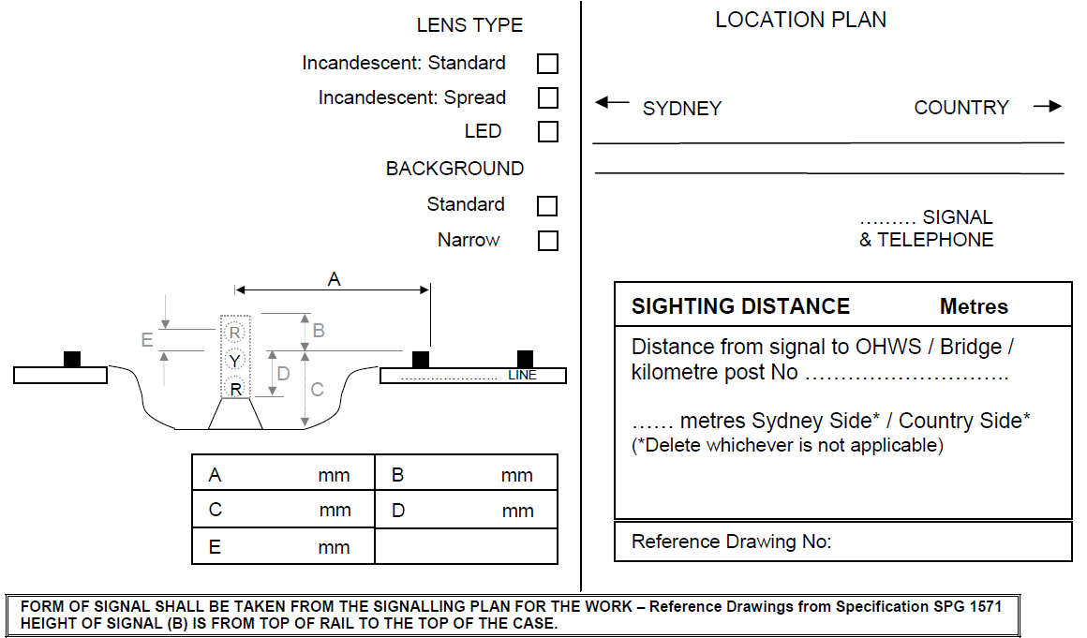

Remarks:
Sighting Restrictions, Sighting Screens, Special foundation requirements, Access restrictions, OHW constraints, etc.

Sighting Committee |  |  |  | Date:
Discipline/Agency | Name | Signature | Phone no |  | Position
Network Operations
Train Crewing – Suburban
Train Crewing – Interurban
Train Crewing – Freight
Safety Professional
Regional Signals – AMD
Regional Signal – NMD
Human Factors
Signal Design
Commissioning Engr/Mgr
Project Delivery Manager
Construction Contractor
Add second page if additional signatures are required.

