<document Title>

Guidance to document user

All material in this template presented in green italics is to be deleted prior to finalisation of the document

EMS title – The document title of this document as published within the EMS.
Document title – The document title as modified and issued by the user of the EMS template. The document title will usually include the location, scope or some other identifier of the project or application.

EMS template metadata:
- EMS title: EMS-06-TP-0066 Revegetation Technical Specification Template
- Version: 4.0
- Document Custodian: Environment Specialist
- Approver: Director Environment.
- Approval date: 26/03/2019
- Review date: 05/04/2022

Contents
1 Introduction 3
1.1 Purpose and Scope 4
1.2 Materials 4
1.2.1 Fertiliser 4
1.2.2 Mulch 4
1.2.3 Organic Fibre Mat 4
1.2.4 Plant Material 4
1.2.5 Soil Moisturiser 5
1.2.6 Tree Guards/Stakes 5
1.2.7 Herbicides and other Pesticides 5
1.2.8 Imported Top soil 6
2 Planting operations 6
2.1 Technical Supervision 6
2.2 Preservation of Existing Vegetation 6
2.3 Setting Out 6
2.4 Preparation 7
2.4.1 Weed Removal 7
2.4.2 Clearing 7
2.4.3 Sediment Control 7
2.4.4 Soil Surface Preparation 8
2.4.5 Laying imported top soil 8
2.4.6 Laying organic fibre matting 8
2.4.7 Laying mulch 8
3 PLANTING 9
3.1 Planting Holes 9
3.2 Planting 9
4 Re-vegetation Treatments 11
4.1 Mixed shrub and understorey treatment with maximum height of 4 metres. 11
4.2 Mixed shrub and understorey treatment with unlimited height 13
4.3 Groundcover only species with maximum height of a half metre. 13
4.4 Specimen trees – small (maximum height 5 metres). 14
4.5 Specimen trees – Medium (maximum height 15 metres). 15
4.6 Wall vine treatment. 16
4.7 Mesh fence treatment. 17
4.8 Shotcrete Cutting and retaining wall treatment. 17
4.9 Specimen trees for Planting into Hard Surfaces Treatment. 18
4.10 Garden bed shrubs on Platform Treatment 19
5 MAINTENANCE 20
5.1 Requirement and Duration 20
5.2 Maintenance Inspections 21
5.3 Watering 21
5.4 Mulch 21
5.5 Weed Control 21
5.6 Disease and Insect Control 22
5.7 Plant Replacement 22
5.8 Tree Guards 22
6 References 23
Appendix 1: Detail Sketches 24
Appendix 2: Site Plan 28

Introduction
NOTE: ALL WORDING IN GREEN IS TO BE REPLACED OR REMOVED BEFORE THE TECHNICAL SPECIFICATION IS ISSUED
This document outlines a range of landscaping and revegetation concepts for Sydney Trains lands. It proposes suggested treatments for various situations where vegetation is to be established and includes recommended plant species. Photos of the various treatments are provided in EMS-09-GD-0074 Revegetation Guide.
This is a guidance document only and some situations may require specialist consideration such as in areas of environmental sensitivity (such as riparian area), heritage precincts or extreme sites (such as very steep or full shade). The document can also be used as a technical specification for re-vegetation works. To do so delete those sections not required.
For any contract specification a schedule of rates similar to the table below should also be requested in the schedule.
The rates (not subject to rise and fall) are as follows.
Item | Services or Works Description | Unit  (hour/each etc) | Rate  ($ per unit)
1 | Supply and plant locally indigenous tubestock | Each with minimum 50 plants | $ per plant
2 | Maintain plants - weed control and water | Each week to minimum 50 plants | $ per plant
3 | Supply and spread eucalypt mulch to 75mm deep. | 5 x cubic metre | $ per cubic m
4 | Perform Bush regeneration and supply all materials and equipment required | Man hour - minimum 4 hours | $ per man hour
5 | Supply worksite protection officer minimum PO1 qualification | Hour - minimum 4 hours | $ per man hour
6 | Waste disposal | Tonne | $ per tonne
7 | Chip branches | Cubic metre(chipped) | $ per cubic m
8 | Brushcutting | Hour - minimum 4 hours | $ per hour
9 | Supply and spray glyphosate | Square metre- minimum 20m² | $ per sq m
Note: The rate is the cost for each unit not the cost for the minimum number. E.g. For item 1, the rate will be a $ cost for each plant and not the $ cost of 50 plants.

Purpose and Scope
This specification is for the revegetation of Sydney Trains land at XXXXXX. On the XXXXX Line. The revegetation site is bounded by the following;
(Note, the details below are an example:
- West boundary- Top of embankment
- East boundary- Toe of embankment or boundary fence
- North boundary- Stanchion BH 12+456
- South boundary- City end of XXXXXX Platform
(The above information should also be outlined in the site plan in Appendix 2 to avoid any confusion.)

Materials

Fertiliser
Fertiliser shall be a slow-release type in pellet or granular form with an 8-9 months release period and an Nitrogen-Phosphorous-Potassium (NPK) ratio approximately equal to 20-4-8.

Mulch
Mulch used in planting works shall be a blend of woodchip and leaf material of the type commonly marketed as forest blend.
Mulch shall comply with the following requirements:
- Mulch shall only be derived from waste timber. Under no circumstances shall wood chip, derived from trees, which have been specifically harvested for that purpose, be accepted by Sydney Trains.
- It shall be free of soil, weeds, stones, vermin, insects or other foreign material.

Organic Fibre Mat
Delete this section if there are no revegetation areas on slopes steeper than 2.5:1.
Organic fibre matting is to be a solid mat made up of 100% organic fibre such as coconut fibre or jute material. The mat is to be of a density/weight of between 350 to 650 grams per square metre. Pins to secure the matting are to be according to the mat manufacturer’s specification.

Plant Material
All plant material is to be sourced locally and provenience to the local area where ever possible.
(If there is sufficient lead time, tubestock should be grown from locally sourced seed and propagation material)
A species list is outlined in section 4.0.
All bedded plant material shall be supplied in gro-tube trays or tubestock, if to be planted within the rail corridor.
Where planting is outside the rail corridor larger plants should be used (the larger the better)
For street tree planting, super advanced or semi-mature trees should be used (optimum of 100 litre pots or council requirements).
All plant material shall be true to species and shall be well grown, of good form, not soft or forced and with large healthy root systems. They shall not be root bound and must be free from disease and insect pests.
Trees shall have a single leading shoot.

Soil Moisturiser
The soil moisturiser shall be a hydroscopic material and shall be pre-mixed with water and incorporated into the excavated planting hole during the planting operations or as per the manufacturer’s instructions.

Tree Guards/Stakes
Tree guards are to be used on tubestock shrubs and trees and shall be either;
- of the green plastic type tree guards of approximately 255 mm dia. x 450 mm long, and shall be secured with three bamboo stakes, of 750mm long and heavy duty. As per the planting detail sketch in Appendix 1. Figure a., or,
- of the 1 litre milk carton type secured using two bamboo stakes of 750mm long and heavy duty.
Tubestock of ground cover and aquatic species shall be marked by a single bamboo stake of 750mm long and heavy duty, as shown in the planting detail sketch in Appendix 1, figure b.
Advanced and semi advanced shrubs and trees shall be marked by a single bamboo stake of 750mm long and heavy duty, as shown in the planting detail sketch in Appendix 1, figure c.
Super advanced trees shall have three stakes of 50 x 50 x 3000 mm made from hardwood. The plant is to be secured to the stakes by 3 individual jute ties. As per the planting detail sketch in Appendix 1, figure d.

Herbicides and other Pesticides
Herbicides and pesticides shall be currently registered for the intended use by the National Registration Authority for Agricultural and Veterinary Chemicals (NRA). Or a permit must be issued for that pesticide and specified usage. Herbicides and pesticides shall be used in accordance with the manufacturer’s directions supplied with the product.
The choice of herbicide used in site preparation and in maintenance will be the most appropriate herbicide for the species and circumstances present on the site. The most appropriate recommended herbicide is to be found in the Department of Primary Industries NSW Weed Control Handbook (most current issue).
A compatible vegetable based dye must be used with all herbicide applications that result in a distinct colour that will clearly indicate where herbicide has been applied to foliage or stumps.
The Sydney Trains procedure EMS-11-PR-0017 Pesticide must be followed for all pesticide usage on Sydney Trains lands and only those pesticides listed in EMS-11-RG-0073 Sydney Trains Pesticide Register can be used for the purpose specified.
All persons applying pesticides on Sydney Trains lands must hold the appropriate ChemCert qualification for the type of application and the pesticides to be used as specified in EMS-11-RG-0073 Sydney Trains Pesticides Register.

Imported Top soil
Where the site soil is unsuitable for establishing vegetation, top soil should be imported to supplement site soil. Delete this section if imported top soil is not to be used.
Where site soil is to be imported to site for plant establishment it is to conform to the Australian Standard AS4419 Soils for Landscape and Garden Use, and specifically targeted to use for Australian native plants – ie low in phosphorous levels.

Planting operations

Technical Supervision
All preparation, planting and maintenance of planting sites should be supervised on site at all times by a competent and qualified Landscape Tradesman who is experienced in revegetation techniques. The Minimum qualification is a NSW TAFE Certificate in Horticulture or equivalent and a minimum of 2 years industry experience.
Note safety supervision requirements must be stipulated elsewhere.

Preservation of Existing Vegetation
If any locally indigenous vegetation is present on site it should be retained unless specified by the principal (for example where large growing species are not suitable for operational constraints).
If the site supports any threatened species, population or ecological community are likely to be impacted. Suitable environmental impact assessment must be undertaken by the principal. (Refer to EMS-11-PR-0008 Environmental Impact Assessment)

Setting Out
General requirements additional to the site plans. Except where otherwise stated;
- Only ground cover species (or vines) are to be planted within 1 metre of the ballast shoulder of the track.
- Only vegetation with a mature height of four (4) metres or below is to be planted in or adjacent to the rail corridor where an electrical feeder is located on that side of the track.
- All vegetation over six (6) metres tall mature height must be planted a minimum of the plant’s mature height from rail infrastructure.
- No plants are to be planted directly in front of vehicular or pedestrian gateways unless specified.

Preparation

Weed Removal
Where weed infestation occurs (or any existing vegetation is to be removed) the following action is to be taken before clearing and planting.
- for those species listed by the relevant local government authority as noxious, Class 1, 2, 3, 4 and 5 under the Noxious Weeds Act 1993, action shall be taken as required by that local government authority, and
- for all other species, treat with the herbicide by the technique to give the most effective control as per section 1.2.6.
Areas sprayed with herbicide shall remain undisturbed for two weeks unless a longer period is recommended by the herbicide manufacturer.
Weed control sessions are to be undertaken over the site using whatever method is deemed the most effective to limit the extent of viable weed propagules on the planting site.
After the initial weed control application no weed should be allowed to reach maturity and/or set seed. The effectiveness of weed control should be monitored at a minimum of once every 2 weeks or whatever period is necessary to ensure that no weed reaches maturity or sets seed or produces viable propagules.

Clearing
All planting areas are to be cleared by slashing or manual clearing to a height of not more than 100 mm together with a perimeter area 1.5 m wide, (except vegetation to be retained). All slashings unsuitable for mulching on site should be removed from site. Any rubbish, debris, litter and extraneous construction materials found on the surface of the planting sites should be removed from site and disposed of at a licensed land fill site.

Sediment Control
No area shall be left exposed to erosion from wind or water. All areas cleared of vegetation or cultivated and not immediately protected by mulching, or matting shall have appropriate sediment control measures installed at all egress points around the sites as outlined in the LANDCOM “Bluebook” Soils and Construction, Vol 1. March 2004.

Soil Surface Preparation
All areas for revegetation must be roughened/cultivated with chains or tynes, particularly if the batter has been graded smooth. If the embankment was previously vegetated with weeds or exotic vegetation, this may not be necessary.
Hold Point.
No application of top soil, mulch or fibre matting is to be carried out until weed control and ground preparation has been inspected by the Sydney Trains Representative and written approval is provided.

Laying imported top soil
Delete this section if imported top soil is not to be used in this project.
Existing soil surface is to be ripped to a depth of 100mm on areas accessible to tractor mounted gear, other areas are to have the surface roughened prior to spreading topsoil. Top soil is to be laid to a depth of 100mm over the entire planting site.

Laying organic fibre matting
Delete this section if organic fibre mat is not to be used, ie there are no areas to revegetate that are steeper than 2.5:1 in this project.
Organic fibre mat is to be laid over the areas of the site that are steeper than 2.5:1. Matting is to overlap by a minimum of 50mm were ever joins in the mat occur. Matting is to be securely pined into the ground using pins approved by the manufacturer. The mat is to be pinned so as not to move during planting or high wind or rainfall events. As a minimum, all outer edges of each section of mat are to be pinned every metre and the body of the mat is to have a securing pin every square metre. Do not lay organic fibre mat over rock, leave these areas free of mat and plant up any pockets of soil material as specified.

Laying mulch
The spreading of mulch prior to planting is the best method of mulching beds. Individual advanced specimens should be mulched after planting.
Mulch can be applied to the site manually or by using a mulch blower if access to machinery is difficult.

Hold Point.
No planting is to be carried out until ground preparation and mulching have been inspected by the Sydney Trains Representative and written approval is provided.

PLANTING

Planting Holes
Planting holes should be excavated to the following minimum dimensions depending on the size of the plant container, as shown in Appendix 1.
Table 3.1: Planting Hole
Plant Size | Planting Hole
“Gro tube” or tubestock | 200 mm x 200 mm x 200 mm deep
“Semi-advanced” | 400 mm x 400 mm x 400 mm deep
“Advanced” | 600 mm x 600 mm x 600 mm deep
“Super advanced” | To be determined based on container size
See details in Appendix 1.

Planting
Delete any clauses that are not relevant to the project in this section.
Planting should not be carried out into dry soil or in extreme weather conditions. Plant root systems shall be maintained moist at all times with particular attention paid during the on-site period prior to and during planting.
Following excavation of the planting hole, place and spread a soil moisturiser, pre mixed with water in accordance with the manufacturer’s recommendations, at the bottom of each planting hole.
During planting and back filling with site topsoil, slow release fertiliser granules shall be mixed with the back fill soil avoiding clumps of fertilizer likely to burn plant roots.
The back filling of each hole shall be completed and lightly compacted by tamping down so that on completion the back filled area is flush with the level of the surrounding soil.
A soil berm is to be constructed around the plant to retain a minimum of five litres of water (for tubestock) and 20 litres (for super advanced) as per details in Appendix 1.
In mulched beds the mulch shall be placed over the disturbed area but kept clear of the plant stem. Mulch shall be applied to a minimum depth of 75 mm over the entire planting bed. Areas not mulched to adequate depth will require the addition of further mulch at the contractors expense.
Where organic fibre matting has been laid on steeper areas of the revegetation site, individual cuts are to be made in the mat for each plant and the plants are to be planted as specified. After planting the mat is to be reinstated around the newly installed plant.
Where “super advanced” trees are planted into turf, an area of 4 square metres is to be mulched to specification around each. Where they are to be planted into mulched beds the mulching is to be continuous across treatments.
A tree guard as outlined in section 1.5 shall be installed around each tubestock shrub or tree plant as detailed in the planting detail in Appendix 1. More advanced trees and shrubs, Grasses and ground cover species will not require tree guards however they should be marked with a single bamboo stake.
Super advanced trees shall have three stakes of 50 x 50 x 3000 mm made from hardwood. The plant is to be secured to the stakes by a minimum of 3 individual jute ties or as many as is required to achieve adequate support in pending environmental conditions as per the planting detail in Appendix 1. Other trees requiring support should have 2 or 3 suitably sized stakes arranged and secured with jute ties.
Each plant shall receive 5 litres (tubestock) of water or 20 litres of water (super advanced stock) or what ever amount is required to ensure an adequate moisture status for the plant and surrounding soil, in a manner which causes minimal disturbance to the mulch.

Hold Point.
The Sydney Trains representative is to be advised well in advance when planting is to commence so they can be on site to approve the quality of planting stock and ensure the plant set out can be observed prior to planting.

Re-vegetation Treatments
The following potential planting situations are presented with recommended species for planting. Note wherever native species are recommended the plant material should be sourced from the local area wherever possible.
See EMS-11-GD-0074 Revegetation Guide for photographic representation of selected treatments and species.
Check the general requirements for planting in section 2.3 above.

Mixed shrub and understorey treatment with maximum height of 4 metres.
This treatment would be suitable on embankments or as a screen to fences or structures where maximum height clearance is required. (Note where weed burden is considered high remove Themeda triandra from the ground cover species mix)
This treatment is to comprise mulched beds of randomly placed clumps of some or all of the listed shrub species and an understorey of the listed ground cover species. Ground cover species should constitute approximately 30 % of the area planted.
Where this treatment is used to screen, larger plants should be planted closer to the item to be screened and scaled down in height out from it, finishing with ground cover species.
Table 4.1: Species List – mixed shrub and understorey treatment < 4.0 metres
Species List - Small Shrubs | Plants per square metre | Suitable for  Eastern Sydney | Suitable for Western Sydney | Suitable for Blue Mountains | Suitable for the Illawarra | Suitable for Central Coast
Acacia falcate | 1 | X | X |  | X | X
Acacia floribunda | 1 | X | X | X | X | X
Acacia linifolia | 1 | X | X |  | X | X
Acacia longissima | 1 | X | X
Acacia terminalis | 1 | X | X | X | X | X
Acacia ulicifolia | 1 | X | X | X | X | X
Allocasuarina distyla | 1 | X | X | X | X | X
Allocasuarina nana | 1 |  |  | X | X
Banksia ericifolia | 1 | X |  |  | X | X
Bursaria spinosa | 1 | X | X |  | X | X
Cassinia arcuata | 1 |  | X | X
Darwinia fascicularis | 1 | X |  |  | X | X
Dodonea triquerta | 1 | X | X | X | X | X
Epacris longifolia | 1 | X |  | X | X | X
Eucalyptus stricta | 1 |  |  | X
Exocarpos strictus | 1 | X | X | X | X | X
Grevillia buxifolia (local form) | 1 | X |  | X | X | X
Grevillia sericea | 1 | X |  | X | X | X
Grevillia shiressii | 1 |  |  |  |  | X
Hakea dactyloides | 1 | X | X | X | X | X
Hakea microcarpa | 1 |  |  | X
Hakea sericea | 1 | X |  | X | X | X
Indigofera australis | 1 | X | X | X | X | X
Kunzea ambigua | 1 | X | X | X | X | X
Lambertia formosa | 1 | X |  | X | X | X
Leptospermum attenuatum | 1 | X |  | X | X | X
Leptospermum juniperinum | 1 | X |  | X | X | X
Leptospermum laevivigatum | 1 | X |  |  | X | X
Melaleuca hypericifolia | 1 | X |  |  | X | X
Melaleuca nodosa | 1 | X |  |  | X | X
Melaleuca thymifolia | 1 | X | X | X | X | X
Melaleuca squamea | 1 | X | X |  | X | X
Myoporum acuminatum | 1 | X | X |  | X | X
Polyscias sambucifolia | 1 | X | X | X | X | X
Pulteneaea elchila | 1 | X | X |  | X | X
Pulteneaea villosa | 1 | X | X |  | X | X
Westringia fruiticosa | 1 | X |  |  | X | X
Westringia longifolia | 1 |  | X |  |  | X

Species List - Ground Covers | Plants per square metre | Suitable for  Eastern Sydney | Suitable for Western Sydney | Suitable for Blue Mountains | Suitable for The Illawarra | Suitable for Central Coast
Dianella sp ( local species) | 4 | X | X | X | X | X
Imperata cylindrica | 4 | X | X | X | X | X
Lomandra longifolia | 4 | X | X | X | X | X
Themeda triandra | 4 | X | X | X | X | X

Mixed shrub and understorey treatment with unlimited height
This treatment would be suitable on embankments or as a screen to fence or building lines where no height clearance is required.
Include the suitable shrub and ground cover species from Section 4.1 and add a range of suitable taller growing species from the following table.
This treatment is to comprise mulched beds of randomly placed clumps of some or all of the listed shrub/tree species and an understorey of the listed ground cover species. Ground cover species should constitute approximately 30 % of the area planted.
Where this treatment is used to screen, larger plants should be planted closer to the item to be screened and scaled down in height out from it, finishing with ground cover species.
Table 4.2: Species List – Large Shrubs/Trees
Species List - large Shrubs/trees | Plants per square metre | Suitable for  Eastern Sydney | Suitable for Western Sydney | Suitable for Blue Mountains | Suitable for The Illawarra | Suitable for Central Coast
Acacia decurrens | 1 | X | X | X | X | X
Acacia implexa | 1 | X | X | X | X | X
Acacia parramattensis | 1 | X | X |  | X
Acacia prominens | 1 | X |  |  |  | X
Banksia marginata | 1 | X | X | X | X | X
Banksia serrata | 1 | X |  | X | X | X
Callistemon salignus | 1 | X | X |  | X | X
Casuarina glauca | 1 | X | X |  | X | X
Melaleuca decora | 1 |  | X

Groundcover only species with maximum height of a half metre.
This treatment would be suitable anywhere, even when occasional vehicle access is required. Groundcovers can be planted where limited room for planting is available, or where maximum clearance is required for example in front of a bill board or adjacent to structures.
(Note where weed burden is considered high remove Themeda triandra from the species mix)
This treatment will comprise mulched beds of a dense swathe of each ground cover species in substantial clumps of the same species blending between species in organic curves.
Table 4.3: Species List – Ground Covers
Species List - Ground Covers | Plants per square metre | Suitable for  Eastern Sydney | Suitable for Western Sydney | Suitable for Blue Mountains | Suitable for The Illawarra | Suitable for Central Coast
Dianella sp ( local species) | 4 | X | X | X | X | X
Imperata cylindrica | 4 | X | X | X | X | X
Lomandra longifolia | 4 | X | X | X | X | X
Themeda triandra | 4 | X | X | X | X | X

Specimen trees – small (maximum height 5 metres)
This treatment would be suitable for any street tree replanting where there is minimal clearance such as under overhead wiring.
Note; choose the most appropriate species for the situation remembering it is best to consistently use the same species in any location.
For situations where winter sunlight is required choose a deciduous species.
This treatment comprises of individual specimen trees mulched around the base with 4 square metres of mulch, or in a continuous row within a fully mulched bed spaced at the minimum spacing indicated or greater.
Table 4.4: Species List – Small Specimen Trees
Species List - Small trees | Minimum spacing | Suitable for  Eastern Sydney | Suitable for Western Sydney | Suitable for Blue Mountains | Suitable for The Illawarra | Suitable for Central Coast
Crepe myrtle (Deciduous)  Lagerstroemia indica | 5 | X | X | X | X | X
Dogwood (Deciduous)  Cornus florida | 5 |  |  | X
Dwarf Apple  Angophora hispida  (not suitable for a standard tree shape) | 5 | X |  | X | X | X
Evergreen Ash,  Fraxinus griffithii | 5 | X | X | X | X | X
Fried Egg Plant  Gordonia axillaris | 5 | X |  | X | X | X
NSW Christmas bush  Ceratopetalum gummiferum  (do not use where a raised crown is required). | 5 | X | X | X | X | X
Watergum,  Tristaniopsis laurina | 5 | X | X | X | X | X
Weeping Bottlebrush,  Callistemon viminalis (choose cultivars suitable for the location and the correct height restriction) | 5 | X | X | X | X | X

Specimen trees – Medium (maximum height 15 metres).
This treatment would be suitable for any street tree replanting where there is maximum clearance. Check local council’s preferred street tree list.
This treatment comprises of individual specimen trees mulched around the base with 4 square metres of mulch.
Table 4.5: Species List – Medium Height Trees
Species List - Medium height trees (approx height in metres) | Minimum spacing | Suitable for  Eastern Sydney | Suitable for Western Sydney | Suitable for Blue Mountains | Suitable for The Illawarra | Suitable for Central Coast
Narrow leafed Apple  Angophora bakeri  (15 metres) | 6 | X |  | X | X | X
Willow Bottlebrush  Callistemon salignus  (6 metres) | 6 | X | X | X | X | X
Western Australian Gum  Eucalyptus ficifolia  (8 metres) | 6 | X | X |  | X | X
Blueberry Ash  Elaeocarpus reticulatus  (10 metres) | 6 | X | X | X | X | X
White Feather Honey Myrtle  Melaleuca decora  (10 metres) | 6 | X | X |  | X | X
Plum Pine  Podocarpus elatus  (6 metres) | 8 | X | X | X | X | X
New Zealand Christmas Bush  Metrosideros excelsa  (8 metres) | 6 | X | X | X | X | X
Queensland Laurel  Pittosporum rhumbifolium  (6 metres) | 6 | X | X |  | X | X
Tuckeroo  Cupaniopsis anacardioides  (10 metres) | 6 | X | X |  | X | X
Pistachio (Deciduous)  Pistachio chinensis  (8 metres) | 6 | X | X |  | X | X

Wall vine treatment.
This treatment would be suitable where a solid masonry wall is available and could be planted with a self clinging vine to replace some other vegetation that is providing screening to the wall – particularly relevant on walls prone to graffiti or noise barrier walls. Note that there are no native species that are self-clinging, so exotic species will need to be used. Alternatively a mesh fence erected in front of the wall could be treated as in treatment 4.7. Note you could use both species together, alternating along the wall.
This treatment comprises of vines spaced along the base of the wall. The entire row should be mulched out from the wall to a distance of 1 5 metres.
Table 4.6: Species List – Wall Vines
Species List – Wall Vines | Single row with spacing at; | Suitable for  Eastern Sydney | Suitable for Western Sydney | Suitable for Blue Mountains | Suitable for The Illawarra | Suitable for Central Coast
Virginia Creeper (Deciduous)  Parthenocissus quinquefolia | 2 metres | X | X | X | X | X
Creeping Fig  Ficus pumila | 3 metres | X | X | X | X | X

Mesh fence treatment.
This treatment would be suitable where a mesh fence requires softening or to screen something beyond the fence. It could be used where a mesh fence is erected in front of a wall targeted by graffiti vandals. Mesh fence should be spaced from 100 to 200mm from the graffiti prone surface. Note you could use two species together, alternating along the wall.
This treatment comprises of vines spaced along the base of the fence. The entire row should be mulched out from the fence to a minimum distance of 1 metre (either side of the fence if possible.
Note that some training of vines to climb the fence may be required.
Table 4.7: Species List – Mesh Fence Vines
Species List – Mesh Fence Vines | Single row with spacing at; | Suitable for  Eastern Sydney | Suitable for Western Sydney | Suitable for Blue Mountains | Suitable for The Illawarra | Suitable for Central Coast
Wonga Vine  Pandorea pandorama | 2 metres | X | X | X | X | X
False Sasparilla  Hardenbergia violacea | 2 metres | X | X | X | X | X
Coral Pea  Kennedia rubicunda  (additional training required in the establishment phase) | 2 metres | X | X | X | X | X
Trailing Guinea Flower  Hibbertia dentata | 2 metres | X | X | X | X | X

Shotcrete Cutting and retaining wall treatment.
This treatment would be suitable to plant along the top of shotcrete cuttings, embankments and retaining walls so as to trail over and soften the impact or to screen the cutting from potential graffiti attack. Shotcrete can also be designed with gaps that can incorporate such plants to scramble over the surface.
This treatment comprises of scrambling or trailing plants spaced along the top of the cutting. The entire row should be mulched out from the edge of the shotcrete to a minimum distance of 1 metre.
Table 4.8: Species List – Scrambers
Species List - Scramblers | Single row with spacing at; | Suitable for  Eastern Sydney | Suitable for Western Sydney | Suitable for Blue Mountains | Suitable for The Illawarra | Suitable for Central Coast
Coral Pea  Kennedia rubicunda- (do not use where other species are planted as they will be swamped) | 2 metres | X | X | X | X | X
False Sasparilla  Hardenbergia violacea  (ensure you don’t use upright varieties) | 2 metres | X | X | X | X | X
Trailing Guinea Flower  Hibbertia dentata  (This species is less suitable for larger areas of shotcrete) | 2  metres | X | X | X | X | X
Royal Mantle Grevillea  Grevillea Poorinda “Royal Mantle”  (This species is good to trail down high retaining walls) | 2  metres | X | X | X | X | X

Specimen trees for Planting into Hard Surfaces Treatment.
This treatment would be suitable for any where a small specimen trees is required to be planted into a paved, concrete or bitumen surface where there is minimal clearance.
Note; there is a separate specification for planting specimen trees on platforms, consult EMS-06-TP-0095 Station Garden Bed Technical Specification
Note; choose the most appropriate species for the situation remembering it is best to consistently use the same species in any location.
For situations where winter sunlight is required choose a deciduous species.
This treatment comprises of individual specimen trees mulched around the base with 4 square metres of mulch.
Table 4.9: Species List – Small Trees for Platforms and other hard surfaces
Species List - Small trees for Platforms | Minimum spacing | Suitable for  Eastern Sydney | Suitable for Western Sydney | Suitable for Blue Mountains | Suitable for The Illawarra | Suitable for Central Coast
Black Wattle  Callicoma serratifolia | 5 |  |  | X
Crepe myrtle (deciduous)  Lagerstroemia indica | 5 | X | X | X | X | X
Evergreen Ash,  Fraxinus grithitiii | 5 | X | X | X | X | X
Fried egg plant  Gordonia axillaris |  |  |  | X
Watergum,  Tristaniopsis laurina | 5 | X | X |  | X | X
NSW Christmas bush  Ceratopetalum gummiferum (do not use where a raised crown is required). | 5 | X | X | X | X | X
Weeping Bottlebrush,  Callistemon viminalis | 5 | X | X | X | X | X

Garden bed shrubs on Platform Treatment
This treatment can be used on Station Platforms where existing or new garden beds are formed up. This native theme is likely to suit any non-heritage stations with good growing conditions that are well drained with adequate sunlight. For garden beds of heritage gardens or where unusual conditions prevails such as under structures/ low light/ very wet, seek professional advice.
Note; generally shrub species are not suitable for use on platforms as they may not comply with Crime Prevention Through Environmental Design guidelines. It is recommended that platform garden beds comprise of only small trees with surrounding ground cover species as outlined in the specification EMS-06-TP-0095 Station Garden Bed Technical Specification that also provides detail on standard Sydney Trains bed dimensions and edging requirements.
This treatment is to comprise mulched beds of the following species and include a shrub and understorey layer. If the bed is against a fence of wall the shrubs should be planted close to the wall or fence and the fore ground planted with the ground cover species. Where the bed is accessible from all sides the shrubs should be centered in the bed and surrounded with ground cover species.
Table 4.10: Species List – Small Shrubs for Platforms
Species List - Small Shrubs for Platforms | Plants per square metre | Suitable for  Eastern Sydney | Suitable for Western Sydney | Suitable for Blue Mountains | Suitable for The Illawarra | Suitable for Central Coast
Westringia fruticosa (Coastal rosemary can be clipped into shape) | 1 | X | X |  | X | X
Kunzea ambigua | 1 | X | X | X | X | X
Doryanthes excelsa (Gymea lily makes a good feature plant) | 1 | X | X |  | X | X
Dillwynia retorta | 1 | X | X | X | X | X
Lambertia formosa |  | X |  | X | X | X
Banksia spinulosa | 1 | X | X |  | X | X

Table 4.11: Species List – Ground Covers for Platforms
Species List - Ground Covers | Plants per square metre | Suitable for  Eastern Sydney | Suitable for Western Sydney | Suitable for Blue Mountains | Suitable for The Illawarra | Suitable for Central Coast
Dianella sp. (select miniature varieties such as “Little Jess” | 4 | X | X | X | X | X
Hibbertia dentata (prostrate scambler) | 2 | X | X | X | X | X
Lomandra longifolia | 4 | X | X | X | X | X
Lomandra ”Tanika” | 4 | X | X | X | X | X

MAINTENANCE

Requirement and Duration
Maintenance should be carried out for as long as is possible to ensure the best establishment possible.
The contract maintenance period is for 18 months/ 12 months/ 6 months (delete which ever is not applicable). The maintenance period will commence once planting operations have been completed to the satisfaction of Sydney Trains.

Hold Point.
The official start of the maintenance period will not commence until the site has been inspected and all works are to the satisfaction of the Sydney Trains Representative and written approval is provided.

Maintenance Inspections
The site should be visited at intervals not exceeding fourteen (14) days to determine the status of the re-vegetation plantings and the effectiveness of maintenance previously carried out and in progress. All items listed in sections 5.3 to 5.8 must be addressed at each maintenance visit. However this is a minimum requirement and if the site conditions require more frequent visits such as for watering plants in dry weather conditions then a more regular visitation program is to be instigated.
Note that the fourteen day visit interval can be altered to take into account site conditions, time of year etc.

Watering
Each watering shall comprise the application of five (5) litres of water per tube stock plant (and 20 litres for super advanced plants) at weekly intervals for a period of eight (8) weeks from the commencement of the maintenance service period. For the remainder of the contract, each plant shall receive the same level of watering at fourteen day intervals depending on the soil moisture of the planting site.
Plants should not be permitted to dry out at any time. The frequency of watering may be varied during periods of adequate rainfall. Weather conditions will dictate if more frequent than fortnightly watering is required.

Mulch
The mulch should be kept in a weed free condition and additional mulch reinstated as required.
The cost of mulch maintenance shall be borne by the Contractor, unless resulting from damage caused by a third party. In these cases, the cost of reinstatement of the mulch shall be treated as a Variation to the Contract.

Weed Control
All planting areas out to the limit of clearing as specified in Clause 2.4.2 should be kept free of exotic grass and weeds.
- Weed removal shall be carried out at intervals of not more than two (2) weeks. For those species listed by the relevant local government authorities as noxious class 1, 2, 3, 4 or 5 under the Noxious Weeds Act 1993, action shall be taken as required by that local government authority. For all other species, treat with the most appropriate herbicide by the technique to give the most effective control as per section 1.2.6 in accordance with the manufacturer’s recommendations.
Weeds which cannot be controlled by herbicide and their treatment is likely to impact on desirable plants, shall be removed by hand, such as those weeds occurring within the tree guard. The entire weed shall be removed.
Any weed material not suitable to leave on site (ie that may propagate from residual material) should be bagged and removed from site.
Where super advanced trees are planted into existing turf the edge of the turf is to be sprayed with herbicide so that it does not encroach into the mulch surrounding the tree.

Disease and Insect Control
Plants shall be sprayed to control disease and insect infestation when required. Sydney Trains must be notified prior to the application of fungicides and insecticides and must be in accordance with EMS-11-PR-0017 Sydney Trains Pesticides.

Plant Replacement
Missing or dead plants and plants that are unsatisfactory shall be replaced immediately they are identified by the contractor or brought to their attention by Sydney Trains. Replacement plants shall be of similar size and quality and of identical species and variety to the plant being replaced unless agreed otherwise by Sydney Trains.

Tree Guards
Tree guards and stakes are to be maintained around each plant so that the natural plant growth is not impeded or restricted. Damaged and missing tree guards or stakes shall be replaced as soon as practicable after being identified.
Tree guards are to be removed from around all the plants on the site during the final month of the operation maintenance period (no later that 18 months after planting). If the maintenance period is short, plants may not have established sufficiently to remove tree guards, in such cases they should be left in-situ.

References
EMS-03-PR-0008 Environmental Impact Assessment
EMS-11-RG-0073 Sydney Trains Pesticide Register
EMS-06-GD-0074 Revegetation Guide
LANDCOM “Bluebook” Soils and Construction, Vol 1. March 2004.
NSW Weed Control Handbook (latest edition), NSW Department of Primary Industries
Noxious Weeds Act 1993

Appendix 1: Detail Sketches

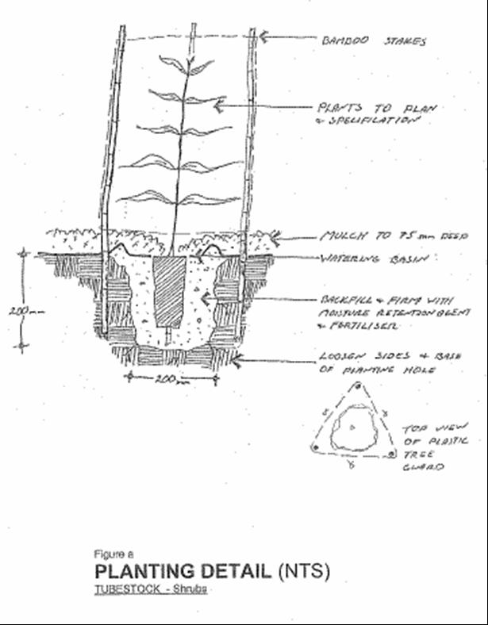
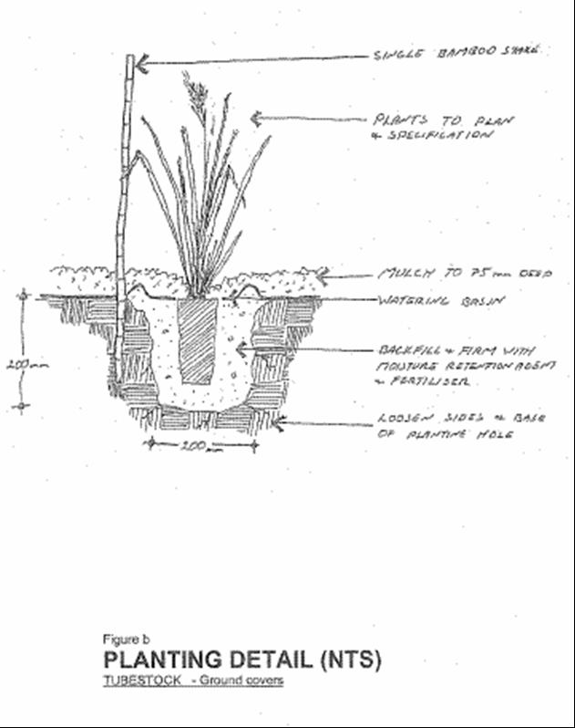
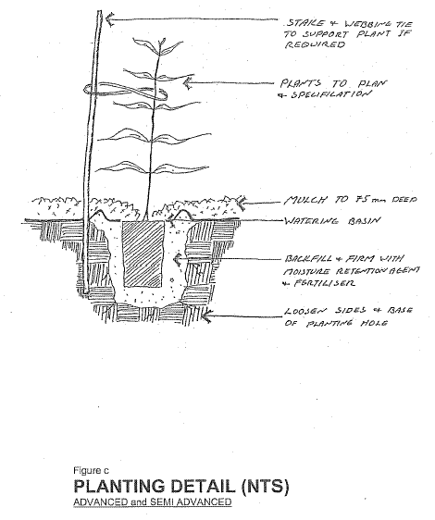

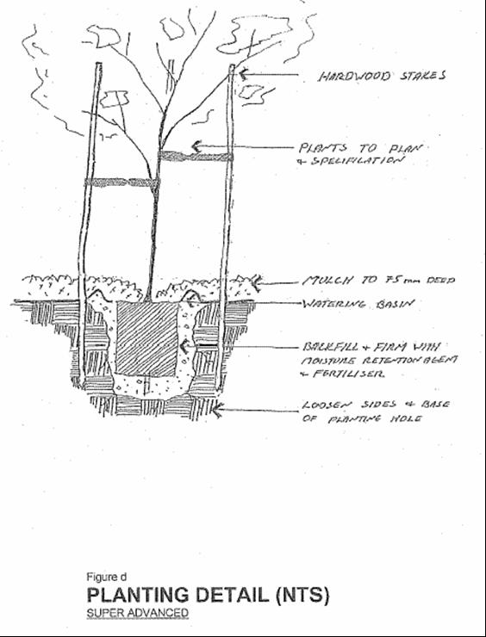

Appendix 2: Site Plan

Insert maps or plans of the revegetation sites. Ensure that site boundaries are clearly shown so that tenderers can estimate areas and there is no confusion regarding the scope. Note; always leave it to the contractor to estimate the area of coverage for revegetation.

