- This form is driven by and should be used in conjunction SMS-06-OP-3028 WHS Risk Management Procedure.
- Note: where there is debate and disagreement with risk ratings/rankings, the final decision shall be made by the Risk Owner.
- The table(s) in Section 2 provide guidance and can be deleted following completion of the risk assessment.
- Details must be entered into a risk register and an authorised database; a copy of this form must also be retained for record-keeping purposes.

Section 1: Details of Risk Assessment
Business Unit/Segment Information
Business Unit/Segment: | Date of assessment: | Date of next review: | Location:

Activity/Process
Describe the activity/process (what, why, where, how):
Relevant documents and evidence used during the risk assessment e.g. Legislative references, Codes of Practice, Australian Standards, related risk assessments, system documentation, records of occurrences, etc.:

Scope of Risk Assessment
Describe the scope of the risk assessment (including assumptions, data sources and/or methods used):

Risk Assessment Team Members / Representation
Team Leader(s): | Management Representative(s): | Workers/ HSRs:
Other personnel involved in the Risk Assessment Process:

Sign-off and authorisation
Name: | Position: | Signature: | Date:

Section 2: Risk Assessment
Note: the aim MUST always be to eliminate a hazard, which is the most effective control. If this is not reasonably practicable, you must minimise the risk by working through the other alternatives in the ‘hierarchy of controls’.
Hazard Source Guide (table can be deleted once the risk assessment is completed)
Hazard Aspect  (where to look) | Hazards to consider during the hazard identification process (what you might find) | Potential harm examples (Source: How to manage WHS risks Code of Practice).
Work Premises | Access/Egress, Layout and condition, workstation design, lighting conditions, suitability of furniture/equipment and cramped working conditions, fire, bomb threat or other threatening situation, medical emergency, materials of construction e.g. asbestos. | Inappropriate lighting can cause eye strain.  Exposure to friable asbestos may result in mesothelioma (type of lung cancer).
Physical Working Environment | Electricity, pressure, confined spaces, working at height/depth, confined spaces, fire or explosion, slips/trips/falls, workplace violence, weather conditions, contact with moving or stationary objects, exposure to dust/fumes/ vapour/ noise/ heat/ cold/ vibration/ radiation/static electricity or contaminated atmospheres, company vehicle involved in an accident.  Note: refer to Section 3.4 and Appendix C in the Confined Spaces Code of Practice to support risk assessments involving Confined Spaces. | Falling objects, falls, slips and trips of people can cause fractures, bruises, lacerations, dislocations, concussion, permanent injuries or death.
Work Practices, Work Systems and Shift Working Arrangements | Hazardous processes, psychological/psychosocial hazards, fatigue-related hazards, training, skills, experience, level of supervision, emergency planning arrangements, injury recovery, occupational violence.  Note: psychosocial hazards can arise from or relate to the other hazard aspects already listed in this table i.e. the design or management of work, work environment or plant at a workplace. Psychosocial hazards can also include workplace interactions or behaviours, bullying, harassment, lack of support/control, lack of recognition.  Refer to Schedule 1 Division 11 in the Work Health and Safety Amendment Regulation 2022 and SafeWork NSW Code of Practice: Managing psychosocial hazards at work to support facilitating the risk assessment process for psychosocial hazards. | Effects of work-related stress, bullying, violence and work-related fatigue that can result in psychological harm, whether or not it may also cause physical harm.
Plant and Equipment | Transport, installation, erection, commissioning, use, repair, maintenance, dismantling, storage or disposal of plant, unplanned and uncontrolled energy release, rotating equipment, vehicle movement, working outside technical specifications, plant not used for intended purpose i.e. task specific, plant not maintained within manufacturer and design specifications. | Being hit by moving vehicles or being caught by moving parts of machinery can cause fractures, bruises, lacerations, dislocations, permanent injuries or death.
Workplace Chemicals | Production, handling, use, storage, transport or disposal, spillage, hazardous chemical leak. | Chemicals (such as acids, hydrocarbons, heavy metals) and dusts (such as asbestos and silica) can cause respiratory illnesses, cancers or dermatitis.
Biological Organisms, Products or Substances | Exposure, storage, handling, use, transport or disposal. | Micro-organisms can cause hepatitis, legionnaires’ disease, Q fever, HIV/AIDS or allergies.
Manual Tasks | Actions, movements, workplace/workstation layout, posture, duration and frequency of manual handling.  Note: Section 3 and Appendices C, D and F in the Hazardous Manual Tasks Code of Practice can be used to support risk assessments involving Hazardous Manual Tasks. | Overexertion or repetitive movement can cause muscular strain.

Note: the following diagram has been extracted from the Sydney Trains’ ERM Framework Risk Ranking Table and must be used to determine risk rankings/ratings AND control effectiveness assessments:
Risk Ranking Table
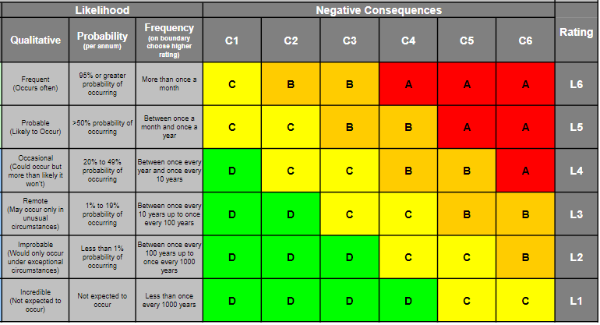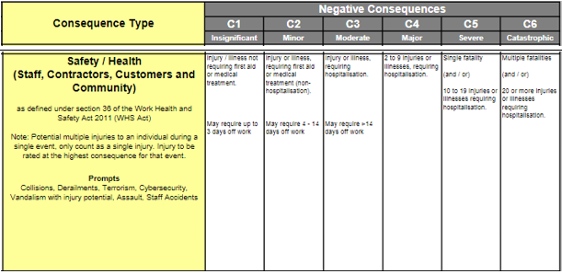
Risk Control Effectiveness Evaluation Guidance
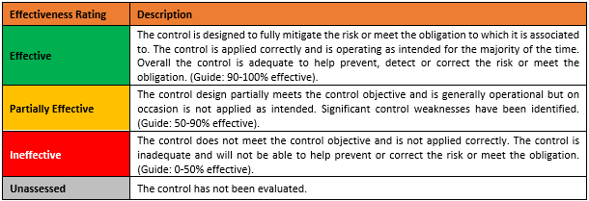 | 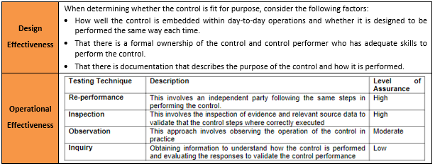

Add rows for each hazard as required
Hazard(s) | Expected Consequence | Likelihood | Current Controls  (based on Hierarchy of Control) | Effectiveness of Existing Controls  (Unassessed, Ineffective, Partially Effective, Effective) | Residual Risk Ranking | Further Controls to be Implemented  (based on Hierarchy of Control) | Revised  Risk Ranking
 |  |  | Substitution:  Yes No N/A  Comments:  Isolation:  Yes No N/A  Comments:  Engineering:  Yes No N/A  Comments:  Administration:  Yes No N/A  Comments:  PPE:  Yes No N/A  Comments:  Comments on control effectiveness: |  |  | Substitution:  Yes No N/A  Comments:  Isolation:  Yes No N/A  Comments:  Engineering:  Yes No N/A  Comments:  Administration:  Yes No N/A  Comments:  PPE:  Yes No N/A  Comments:  Comments on control effectiveness:

Section 3: Risk Control Plan
(Note: A combination of risk control measures, that considers the Hierarchy of Control, may be required to decrease risk so far as is reasonably practicable).
1. Can you stop doing the task or part of the task to eliminate the risk? | Yes (document below how this will be achieved) | No, or only part of it

- Can you eliminate or reduce the risk by doing one or more of these things?
Document the actions below and consider what information, instruction, training and supervision may be necessary to make these controls work properly.
 | - altering the workplace |  | - changing the objects used in the task, or
 | - altering the environmental conditions |  | - using mechanical aids
 | - altering the systems of work

Short-term control action plan (immediately to within one week)
Action required | Person responsible | Targeted due date | Commencement date | Reviewed date | Effectiveness of Controls | Action completed
Medium-term (from one week to three months)
Action required | Person responsible | Targeted due date | Commencement date | Reviewed date | Effectiveness of Controls | Action completed
Long-term (greater than three months)
Action required | Person responsible | Targeted due date | Commencement date | Reviewed date | Effectiveness of Controls | Action completed

