Cycling events around Shoalhaven
Jump on your bike
and join us for some fun-filled rides around the Shoalhaven area.
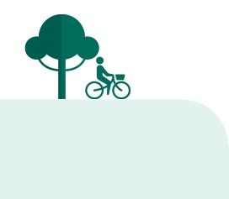
These rides will explore the beautiful local scenery and are suitable for the whole family.
Bush tucker ride and nature walk

Sunday 18 September 2016

Join us for a bike ride to the Botanic Garden in the Booderee National Park. We’re then meeting up with the National Park RanZ nature walk around the gardens and learning
about bush tucker. Bring along a picnic lunch to enjoy in the beautiful gardens.

The ride is 34km from Huskisson return at a moderate pace. There’s some traffic and we use off-road shared paths.
Three meeting points depending on how far you wish to ride:
- 9.00am Huskisson hotel car park. Cycle along the cycle pathway beside beautiful Jervis Bay (34km return).
- 9.30am Vincentia car park near the roundabout (22km return).
- 10.30am corner of Jervis Bay Road and Hyams Beach turn-off (12km return).

Huskisson to Vincentia with a BBQ by the Bay
Thursday 22 September 2016
This easy two hour ride around the winding Shoalhaven paths takes in the spectacular views of Jervis Bay and Point Perpendicular. Cycle along the beautiful pathway to Vincentia and return to enjoy a BBQ by the Bay.
Meet at 10.00am at White Sands Park.

For details on this event, and
other NSW Bike Week events in the Shoalhaven area, call Shoalhaven
City Council’s Road Safety Officer
on 4429 3484 or 0413 138 605.
Sussex Inlet scenic ride
Sunday 25 September 2016
A 25km ride set at a slow pace and suitable for beginners Enjoy a very easy meander around Sussex Inlet with many stops for taking in the scenery.
Meet at 10.00am at Sussex Inlet RSL car park, 200 Jacobs Drive, Sussex Inlet.

