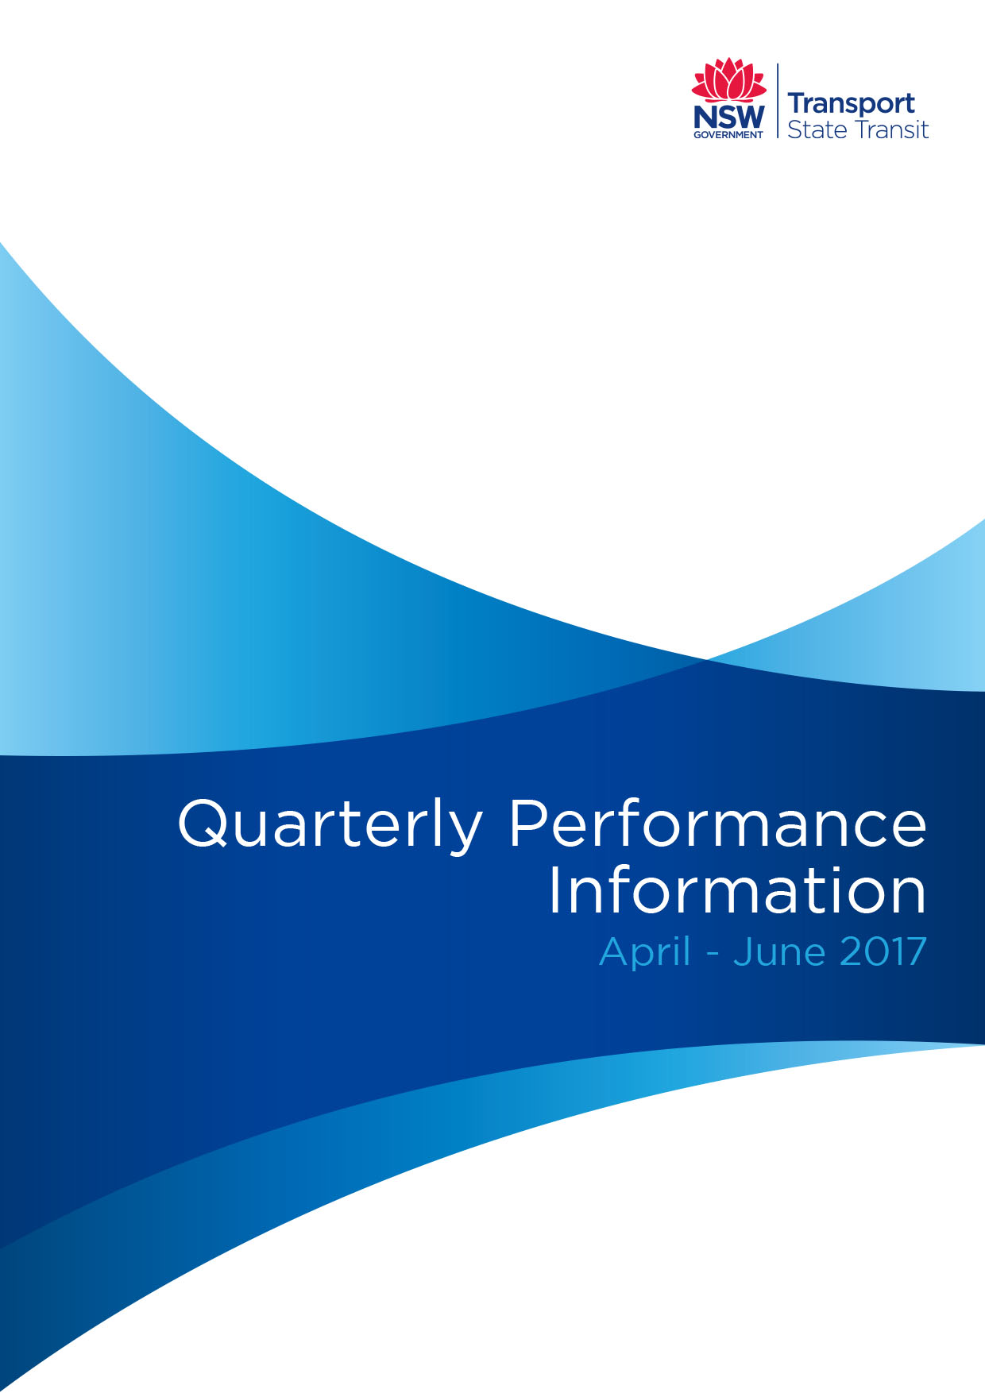

Proactive Release Information
Under the Government Information (Public Access) Act 2009 (‘GIPA Act’), government services are encouraged to release information about their operations proactively, unless there is an overriding public interest against disclosure.
The Quarterly Report is intended as a snapshot of our recent performance, providing a focus on key performance areas. The report provides updates for the recent quarterly period, and comparisons to the previous quarter, and for the same period for the previous year.
The Sydney Buses information is a combination of the performance information for Regions 6, 7, 8 and 9. The State Transit information is a combination of information for Sydney Buses and Newcastle Buses and Ferries.
The information that is provided in this report includes the following:
Measure | Description | Page Number
On-time Running | % of buses starting their trip within 1 minute and 59 seconds before and 5 minutes and 59 seconds after their scheduled departure time | Page 5
Reliability | % of timetable trips commenced their route | Page 6
Patronage | Total patronage | Page 7
State Transit Fleet | Total fleet  Air-conditioned and wheelchair-accessible buses  Average age | Page 8
Mechanical Changeovers | Number of mechanical changeovers per 100,000 kilometres | Page 9
Drug & Alcohol Testing | Total tests conducted  Total positive tests recorded | Page 10
The report also provides a further breakdown of the data that is provided in the annual reports.
The information presented in this report is provided by the following contract regions:
Region 6 - Services for the Inner Western and South Western suburbs
Provides services for the regional centres of Lidcombe, Strathfield, Burwood, Five Dock, Ashfield, Marrickville, Kogarah, Leichhardt, Newtown, Balmain, Glebe, Pyrmont and the CBD.
Region 7 - Services for the North Western, Northern Harbour and Riverside suburbs
Provides services for the regional centres of Crows Nest, Chatswood, Ryde, Epping, Macquarie Park, Eastwood and Artarmon.
Region 8 - Services for the Northern Beaches and Lower North Shore
Provides services for the regional centres of North Sydney, Neutral Bay, Mosman, Manly, Dee Why, Brookvale, Mona Vale and Palm Beach.
Region 9 - Services for the Eastern and South Eastern suburbs
Provides services for the regional centres of Kings Cross, Paddington, the Airport, Botany, Maroubra, Coogee, Bondi Beach, Bondi Junction, Randwick, Double Bay and Redfern.
OSMBSC 5 - Services for the Newcastle and Lake Macquarie areas

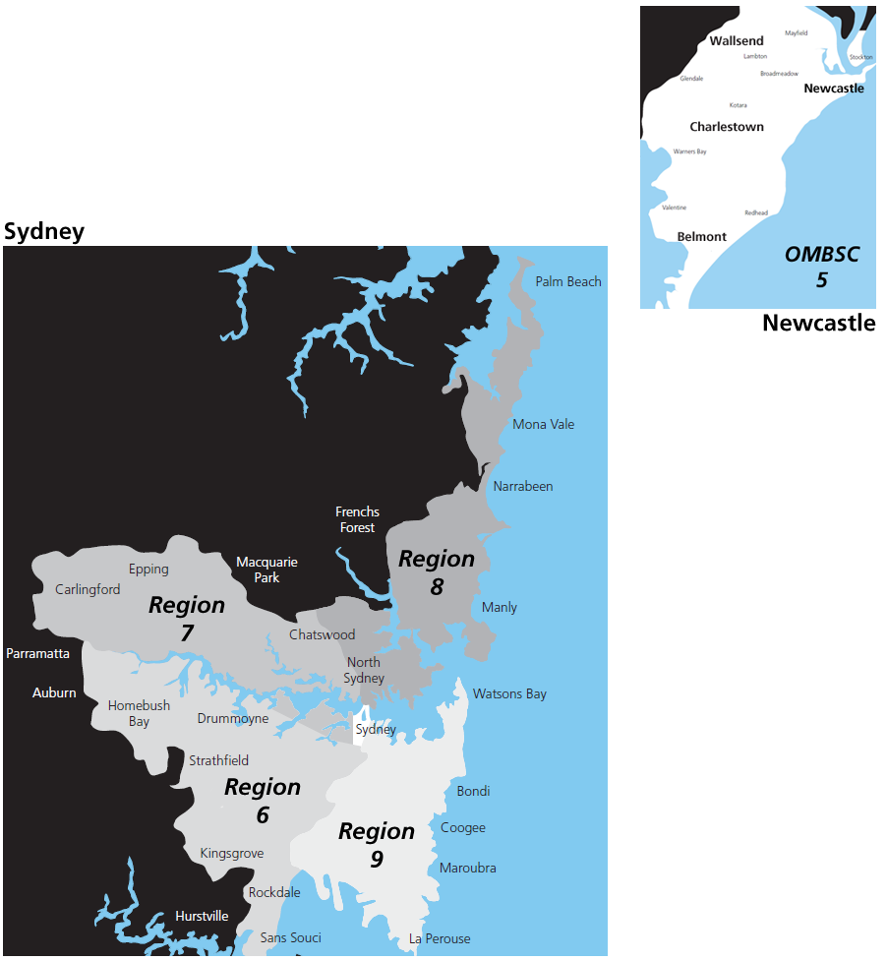

Summary
Boasting the biggest bus fleet in Australia and also one of the most modern, State Transit manages one of the largest bus networks in the world.
During the June quarter, 2017:
- 53 million passengers were carried on State Transit services;
- The State Transit fleet consisted of 2,172 buses;
- More than 1.37 million Sydney Buses services operated during the June quarter and more than 102,000 Newcastle Buses services operated over the same period;
- The rate of mechanical breakdowns for Sydney Buses was 7.70 per 100,000kms; and
- State Transit conducted 369 breath tests and 221 drug tests across its staff.
Compared to the same quarter last year (June quarter, 2016):
- Combined patronage on Sydney Buses and Newcastle Buses and Ferries services increased by 0.8 per cent: 53.14 million (June quarter, 2017) v 52.72 million (June quarter, 2016).
- State Transit increased the number of wheelchair-accessible buses in its fleet to 1,952 (89.9 per cent of the fleet v 88 per cent in the June quarter, 2016).
- State Transit increased the number of air-conditioned buses in its fleet to 2,169 (99.9 per cent of the fleet v 99 per cent in the June quarter, 2016).
- State Transit’s average fleet age was 10.86 years, well below the average age of 12 years required under its contracts with Transport for NSW.
- The average reliability for Sydney Buses during the June quarter was 99.57 per cent, with Newcastle Buses and Ferries average reliability 99.78 per cent, both exceeding the target set in State Transit’s Outer/Sydney Metropolitan Bus Service Contracts.
- The rate of mechanical changeovers for Sydney Buses services decreased from 10.0 to 7.7.

On-time Running
On-time running is important to everyone and State Transit is working with Transport for NSW, the Transport Management Centre and the Roads and Maritime Services to address factors that can delay timetabled bus services.
Following a successful pilot program at Kingsgrove Depot, which has seen considerable improvements to the on-time running of Kingsgrove bus services of between 5 and 10 per cent, State Transit began rolling out the Four Disciplines of Execution (4DX) methodologies across its organisation from January 2014 with the program officially launched across all depots in April 2014.
The program focuses on a number of factors within State Transit’s control that can improve on-time running including:
- Bus drivers departing the depot and terminus on time;
- Improving bus availability with a focus on refining maintenance processes;
- Improving berthing and despatch; and
- Reviewing on-time running performance to improving bus schedules.
There are however, many factors outside of State Transit’s control that can affect the reliable performance of bus services including traffic accidents, special events, wet weather conditions and road works. Bus services are also delayed by motorists who park in bus stops, illegally use bus-only lanes, park in clearways and those who refuse to give way to buses when pulling out from bus stops, all of which are driving infringements that are enforced by NSW Police.
State Transit’s on-time running is measured by Transport for NSW as part of its operating contracts. On-time running data is collected in the morning peak only, between 6am and 10am, over three separate days each month, across 11 different locations within State Transit’s operating areas. These on-time running figures are a snapshot only and cannot be extrapolated to reflect State Transit’s on-time running performance for all services across its operating network.
A bus service is deemed as having operated on-time if it starts its trip between one minute before and five minutes after its scheduled departure time.
Table: Percentage on-time running
 | Apr 17 | May 17 | Jun 17
Region 6 | 88.7% | 89.0% | 90.2%
Region 7 | 94.3% | 88.9% | 94.7%
Region 8 | 92.5% | 94.7% | 96.2%
Region 9 | 84.6% | 85.1% | 86.6%
OSMBSC 5 | 93.7% | 93.4% | 93.8%

Reliability
The reliability of bus services is a critical component in State Transit’s objective of attracting customers to public transport.
The reliability of State Transit services is measured by the number of timetabled services that are operated.
State Transit is required to achieve a reliability of >99.0 per cent of timetabled trips operated, as part of its Outer Sydney Metropolitan and Sydney Metropolitan Bus Service Contracts with Transport for NSW.
Table: Reliability June Quarter 2017
 | Total timetabled trips | Total trips operated | Timetabled trips operated (%)
Region 6 | 429,000 | 427,033 | 99.54%
Region 7 | 285,455 | 284,052 | 99.51%
Region 8 | 228,640 | 228,099 | 99.76%
Region 9 | 437,795 | 435,798 | 99.54%
Sydney Buses | 1,380,890 | 1,374,982 | 99.57%
OSMBSC 5 | 102,465 | 102,236 | 99.78%
Table: Reliability March Quarter 2017
 | Total timetabled trips | Total trips operated | Timetabled trips operated (%)
Region 6 | 421,152 | 419,632 | 99.64%
Region 7 | 288,491 | 286,840 | 99.43%
Region 8 | 225,292 | 224,659 | 99.72%
Region 9 | 434,485 | 431,905 | 99.41%
Sydney Buses | 1,369,420 | 1,363,036 | 99.53%
OSMBSC 5 | 108,241 | 108,132 | 99.90%
Table: Reliability June Quarter 2016
 | Total timetabled trips | Total trips operated | Timetabled trips operated (%)
Region 6 | 408,247 | 407,341 | 99.78%
Region 7 | 281,196 | 280,527 | 99.76%
Region 8 | 219,918 | 219,637 | 99.87%
Region 9 | 441,384 | 439,848 | 99.65%
Sydney Buses | 1,350,745 | 1,347,353 | 99.75%
OSMBSC 5 | 107,852 | 107,745 | 99.90%

Patronage
State Transit is committed to increasing the share of commuter trips by public transport.
To attract customers to bus services, State Transit works hard to maintain a high level of service reliability, a high level of comfort on board the buses and convenience for the customer in ensuring that services go to where they need them to go.
With the retirement of magnetic stripe tickets, the Transport network is now operating a single integrated ticketing system. Patronage statistics below are made up of Opal, cash sales, SSTS (school students) and charters.
Table: Patronage
 | Jun Quarter 2017 | Mar Quarter 2017 | Jun Quarter 2016
Sydney Buses | 50,219,391 | 49,364,681 | 49,852,256
Newcastle Buses & Ferries | 2,926,465 | 2,644,319 | 2,865,629

State Transit Fleet
The number of buses in the State Transit fleet, as of 30 June 2017 was 2,172.
Over the past 12 months, with the introduction of new buses and the retirement of older vehicles, the overall number of wheelchair-accessible buses in the fleet increased by 47 with the number of air-conditioned buses increasing by 14.
Under the Sydney Metropolitan and Outer Metropolitan Bus Service Contracts, the average age of the State Transit fleet should be no more than 12 years. As of the 30 June 2017, the average age of the State Transit bus fleet was 10.86 years.
Table: State Transit fleet
 | Jun Quarter 2017 | Mar Quarter 2017 | Jun Quarter 2016
Total number of buses | 2,172 | 2,167 | 2,159
Wheelchair accessible | 1,952 (89.9%) | 1,940 (89.5%) | 1,905 (88%)
Air-conditioned | 2,169 (99.9%) | 2,163 (99.8%) | 2,155 (99%)
Average fleet age | 10.86 years | 10.71 years | 10.34 years

Mechanical Changeovers
State Transit’s current fleet of 2,172 buses operate more than 16,000 services a day, travelling more than 90 million kilometres every year. Travelling such distances means significant amounts of wear and tear on buses, engines and fittings.
Mechanical failures are to be expected in any vehicle industry, and State Transit works hard to drive repairs down.
State Transit arranges for a changeover of a bus for a number of different types of incidents, in order to maintain service delivery. These incidents may include engine, transmission, overheating or braking problems that may prevent a bus from safely continuing its journey, as well as incidents where an electrical, bus body or air-conditioning fault may impact on customer comfort.
Table: Changeovers June Quarter 2017
 | Total Kilometres Operated | Mechanical Changeovers per 100,000kms
Region 6 | 6,402,020 | 6.50
Region 7 | 5,185,513 | 9.53
Region 8 | 4,536,007 | 5.09
Region 9 | 6,240,184 | 9.33
Sydney Buses | 22,363,724 | 7.70
OSMBSC 5 | 2,335,322 | 2.48
Table: Changeovers March Quarter 2017
 | Total Kilometres Operated | Mechanical Changeovers per 100,000kms
Region 6 | 6,267,677 | 9.7
Region 7 | 5,133,561 | 15.0
Region 8 | 4,444,161 | 7.8
Region 9 | 6,213,354 | 14.0
Sydney Buses | 22,058,753 | 11.8
OSMBSC 5 | 2,503,493 | 2.8
Table: Changeovers June Quarter 2016
 | Total Kilometres Operated | Mechanical Changeovers per 100,000kms
Region 6 | 6,113,116 | 8.7
Region 7 | 5,212,454 | 11.4
Region 8 | 4,350,757 | 7.3
Region 9 | 6,341,818 | 12.1
Sydney Buses | 22,018,145 | 10.0
OSMBSC 5 | 2,474,151 | 2.2

Drug and Alcohol Testing
State Transit introduced an alcohol and drugs program in 2004 with a commitment to a safe and clean environment. The organisation has taken steps to ensure that all employees are aware of their obligations under its stringent alcohol and drug testing policy.
All Transport Safety Employees are subject to random drug and alcohol testing, 24 hours a day, seven days a week, and all State Transit employees are subject to testing as a result of an incident, or if there is reasonable cause that the employee may be under the influence of alcohol or other drugs while at work.
Table: Alcohol Testing June Quarter 2017
 | Tests Conducted | Positive Test Recorded | Positive Results (%)
Region 6 | 74 | 0 | 0.00%
Region 7 | 64 | 0 | 0.00%
Region 8 | 86 | 0 | 0.00%
Region 9 | 76 | 0 | 0.00%
Sydney Buses | 300 | 0 | 0.00%
OSMBSC 5 | 68 | 0 | 0.00%
Table: Alcohol Testing March Quarter 2017
 | Tests Conducted | Positive Test Recorded | Positive Results (%)
Region 6 | 194 | 0 | 0.00%
Region 7 | 72 | 0 | 0.00%
Region 8 | 132 | 0 | 0.00%
Region 9 | 73 | 0 | 0.00%
Sydney Buses | 471 | 0 | 0.00%
OSMBSC 5 | 25 | 0 | 0.00%
Table: Alcohol Testing June Quarter 2016
 | Tests Conducted | Positive Test Recorded | Positive Results (%)
Region 6 | 167 | 0 | 0.00%
Region 7 | 84 | 0 | 0.00%
Region 8 | 139 | 1 | 0.72%
Region 9 | 336 | 0 | 0.00%
Sydney Buses | 726 | 1 | 0.14%
OSMBSC 5 | 27 | 0 | 0.00%
Table: Drug Testing June Quarter 2017
 | Tests Conducted | Positive Test Recorded | Positive Results (%)
Region 6 | 26 | 0 | 0.00%
Region 7 | 44 | 0 | 0.00%
Region 8 | 50 | 0 | 0.00%
Region 9 | 56 | 1 | 1.79%
Sydney Buses | 176 | 1 | 0.57%
OSMBSC 5 | 45 | 0 | 0.00%

Table: Drug Testing March Quarter 2017
 | Tests Conducted | Positive Test Recorded | Positive Results (%)
Region 6 | 42 | 0 | 0.00%
Region 7 | 28 | 0 | 0.00%
Region 8 | 58 | 0 | 0.00%
Region 9 | 35 | 1 | 2.86%
Sydney Buses | 163 | 1 | 0.61%
OSMBSC 5 | 16 | 0 | 0.00%
Table: Drug Testing June Quarter 2016
 | Tests Conducted | Positive Test Recorded | Positive Results (%)
Region 6 | 60 | 0 | 0.00%
Region 7 | 36 | 1 | 2.78%
Region 8 | 53 | 1 | 1.89%
Region 9 | 49 | 0 | 0.00%
Sydney Buses | 198 | 2 | 1.01%
OSMBSC 5 | 23 | 0 | 0.00%

