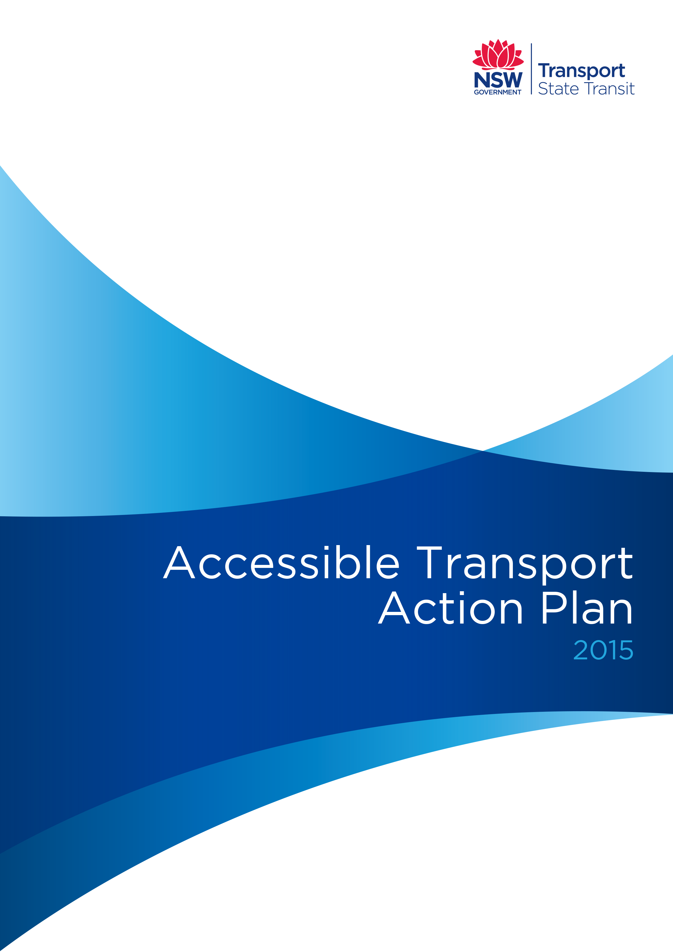
Introduction
The NSW State Government and NSW transport operators recognise that public transport is an essential service that everybody needs to access, including those with disability. Full accessibility can only be achieved by the progressive removal of barriers so that the entire community can share in the benefits of the transport system.
Recognising the need for an increasingly integrated approach to accessible transport service delivery, State Transit has developed an Accessible Transport Action Plan to address Federal and State legislative requirements and guidelines. The plan compliments the programs identified in the Transport for NSW (TfNSW) Disability Action Plan 2012 – 2017.
This plan outlines:
- The legal responsibilities of State Transit and its regions
- The principles for accessible bus services
- Progress to-date and future strategies for the provision of accessible bus services
Key objectives of the plan focus on:
- Building an accessible transport network
- Reducing transport disadvantage
- Improving the journey experience of people with disability
- Enhancing customer insight and engagement of people with disability or limited mobility
- Increasing employment opportunities for people with disability
Key strategies cover access to information, staff training and employment, promoting positive community attitudes towards the provision of fully accessible bus services and procedures for dealing with complaints.
Core Requirements
State Transit has a responsibility for the provision of accessible bus services under the following Commonwealth and NSW legislation, policies and guidelines:
- Disability Discrimination Act 1992 (Commonwealth)
- Disability Standards for Accessible Public Transport 2002 (Transport Standards)
- Anti-Discrimination Act 1977 (NSW)
- Disability Services Act 1993 (NSW)
- Transport for NSW (TfNSW) Disability Action Plan 2012 – 2017
- Guidelines for Disability Action Planning by NSW Government Agencies (2008)
The Commonwealth Disability Discrimination Act 1992 requires that the delivery of services should provide equitable access for those with a disability. The practical applications of the requirements of the Act are outlined in the Disability Standards for Accessible Public Transport 2002. The Transport Standards establish the specific requirements for access to bus services within compliance timeframes set down in the Transport Standards.
The Disability Services Act 1993 (NSW) establishes actions to be undertaken in relation to service provision for people with disability. The TfNSW Disability Action Plan sets the 5-year blueprint for addressing transport disadvantage by providing a view of future, integrated transport programs to continuously improve the provision of services to all customers including those who have disabilities or mobility constraints.
The Outer Sydney Metropolitan and Sydney Metropolitan Bus Service Contracts (O/SMBSCs) require the development and publication of the State Transit Accessible Transport Plan to document plans and progress towards reduction in transport disadvantage, access to information, improvements to the journey experience, staff training, customer services and engaging with people with disability.
The Guiding Principles
Access for the entire community
Improvements to the accessibility and inclusiveness of transport services benefit all users, not just people with disability who rely on accessible transport. Accessibility can be achieved through adoption of universal design principles that remove physical barriers to access and create buildings, products and environments that are usable by people of all abilities. Universal design requires that transport services also provide barrier free access for people who have vision, hearing or cognitive impairments.
Whole of journey accessibility
Accessible transport needs to provide for ‘whole of journey’ accessibility, including boarding points and seamless transfers across modes. This may require access to rail, bus, ferry and taxi and interchange between those modes. Such a journey is only fully accessible if journey planning, information, connection and integration between each part of the journey is easy and safe.
Equivalent access
Whilst the Transport Standards have specific requirements, Sydney Buses may also provide methods, equipment or facilities that provide alternative mean of access with equivalent amenity, availability, comfort, convenience, dignity and safety as those methods specified in the Standard, including offering direct access assistance to passengers.
Reporting Protocols
This plan will be reviewed annually to maintain as current. In addition, all accessibility reporting required under the O/SMBSCs will be provided within the prescribed timeframes.

