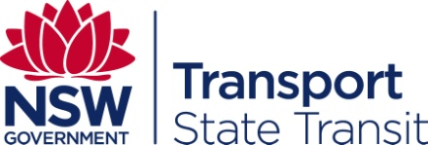 Procurement Complaints Management

State Transit is committed to conducting its procurement activities in an honest, fair, accountable and transparent manner. To assist suppliers State Transit has developed a process to manage concerns raised regarding procurement activities.

Resolving procurement issues in a timely manner is a key principal of State Transit’s approach to complaints management. For this reason, suppliers are encouraged to resolve issues in the first instance directly with the area of the business managing the procurement process.

Recognising that this may not always be possible, State Transit has developed an escalation process to ensure appropriate resolution avenues are available.

The following represents the escalation process for compliant management:

- Issues that relate to tendering activities should be raised with the nominated Contact Officer published on the Invitation to Tender.

- Issues that relate to purchasing activities should be raised with the officer conducting the purchasing process.

- Issues by contractors that relate to a contract they hold with State Transit should be raised with the nominated Contract Manager.

For all other procurement issues, if an issue remains unresolved following the above process or if there is a concern regarding the appropriateness of raising an issue with any of the above officers, issues may be raised directly with:

Manager Contracts and Procurement
Tel: 02 9245 5764
Email: dnolan@sta.nsw.gov.au.

If, following review and a response by the Manager Contracts and Procurement the issue remains unresolved, or where it is more appropriate to raise the issue with an officer independent of State Transit’s procurement unit, the issue may be referred to:

State Transit Procurement Complaints Officer
Tel: 02 9245 5738
Email: procurement@sta.nsw.gov.au

State Transit undertakes to investigate issues promptly and will attempt to respond within 15 business days. Where a prolonged investigation is necessary, regular feedback will be provided.

A complainant may seek a final review of the Procurement Complaint Officers determination from the Executive Director Finance and Corporate Services.

At the conclusion of State Transit’s investigation process if the complainant is not satisfied, the matter including all related documentation, may be referred to the NSW Procurement Board who will review how State Transit has dealt with the matter and determine if further action is warranted.

