COVID-19 MANAGEMENT PLAN

P15794-SSWJV-XX-XXX-000000

FOR

Mardi to Warnervale Pipeline

Contract No: CPA1305

Client: Central Coast Council

Reviewed and Approved

Project Manager

Matt Aldrick

DOCUMENT CONTROL

SCHEDULE OF REGISTERED HOLDERS

Copy No | Holder Title | Date Transmitted
1 | Central Coast Council
2 | SSWJV
3
4
5
*Note on Controlled / Uncontrolled Copies

Only those copies listed in the Schedule of Registered Holders are Controlled Copies, subject to further official amendment.
All other copies are Uncontrolled Copies, not subject to amendment notification or any further control.

EDITION / REVISION REGISTER – THIS PROJECT SPECIFIC PLAN

The following revision register provides details on all versions of this project specific plan. All superseded versions of this plan are kept in archive for reference purposes and available on request.

All revision changes will be marked in blue font.

Rev | Rev Date | Rev Details | Approved By
A | 1/04/2020 | DRAFT Submission | M Aldrick

TABLE OF CONTENTS
Page
1 INTRODUCTION 5
1.1 Context 5
1.2 Purpose 5
1.3 Covid-19 Facts 5
1.4 Definitions 6
2 ROLES AND RESPONSIBILITIES 7
2.1 Project Senior Leadership Team 7
2.2 JV Steering Committee Members 7
2.3 Project Manager 7
2.4 Site Manager / Supervisors 7
2.5 Safety Manager 7
2.6 Workers 8
3 MANAGEMENT SYSTEM TOOLS 9
3.1 Management Plan 9
3.2 Risk Register 9
3.3 Specific Emergency Response Plan 9
3.4 Induction 9
3.5 Weekly Top 5 Risks 9
3.6 Daily Prestart 9
3.7 Safe Work Method Statement 9
3.8 Task Hazard Review Cards 9
3.9 Safety Posters 9
3.10 Pandemic scenario preparation 9
4 STANDARD PREVENTATIVE MEASURES 10
4.1 Hygiene Practices 10
4.2 Social Distancing 10
4.3 Self-Isolation 11
4.4 Working from Home 11
4.5 Meeting Restrictions 11
4.6 Worker Interactions 12
4.6.1 Visitors 12
4.6.2 Prestart Meetings 12
4.6.3 Employee Break Considerations 12
4.6.4 Sharing of Items 12
4.6.5 Vehicle Sharing 12
5 PROJECT SPECIFIC PREVENTATIVE MEASURES 13
5.1 Specific measures 13
5.2 Working within 1.5m of other personnel 13
5.3 Managing Stress and anxiety 14
6 COMMUNICATION & REPORTING 16
6.1 Communicating to the Project Team 16
6.2 Communicating to the Public 16
6.3 Reporting 16
7 MANAGEMENT OF (POTENTIAL) CASES 17
7.1 Worker has no symptoms but has been exposed to a potential case 17
7.2 Worker has no symptoms but has had casual contact to a confirmed case 17
7.3 Worker has no symptoms but has had close contact to a confirmed case 18
7.4 Worker develops symptoms 18
7.5 Worker is diagnosed 19
8 ONGOING ACTIONS 20
8.1 Contingency Planning 20
8.2 Continual Review 20
Appendix A – COVID-19 FLOWCHART 21
Appendix B – COVID-19 SCREENING TOOL 22
Appendix C – RISK ASSESSMENT 23
Appendix D – CORONAVIRUS POSTERS 25
Appendix E – HOT TO WEAR A SURGICAL MASKS 29
Appendix F – PANDEMIC RESPONSE CHECKLIST 30

- INTRODUCTION
  - Context
The World Health Organisation has announced that the Coronavirus (COVID-19) is a pandemic (an infectious disease outbreak that spreads on a global scale). The spread and effects of the Coronavirus (COVID-19) around the world is having a devastating impact to people, communities and businesses.
The Australian Government is managing the COVID-19 as a health emergency. SSWJV is relying on the information provided by the Australian Government Health Department for our decisions regarding the Coronavirus. Whilst we will update this plan regularly, we encourage all our employees to stay up to date with the latest advice which can be found here:
https://www.health.gov.au/news/health-alerts/novel-coronavirus-2019-ncov-health-alert
This plan has been developed to outline SSWJV’s strategies and initiatives in implementing risk management and deploying resources to limit the impact of COVID-19.
It should be acknowledged that this Covid-19 Management Plan is not a plan provided in accordance with or under the Contract requirements and that measures imposed by the government and regulatory authorities, together with potential market supply deficiencies of plant, labour or materials (if they occur) will reduce SSWJV’s ability to maintain progress or emergency response. Where this occurs, we will advise Central Coast Council of the need for supplementary support and resources or relaxations.

  - Purpose
The purpose of this management plan is to:
- to provide guidance to SSWJV’s project team on potential actions to minimise the risk of Coronavirus workplace infections;
- assist the site management team in understanding their operational and project responsibilities for managing the risks associated with COVID-19;
- outline the procedures in place to address the risks associated with COVID-19 and maintain a ‘business as usual’ approach as much as is practicable.
- minimise overall business disruption and uncertainty

  - Covid-19 Facts
Coronavirus (COVID-19) is a respiratory illness. Symptoms range from a mild cough to pneumonia, potentially spreading from person to person.
The virus is most likely spread through:
- Close contact with an infectious person
- Contact with droplets from an infected person’s cough or sneeze
- Touching objects or surfaces (like door handles) that have cough or sneeze droplets from an infected person, and then touching your mouth or face.
The following short video provides a thorough explanation on the virus and the preventative hygiene measures to prevent infection.
https://www.swhealth.org/dr-peter-lin-breaks-down-information-on-coronavirus-covid-19/

  - Definitions
Acronym | Definition
COVID-19 | Novel Coronavirus as defined by the World Health Organisation
PE | Project Engineer
PM | Project Manager
SERP | Specific Emergency Response Plan
SM | Safety Manager
SSWJV | A Joint Venture between Spiecapag Australia Pty. Limited ACN 067 306 138 and Seymour Whyte Constructions Pty Ltd ACN 105 493 187, jointly and severally.
SWMS | Safe Work Method Statement
THRC | Task Hazard Review Card
Close contact | - Someone who has had greater than 15 minutes face-to-face (e.g. within 1.5m) contact in any setting with a confirmed case in the period extending from 24 hours before onset of symptoms in the confirmed case, or  - Someone who has shared a closed space with a confirmed case for more than 2 hours in the period extending from 24 hours before onset of symptoms in the confirmed case  - A close contact includes a person meeting any of the following criteria:  - Living in the same household  - Direct contact with the body fluids without recommended PPE or failure of PPE  - A person in the same hospital room when an aerosol generating procedure is undertaken on the case, without recommended PPE  - Aircraft (or long bus or train trip) passengers who were seated in the same row, or the two rows in front or behind a symptomatic confirmed case
Casual contact | - Someone who has had less than 15 minutes face-to-face (e.g. within 1.5m) contact in any setting with a confirmed case in the period extending from 24 hours before the onset of symptoms in the confirmed case; or  - Someone who has shared a closed space with a confirmed case for less than two hours in the period extending from 24 hours before the onset of symptoms in the confirmed case  - Other casual contacts may include:  - Aircraft (or long bus or train trip) passengers who were not seated in the same row, or the two rows in front or behind a symptomatic confirmed case
Suspected case | - International travel in the 14 days before the onset of illness, or  - Close or casual contact (see close and casual contact definitions) in the 14 days before illness onset
Symptomatic person | Someone suspected as displaying symptoms consistent with COVID-19.
Confirmed case | A person who tests positive to a validated specific nucleic acid test or has the virus identified by electron microscopy or viral culture, at a reference laboratory.

- ROLES AND RESPONSIBILITIES
Everyone has a duty of care, a responsibility, to make sure that they and other people are safe in the workplace. SSWJV has the main responsibility for the health and safety of everyone in the workplace, including visitors.
  - Project Senior Leadership Team
Name | Role
Steve Lambert  John Walsh | JV Steering Committee
Matt Aldrick | Project Manager
Jim Agllias | Principal’s Representative
Joel Singles | Site Manager
  - JV Steering Committee Members
- Ensure governance for the project
- Ensuring the continual review of this management plan
- Review and approve this plan
- Distribute corporate policies and strategies related to COVID-19
- Develop a plan for the continuity of leadership in the event of absence of key decision makers and executives
  - Project Manager
- Develop this plan
- Ensuring the project has a Specific Emergency Response Plan for the return of a positive result of COVID-19 for a project worker.
- Implementation on site of controls and strategies
- Provision of adequate resources
- Liaison with CCC project staff
- Providing feedback to the SLT on the effectiveness or otherwise of controls and project generated initiatives or issues.
- Understand and plan for business/economic disruptions, including possible shortages of supplies, supply chain interruptions and delays, and identify supplier alternatives to manage this.
- Work with the workforce to consider flexible work arrangements for high-risk Workers (e.g. those who are at a higher health risk should they contract COVID-19), as well as Workers who need to stay at home due to other reasons relating to COVID-19, e.g. to take care of family members who have travelled to known affected countries / regions, or in the event schools are closed, or public transport cancelled
  - Site Manager / Supervisors
- Establish alternate teams of Workers (e.g. Team A & Team B) who can be deployed at different work schedules. Monitor and enforce separation or Social Distancing of personnel
- Review and monitoring of the effectiveness of controls
- Ensure workers to site are adequately trained in the procedures of this plan
- Encourage and enforce adherence to the controls developed in this plan within the workforce
  - Safety Manager
- Develop a Specific Emergency Response Plan for the return of a positive result of COVID-19 for a project worker.
- Ensure there are adequate supplies of tissue paper / single use disposable hand towels, disinfectants / sanitisers, masks and other PPE as required.
- Complete the Pandemic Response Checklist (Appendix F) to help with preparedness planning.
- Initiate a process so that the project has up-to-date contact information for Workers (and next of kin) in case Workers need to be contacted when not at work
- Ensure processes are in place and checking that workplaces have put up notices in relating to:
  - proper hand washing and drying techniques
  - ensuring hygiene stations are available
  - cleaning processes are in place for common areas such as kitchen and washrooms
  - meeting rooms that are to be disinfected/sanitised daily
- Put up notices in relating to proper hand washing techniques, ensure hygiene stations are available and cleaning processes are in place for common areas e.g. kitchen areas, washrooms, meeting rooms to be disinfected daily
- Maintaining a First Aid or other vacant room designated as the ‘isolation room’ for the Worker(s) with an onset of fever and symptoms to use. Identify the isolation route (a route that is not commonly used by Workers/visitors) that leads to an area where they can be transported to a nearby hospital
- Identify local hospital/medical clinics that workers who become symptomatic can attend and notify Project Manager immediately of any worker that develops symptoms
  - Workers
- Adhere to standard preventative measures
- Adhere to project specific measures
- Look out for each other – remind fellow workers of preventative measures
- Notify Supervisor immediately of any worker that develops symptoms

- MANAGEMENT SYSTEM TOOLS
  - Management Plan
This Management Plan has been created to provide an overview on how the current SSWJV Management System is to be updated to incorporate the risks and controls of COVID-19. It also outlines the responsibilities of the team and the communication strategies to be used.
  - Risk Register
The project risk register is to be updated to include COVID-19 risks. An extract relating to Covid-19 risks can be found in APPENDIX C.
  - Specific Emergency Response Plan
A Specific Emergency Response Plan is to be created for “worker tests positive for COVID-19”. This SERP is to provide detail for the immediate steps to follow in the event.
  - Induction
The induction is to be updated to include information on COVID-19. It is to cover some background information, and preventative measures.
  - Weekly Top 5 Risks
The Weekly Top 5 Risks have been updated to be the Weekly Top 6 Risks, allowing for COVID-19 to be identified as a risk and controls also identified each week.
  - Daily Prestart
The daily prestart will include COVID-19 as a specific hazard and be discussed with the workforce each day to serve as a reminder and also provide a forum for feedback on effectiveness of the controls.
  - Safe Work Method Statement
All Safe Work Method Statements are to undergo a review to include COVID-19 as a risk and also to check the current activities and controls are still valid with respected to the preventative measures detailed in section 4 and 5.
  - Task Hazard Review Cards
Individual workers are to include COVID-19 on the task specific Task Hazard Review Card each shift.
  - Safety Posters
Posters are to be created and displayed in prominent positions across the site. Examples can be seen in APPENDIX D - Coronavirus Posters.
  - Pandemic scenario preparation
A checklist for planning for Pandemic Scenario can be found in APPENDIX F.

- STANDARD PREVENTATIVE MEASURES
  - Hygiene Practices
Current advice from the health authorities is that everyone should practise good hygiene to protect against infection and prevent the virus spreading.
Good hygiene includes:
- Covering your coughs and sneezes with your elbow or a tissue;
- Disposing of tissues or cleaning wipes properly:
  - Place waste in bins provided ensuring no hand to rubbish contact
  - All bins to have bin liners and bins must be kept clean (external and internal)
  - Bins to be emptied daily ensuring no hand to bin content contact. (No pushing rubbish content down into bin to make more room for extra waste) Person emptying bins must wear disposable gloves and follow the correct method of glove disposal after removing rubbish
The correct method for removing disposable glove:
- Pinch and hold the outside of the glove near the wrist area.
- Peel downwards, away from the wrist, turning the glove inside out.
- Pull the glove away until it is removed from the hand and hold the inside-out glove with the gloved hand.
- With your un-gloved hand, slide your finger/s under the wrist of the remaining glove, taking care not to touch the outside of the glove.
- Again, peel downwards, away from the wrist, turning the glove inside out.
- Continue to pull the glove down and over the inside-out glove being held in your gloved hand.
- This will ensure that both gloves are inside out, one glove enveloped inside the other, with no contaminant on the bare hands.
- Washing your hands (top, palms, between fingers and around fingernails) often with soap and water, including before and after eating and after going to the toilet for at least 20 seconds;
- Drying your hands drying is equally as important as washing them. Damp hands can spread 1000 times more bacteria than dry hands. Single use paper towels will be used for drying hand thoroughly and then disposed of ensuring no hand to waste contact. Waste bin will be emptied regularly to avoid bin overflow
- Using alcohol-based hand sanitisers (NB. This is a secondary control to correct washing of hands with soap);
- Intact and healthy skin is a main defence to pathogens. Cuts or abrasions should always be covered with a waterproof dressing and kept clean;
- Cleaning and disinfecting surfaces. Wipes to be disposed of after wiping surfaces. A disinfected spray to be used with a single use cloth to avoid cross contamination;
- Cleaning and sanitising using alcoholic wipes, frequently used objects such as mobiles, keys and wallets, hand sanitiser bottles (including the pump top);
- No hand shaking or personal contact; and
- If developing symptoms wear face masks (P2, P3 or surgical masks) and disposable gloves. A Toolbox on the use of masks is provided in Appendix E
  - Social Distancing
NSW Health has implemented social distancing requirements. Social distancing is one of the most effective preventions for Coronavirus spread. It means we reduce the number of close physical and social contacts we have with one another.
The following practices should be implemented in your workplace immediately:
- All personnel are required to keep 1.5m between yourself and others. Constant reminder to workforce of what 1.5m looks like. like (e.g., The length of a broom stick or 1 ½ arm lengths)
- Re-schedule, stagger or cancel large gatherings
- Stop handshaking and other physical greetings
- Hold meetings via video conferencing or phone calls where possible
- Take lunch outside rather than in lunch room where possible
- Consider opening windows (where possible) for more ventilation
Indoor gatherings and workplaces are to adhere to the 1 person per 4m2 legislative requirements. The Project Manager is to undertaken the following measures:
- Calculate their office, crib and other indoor area flor plan area (m2);
- Calculate the maximum people allow in that area (by dividing the area by 4);
- Signpost the floor area (in m2) and the maximum people capacity of the area at the entry to the room or area.
  - Self-Isolation
Current guidelines from the federal government and NSW Health is that personnel cannot attend the workplace and must self-isolate for 14 days if they have:
- Travelled overseas in the last 14days.
- Been in close contact with a confirmed case of COVID-19.
- If you feel sick and are showing symptoms, do not attend work. Self-isolate until test results are received.
For more information on self –isolation requirements please visit the NSW Health website.
Employees who need to self-isolate should notify their manager and not attend the workplace. They should seek medical attention if they become ill during the quarantine period.
In the event of an employee requiring self-isolation, the worker’s manager in consultation with the HR manager, is to assess and develop a suitable flexible working arrangement where relevant and possible.
Employees required to self-isolate, are not permitted to self-isolate in company provided accommodation.
As per government and health authority requirements, employees must not have direct contact with a person in self-isolation.
  - Working from Home
The government has advised that non-essential workers should work from home if possible.
SSWJV management will undertake assessment as deemed necessary to review the ability of certain roles within the business as to where possible employees can productively work from home.
Employees are to discuss flexible working arrangements with their managers.
  - Meeting Restrictions
All managers are required to assess the necessity of all meetings and where possible re-schedule, stagger or cancel all non-essential meetings.
Meetings are not to last longer than 2 hours.
Prior to all essential meetings, the manager should assess other meeting options including having meetings outdoors, conference calls, and video conferencing arrangements to limit close contact with others. All attendees to a meeting that have not previously completed the Appendix B – SCREENING CHECKLIST must complete on arrival.
Should a person inform the manager (or other employee) that completion of the checklist indicates they are ‘at-risk’, then the meeting is to be rescheduled or the at-risk person should be excluded from attending the meeting in person.
Before arranging a meeting, the manager should ensure that the meeting facility (room) is suitably sized to accommodate the health authorities’ current recommendation of 1 person per 4m2 and ensure social distancing requirements are adhered too. Adequate ventilation is to be in place. Clean efficient air conditioning units help control indoor air quality.
  - Worker Interactions
- Visitors
All personnel attending the project office must complete the Appendix B – SCREENING CHECKLIST on arrival each day.
The checklists are to be placed at the front desk next to the visitors register.
- Prestart Meetings
All pre-start meetings and similar work group gatherings are to be conducted outdoors with attendees maintaining social distancing of 1.5m
Individual sign offs on pre-start forms is not permitted. The Site Supervisor is to perform a ‘role call’ of attendees and check employees off on the pre-start form.
- Employee Break Considerations
Employees and workers are encouraged to take their lunch breaks outdoors rather than in shared lunch rooms where possible.
If required, lunch breaks are staggered to ensure adherence to the maximum person capacity for the crib room.
- Sharing of Items
There is to be no sharing of food, drinks, cutlery, plates, cups, etc.
Coffee and Tea supplies and facilities are acceptable provided good hygiene practices are followed.
- Wiping down of containers after use with single use disposable wipe; and
- using utensils to access supplies.

- Vehicle Sharing
There is no current health restriction of the number of people sharing a vehicle whilst travelling for ‘essential’ work related activities. However, the project will adopt the following measures:
- No more than 2 personnel within a light vehicle at any time on site.
- Trips to be no longer than 30 minutes.
- Windows to be down at all times when travelling or AC on fresh air setting if weather prohibits having windows open.
- Inside of vehicles to be cleaned before yes
  - Cleaner to wear disposable gloves
  - All surfaces are to be sprayed and wiped with a clean wet cloth or an antibacterial wipe - paying attention to frequently touched surfaces such as door handles (inside and out), arm rests, steering wheel etc. Dispose of cleaning cloths and disposable gloves.

- PROJECT SPECIFIC PREVENTATIVE MEASURES
  - Specific measures
- Prestart and Toolbox meetings, weather permitting, being held in an outdoor area, or a well-ventilated location with space to encourage attendees to spread out and stand at least 1.5m away from each other
- Split Smoko and lunch breaks, i.e.:
  - Group 1 smoko 09:00 – 09:30 and lunch 13:00 – 13:30
  - Group 2 smoko 10:00 – 10:30 and lunch 14:00 – 14:30
  - Allowing meal breaks to be taken by operator within their machine
- Separating workforce into smaller groups to minimise the number of people in the crib shed at one time and maximising space between personnel, aiming for a maximum of 2 people to each table.
- A temperature gun will be used by the Supervisor or Safety Manager at daily prestart.
It’s understood some temperatures can rise due to the nature of work and location of the works we undertake. Any worker presenting with a slightly elevated temperature, i.e. > 37.5 degrees will be re-tested in private after the worker has a chance to acclimatize to the room temperature, they are sitting in. If temperature is still elevated, we will follow procedures as set out in 7. MANAGEMENT OF (POTENTIAL) CASES.
- Supervisor or Safety Manager to check temperature of workers at PreStart using an infra-red temperature gun. Any readings in excess of 37.5 degrees, the workers is to remain after PreStart and a secondary test to be taken after 15 min in private. If still elevated, proceed in accordance with section 7.
- Procuring additional shelters and tables outside to allow people to spread out
- Ordering in butchers’ paper for each table for each break – use as a place mat and then throw away before the next group sits
- Office set-up – maintain partitions between desks and min 1.5m between seats
- Limiting visitors to site – reconsider need for visitors to attend site in person, visitors to be approved by the Project Manager or Construction Manager
- Providing additional bins. All bins to be emptied each night.
- More frequent cleaning of crib sheds, toilets, porta loos generally
- Additional hand-held radios with allocations to the same worker for project duration
- We will limit the number of people working onsite as exposure to more people increases the risk of COVID-19 transmission
- Each worker to carry their own pen. SSWJV to provide pens if needed.
- Prestart sign-on to be replaced with roll-call
- Prestart machines – wipe down / clean cab controls and radios each morning
- Hot-seating machines - wipe down / clean cab controls between operators
- No ice machine to be in-use, noting that the project predominately will be during winter months.

  - Working within 1.5m of other personnel
- Identify tasks and revise SWMS to include relevant controls
- Do not touch each other
- Where the 1.5M rule cannot be applied due close contact tasks, workers to wear P2/ P3 masks
- Limit time to 30 mins close proximity works and then a 15min break.
- Where practical, we will maintain working partnerships throughout tasks to eliminate different people working in teams each day.
- Gloves to be worn at all times onsite, excluding breaks.
- Wear disposal overalls if contact is inevitable

  - Managing Stress and anxiety
The mental health impacts associated with a pandemic crisis may be significant.
Psychological distress is not something most people are confident addressing.
Many people don’t feel comfortable disclosing their stress or poor mental health to their managers or supervisors which creates extra challenges. Therefore, it is vitally important that managers and supervisor’s check-in regularly with their team to see how they are coping.
SSWJV Management will follow the below steps to minimise workplace stress:
- Keep well informed with information from official sources and regularly communicate with workers to share relevant information as it comes to hand
- Consult with workers on any risks to their psychological health and how these can be managed
- Provide workers with a point of contact to discuss their concerns and on how to find workplace information
- Inform workers about their entitlements if they become unfit for work or have caring responsibilities
- Proactively support workers identified to be more at risk of workplace psychological injury
- Refer workers to appropriate channels to support workplace mental health and wellbeing

Sites for information on caring for mental health:
- Beyond Blue – Looking after your mental health during the coronavirus outbreak
- Australian Psychological Society – Tips for coping with coronavirus anxiety
- Headspace – How to cope with stress related to coronavirus (COVID-19)

Our mental health is equally as important as our physical health during this time; and it’s important to do things that help us to cope and maintain good mental health. While we are keeping physically distant – through social distancing – it’s more important than ever that we remain socially and emotionally connected and support one another. Remember, we’re in this together.
Here are four things you can do for your mental health:
Stay connected via phone, chat, email, or video conferencing – and reach out to your family, friends and colleagues to brighten up your day. Tip: Organise a virtual house party / virtual dinner party with friends. FaceTime will let you chat with up to 32 people at the same time on your iPhone or iPad. Embrace technology.
Keep up a daily routine and set yourself tasks: Start your day to keep up a resemblance of a normal daily routine to get you through this ‘temporary life’ under COVID-19. By setting yourself tasks, and making to-do lists means you will actually achieve something every day – no matter how small the task. This is also good record keeping for your performance review!
Keep active: Read a book and exercise to keep the mind active and mentally healthy. Create an exercise routine that can be completed at/near home, to maintain physical fitness and reduce stress. Exercise will help boost endorphins and make it easier to feel positive – to give your body the best chance of fighting any illness. There are plenty of online personal trainers on YouTube; and it won’t cost you a thing!
Make time for yourself: ‘Me time’ is important – do something each day that makes you feel good.

- COMMUNICATION & REPORTING
  - Communicating to the Project Team
The OHS Management System Tools identified in section 3 will be used to communicate the change in procedures to the wider project team.
The daily Pre-Start will provide a forum for the workforce to give feedback or ask questions.

  - Communicating to the Public
There are three key mediums that the public can access information about the project. An update on how SSWJV is managing the COVID-19 risks whilst still continuing with the project works, is to be added to each of these mediums:
- Community Updates provided via letterbox drop
- https://www.yourvoiceourcoast.com/M2WP
- 1 on 1 conversations with residents

  - Reporting
Any employee, subcontractor, or relevant others (clients, designers etc.) with a suspected or confirmed case of COVID-19 are required to report the incident to their manager immediately. The manager should immediately notify the Project Manager, whom in turn will notify the Senior Leadership Team as per section 2.1.
It is important that confidentiality of the person is maintained.
Daily reporting on the status of suspected / confirmed cases is to be carried out.

- MANAGEMENT OF (POTENTIAL) CASES
  - Worker has no symptoms but has been exposed to a potential case
Where the employee has had exposure to another individual with symptoms of COVID-19 but it is not known, or not yet known, whether that person has COVID-19.
Everyday activities such as travelling to and from work, shopping, walking through public areas and attending meetings are likely to result in employees coming into contact with people who have non-specific symptoms such as coughing, sneezing or nasal congestion. In most such cases the worker will have no other information about the person’s illness.
If the exposure was more than 14 days beforehand and the worker remains well he or she can be advised that the incubation period has passed, that they have not contracted COVID-19 and they may safely work.
If the exposure was less than 14 days beforehand then the worker should be advised that as it is not known whether they have been exposed to COVID-19 or another infection:
- Self-isolation is not necessary
- The exposed worker continues to work
- Await results of COVID-19 testing of the unwell individual, if this is possible
  - If COVID testing of the unwell individual is positive manage as per 7.3
  - If COVID testing of the unwell individual is negative no further action is required
  - If results of COVID testing of the unwell individual cannot be obtained:
    - Continue to work as usual.
    - Monitor health until 14 days have passed from the exposure date.
    - Watch for these signs and symptoms:
      - fever
      - cough
      - shortness of breath
      - other early symptoms to watch for are chills, body aches, sore throat, headache and runny nose.
If the worker develops symptoms then the case should be managed in accordance with section 7.4.
  - Worker has no symptoms but has had casual contact to a confirmed case
A casual contact is someone who has been in face to face contact for less than 15 minutes or been in the same closed space for less than 2 hours, as a person who has tested positive for COVID-19 when that person is infectious i.e. when they had symptoms or in the 24 hours before developing symptoms.
If a worker has been identified to have had casual contact with someone who is confirmed to be infected with COVID-19 while they were infectious they should be advised to:
- Continue to work as usual;
- Monitor their health until 14 days after they were last exposed to the infectious person;
- Watch for these signs and symptoms:
  - fever
  - cough
  - shortness of breath
  - other early symptoms to watch for are chills, body aches, sore throat, headache and runny nose;
If the worker develops symptoms then the case should be managed in accordance with section 7.4.
  - Worker has no symptoms but has had close contact to a confirmed case
Applies where a worker has had close contact with a confirmed case of COVID-19 but he or she is still completely well.
Close Contact is defined as greater than 15 minutes face-to-face contact in any setting with a confirmed case of COVID-19 in the period extending from 24 hours before the onset of symptoms in the confirmed case, or sharing of a closed space with a confirmed case of COVID-19 for more than 2 hours in the period extending from 24 hours before the onset of symptoms in the confirmed case.
- If the close contact exposure was more than 14days before and the worker remains well, he or she should be advised that:
  - The incubation period has passed and they have not contracted COVID-19;
  - They may safely return to work;
  - No contact tracing or further action is required.
- If the close contact exposure was less than 14days before and the worker remains symptomatically well, the employee should be advised:
  - To seek advice from NSW Health regarding the requirement for self-isolation.
  - If NSW Health has advised the individual to self-isolate at home for 14days from the date of the last close contact to the known case:
    - Wear a surgical mask at home if in contact with any other people;
    - Wear a surgical mask if required to leave home e.g. to visit a health professional;
    - Endeavour to maintain a distance of at least 1.5m from others;
    - Monitor their temperature and any other symptoms and implement measures relating to general, hand and respiratory hygiene.
    - If the employee develops symptoms of COVID-19 he or she should manage the situation in accordance with section 7.3.
    - When 14 days have passed from the date of close contact and it is confirmed that they are symptom-free the employee may return to work.
    - If NSW Health has not advised the worker to self-isolate manage as per section 7.1.
  - Worker develops symptoms
Symptoms of COVID-19 are a fever, cough and shortness of breath. Other early symptoms are chills, body aches, sore throat, headache and runny nose.
If at work the worker should don a surgical mask, if available, as soon as possible and leave the workplace and seek medical advice;
The worker should maintain a distance of at least 1.5m from others;
The worker should perform hand hygiene using an alcohol-based hand rub before proceeding to touch taps to complete a thorough wash following correct hand washing with soap and water and then drying thoroughly with a single use disposable hand towel.
The workstation surfaces should be cleaned with a separate disinfecting disposable wipe for each area cleaned. The cleaner should wear a mask and disposable gloves when undertaking the cleaning process. These items should be disposed of with the soiled wipes upon cleaning completion.
Items to be cleaned include:
- the telephone, keyboard, controls, handles and other surfaces that have been touched by the worker.
Any soiled wipes and tissues should be placed in a bin and the bin bag should be tied off and disposed of immediately.
The worker should cover their nose and mouth with a disposable tissue every time that they cough or sneeze, dispose of the tissue in a bin and perform hand hygiene afterwards using an alcohol-based hand rub followed by soap and water hand wash and correct hand drying techniques as already explained.
The worker should seek medical advice in relation to testing for COVID-19.
If COVID-19 is confirmed manage as per section 7.5. If COVID-19 is negative then manage as per a non-COVID respiratory illness.
  - Worker is diagnosed
Call the hotline immediately on 1800 091 966 with the following information:
- Name of employee
- Position and work location
- Supervisor’s name and contact details
- Date symptoms commenced
- The names, and where possible contact details, of fellow employees who were in close contact with the individual (greater than 15 minutes face-to-face contact in any setting with a confirmed case of COVID-19 in the period extending from 24 hours before onset of symptoms in the confirmed case, or sharing of a closed space with a confirmed case of COVID-19 for more than 2 hours in the period extending from 24 hours before onset of symptoms in the confirmed case
- Phone number where the employee can be contacted while receiving treatment and/or in isolation.
Note that NSW Health will conduct contact tracing and inform any co-workers of the need to self-isolate.
Worker should be advised:
- not to attend work or resume work until a doctor confirms a negative result for COVID-19;
- to self-isolate as per medical advice;
- that they should wear a mask if in contact with other people;
- they should maintain a distance from others of at least 1.5m;
- to use general hand and respiratory hygiene practices;
- to contact their manager if their health status changes.
Worker’s manager should be advised that the employee is unfit for work.
Employees who have been unwell with confirmed COVID-19 must not return to work until testing confirms that they have recovered from COVID-19.

- ONGOING ACTIONS
  - Contingency Planning
Contingency planning is ongoing and is to be developed to meet the ongoing COVID-19 threat as it unfolds. This will be completed at a project level and all relevant information/outcomes will be communicated with all workers.
Seymour Whyte recognises that consultation with all parties is the key to successful planning.
We believe in working closely with both our clients and workers. Our aim is to continually improve communication with our workers and increase WHS awareness at all levels within our own organisation
  - Continual Review
SWC will conduct weekly management meetings to discuss emerging issues and updates in relation to COVID-19. These meeting will act as a knowledge share forum from other projects.
Constant monitoring of government and health authority requirements and notifications will be carried out by SWC Senior Management. This information will be processed and distributed to the SSWJV Project Manager.
As a minimum, this management plan will be reviewed each fortnight.

Appendix A – COVID-19 FLOWCHART
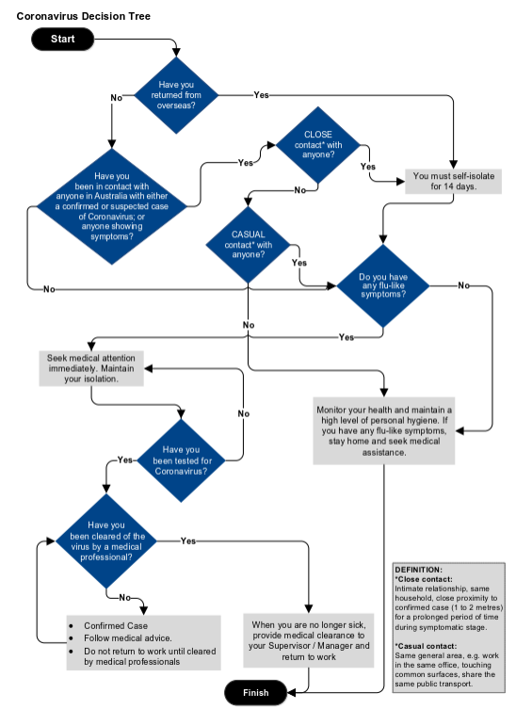
Notes:
            - Should a person present with symptoms on site and require isolation, the Project Manager (or nominee) is to isolate the person by accompanying them to the isolation room. The unwell person and person attending to them shall wear face masks.
            - The Project Manager (or nominee) is to arrange contact with the designated medical clinic or hospital for referral to medical assessment
            - The Project Manager is to notify the Senior Leadership Team as per 2.1.

Appendix B – COVID-19 SCREENING TOOL
COVID-19 – M2WP Project - Questionnaire for all Visitors
Please complete the below questions, sign and submit to a SSWJV staff member before proceeding with your meeting/visit.

Please tick if you have any of the following symptoms;
☐ Fever
☐ Cough
☐ Sore Throat
☐ Shortness of Breath
Have you travelled overseas within the last 14 days?
☐ Yes ☐ No
If yes, have you self-isolated?
☐ Yes ☐ No
Have you come in close contact with someone who has a confirmed case of COVID-19?
☐ Yes ☐ No
If yes, have you self-isolated isolated?
☐ Yes ☐ No

NB. If your conditions, you must immediately notify your Supervisor / Manager.

The below information is advice from NSW Health;
Clean your hands with soap and water for 20 seconds, or an alcohol-based hand rub.
Cover your nose and mouth when coughing and sneezing with tissue or a flexed elbow.
Avoid close contact with anyone with cold or flu-like symptoms.
Name: | Signature: | Date:

Appendix C – RISK ASSESSMENT
 |  |  |  | Raw Risk Ranking Matrix |  |  |  |  |  |  |  |  | Residual Risk  Ranking Matrix |  |  |  |  | SWMS
Risk No | Task / Activity / Condition | Associated Hazards | Risk Description | Consequence |  | Likelihood |  | Risk Level |  | DIN Analysis | Control Measures  (focus on practical / actual controls that will be implemented on the project starting at the highest level of the hierarchy of control order above) | Hierarchy Code | Consequence | Likelihood | Risk Level | DIN Analysis | Forward planning:  Training / Competency Requirements, Emergency Response Planning, Additional First-Aid Provisions, Assessment or induction requirements | Required (Y/N) | Number | Open/Closed | Legal / Legislative References
 |  | Workers unaware of Coronavirus | Contracting / spreading Coronavirus |  |  |  |  |  |  |  |  |  |  |  |  |  |  | Y |  |  | Work Health and Safety Act 2011  Work Health and Safety Regulation 2017  How to Manage Work Health and Safety Risks Code of Practice 2019
 |  | Worker falling into high risk category | Contracting / spreading Coronavirus | C2 | L4 |  | M |  |  |  | - Carry out specific toolbox  - Posters placed around site office  All workers to adhere to social distancing rules | A | C2 | L4 | M |  | C-19 Guide for managers and supporting information  https://www.health.gov.au/news/health-alerts/novel-coronavirus-2019-ncov-health-alert | N |  |  | C-19 Guide for managers and supporting information  https://www.health.gov.au/news/health-alerts/novel-coronavirus-2019-ncov-health-alert
 |  | Meetings and large groups | Contracting / spreading Coronavirus | C2 | L3 |  | H |  |  |  | - Workers at high risk to communicate to management  - Management to make an assessment of all staff  Isolate workers as best as possible from other workforce | A | C2 | L4 | M |  |  | N
 |  | Contact with contaminated surfaces | Contracting / spreading Coronavirus | C2 | L4 |  | M |  |  |  | - Meeting held outside where possible  - Meeting to go no longer than 2 hrs  - Skype meeting to be used as a preference  - Inside meeting to be aware from rest of office workers, preference is to contain in separate room  - If meeting held inside attendance on needs basis once involvement complete person to leave meeting  - Social distancing and personal space addressed at prestart  Make best use of office space utilised  - Team members using office cubical  - Those not in office cubical sit diagonally apart at work stations  - Lunch breaks stagged if required to establish safe distance in lunch shed | I | C2 | L4 | M |  |  | N
 |  | Poor hygiene | Contracting / spreading Coronavirus | C2 | L3 |  | H |  |  |  | Additional cleaning of crib rooms and site office organized and undertaken | E | C2 | L5 | M |  |  | N
 |  | Workers presenting with flu like symptoms  Or  Worker has come in Contact with person with Coronavirus symptoms | Contracting / spreading Coronavirus | C2 | L4 |  | M |  |  |  | - Posters positioned on how to wash hands  - Hand sanitizer at office entrances and work stations  - Workers on site not to share PPE – glass, face shields, gloves  Half face respirators provided to workers undertake works which mechanically generates dust. To extend stock of P2 disposable face masks | A  E | C 2 | L5 | M
 |  | Lack of necessary consumables | Contracting / spreading Coronavirus | C2 | L4 |  | M |  |  |  | Self-isolation and reporting in line with Coronavirus decision tree | I | C2 | L5 | M
 |  |  |  | C2 | L3 |  | H |  |  |  | - Bulk order place for toilet paper, paper towels, hand sanitizer and soap.  - These items secured and separated with limited access. | E | C3 | L5 | L

Appendix D – CORONAVIRUS POSTERS

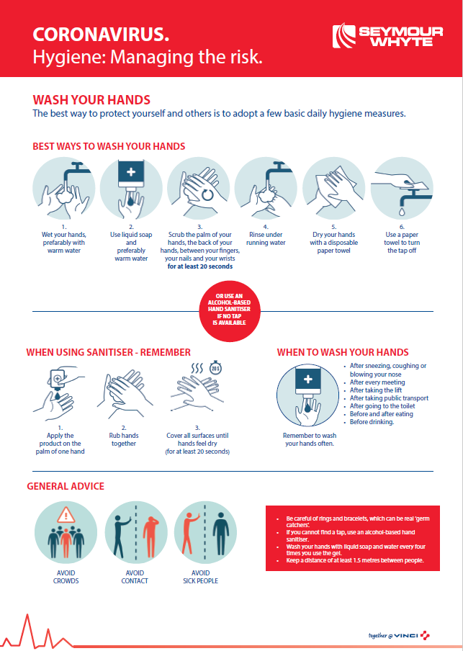

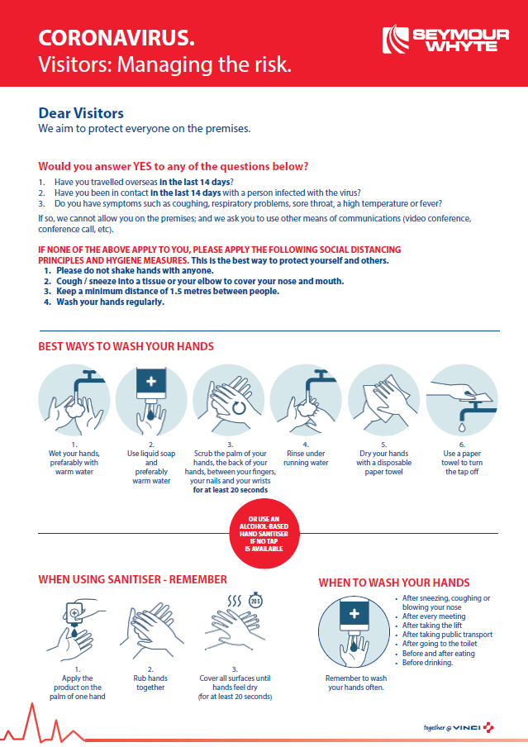

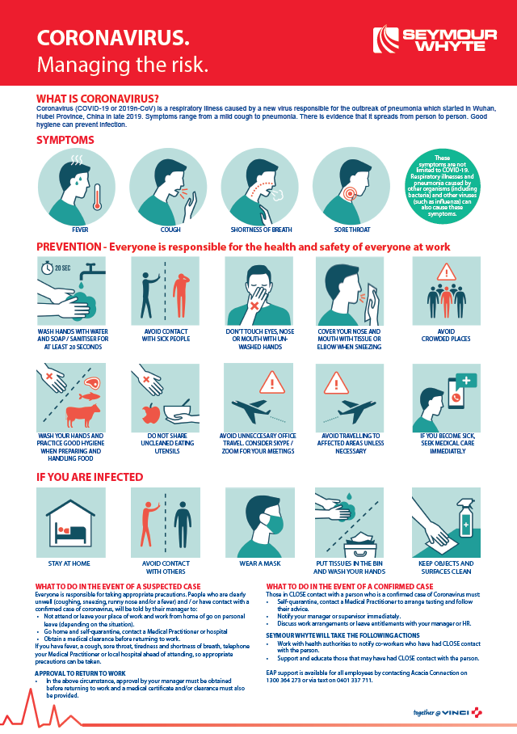

Appendix E – HOT TO WEAR A SURGICAL MASKS

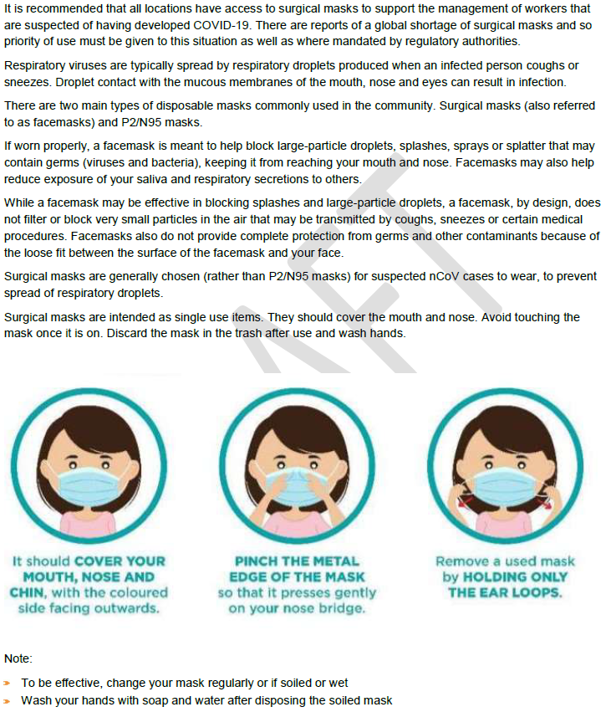

Appendix F – PANDEMIC RESPONSE CHECKLIST

Action | Completed | In Progress
Ensure controls identified in the risk assessment are implemented
Ensure you have enough hand soap in all site and office amenities
Ensure you have a good supply of an alcohol-based hand sanitiser available throughout office areas and in site vehicles
Ensure you have tissues available throughout the office
Ensure you have sanitising wipes for employees to regularly clean surfaces
Display the Coronavirus Managing the Risk posters in your offices / sites
Ensure you have adequate face masks (P2, P3 or surgical masks)
Display the Hand Washing Poster in your bathroom and kitchen facilities
Display the Visitor Poster at your entry
Have discussions with your site / office cleaners to understand the availability of sanitisation / disinfectant services that could be provided as a regular preventative or if there is a confirmed case of Coronavirus
Identify roles that could potentially work from home. Ask those employees to complete a Work from Home Checklist.
Identify and split teams to minimise cross contamination and maintaining adequate supervisory and engineering resources to continue works
Identify a responsible coordinator with defined responsibilities in the event of pandemic.
Identify the critical contracts/sites within your line of business which would have to continue during a pandemic.
Assess potential resourcing, supply impacts and risks to your contracts, your clients (i.e. reduced manning, deferred work, camp infections, restricted site travel (inspections and tests), supply chain interruption or delays, etc.), identify strategic imperatives and assign appropriate priority to your planning process.
Consider how internal staffing resources could be re-allocated to ensure those activities are maintained.
Review existing notification obligations relating to possible delays, suspension, or termination of contractual obligations.
Discuss with your suppliers/sub-contractors whether they have robust Business Continuity plans in place to understand impacts on your project
Understand your current Worker profile. Consider what steps you need to take in preparing a contingent workforce and/or identify what contingent workforce you may require, or whether you may need to reduce resource levels.
Ensure you are aware of where to access reliable pandemic information the Department of Health Website https://www.health.gov.au/news/health-alerts/novel-coronavirus-2019-ncovhealth-alert#current-status
Consider testing the specific actions and controls in this plan in a Stress test and revisit the plan periodically.
Consider how to respond to external stakeholder queries on your pandemic readiness.
Guided by advice issued by Government, forecast and plan for Worker absences during a pandemic. This could be the result of a number of factors including personal illness, family member illness, bereavement, possible disruption to other sectors for example closures of schools or reduced public transport.
Assess your projects needs for continued face to face contact with your customers/suppliers and consider plans to modify the frequency and/or type of face-to-face contact (e.g. video or tele-conferencing instead of travelling to meetings) among Workers and with customers.
For office environments, ensure all internal spaces are well ventilated and air conditioners are regularly cleaned.
Review your workplace contacts, including key stakeholders and update staff and next of kin contact details in PSEM.
Review your supply chain and identify alternative and dual suppliers or products for critical items or equipment.
Test how your project will control entry to the workplace to identify and restrict access to persons who may be infected with a pandemic virus.
Consider CCC operations and access needs during a pandemic and whether to review your projects arrangements to continue to meet those needs.
Review and test IT capabilities to support remote working arrangements, consider the ability to continue operational and financial activities when working remotely or an IT disruption occurs.
Provide briefing and education to supervisors and managers of pandemic specific policies.
Check personal hygiene practices by provision of hand washing facilities or hand-hygiene products, regularly disinfecting workplaces, etc.) together with other advice regarding
personal hygiene e.g. coughing/sneezing into elbow.
Check that Workers keep work areas clean and discourage workers from using other workers’ desks, phones, offices or other equipment, where possible.
Check how additional housekeeping measures to reduce the risk of infection are working, confirm more frequent cleaning on premises is occurring, and ensure the resources to achieve these will be available.
Ensure adequate Personal Protective Equipment (masks, disposable gloves, wipes) are available.
Implement processes for Workers to report when they are sick or experiencing symptoms of the pandemic.
Disseminate information to Workers about your pandemic preparedness requirements and response plan for your business, including their role in this plan.
Review communications on how the project will respond to various scenarios (e.g. closed schools, isolated workers, work from home requirements (i.e. how to access critical business systems at home), workers returning from overseas, how to respond to rumours and how to return to business as usual work activities)

