COVID-19 BUSINESS CONTINUITY PLAN

FOR

Upper Yarra Dam Safety Upgrade

Contract No: 2577

Melbourne Water

Reviewed and Approved

Project Manager

Tom Yates

DOCUMENT CONTROL

SCHEDULE OF REGISTERED HOLDERS

Copy No | Holder Title | Date Transmitted
1
2
3
4
5
6
7
8
9
10
*Note on Controlled / Uncontrolled Copies

Only those copies listed in the Schedule of Registered Holders are Controlled Copies, subject to further official amendment.

All other copies are Uncontrolled Copies, not subject to amendment notification or any further control.

EDITION / REVISION REGISTER – THIS PROJECT SPECIFIC PLAN

The following revision register provides details on all versions of this COVID-19 Business Continuity Plan.

Rev | Rev Date | Rev Details | Approved by
0 | 19/03/2020 | - Initial Draft for SWC Review | RPW
1 | 20/03/2020 | - Draft for SWC Review | RPW

TABLE OF CONTENTS
Page

1 INTRODUCTION 5
1.1 Foreword 5
1.2 Purpose 5
1.3 Objectives 5
1.4 Abbreviations and Definitions 6
1.5 Plan Document Control 7
1.5.1 Initial Draft Version 7
1.5.2 Revision 7
2 IMPLEMENTATION AND OPERATION 8
2.1 Establish coordination teams 8
2.2 Communications and advice 9
2.2.1 Updated expert advice 9
2.2.2 What is Coronavirus and how is it transmitted? 10
2.2.3 General Prevention 10
2.3 Social distancing 11
2.3.1 Project Specific Initiatives 11
2.3.2 Travel 12
2.3.3 Public and Corporate Events 12
2.3.4 Internal Meetings 13
2.3.5 External Meetings 13
2.3.6 Visitors 13
2.4 Potential future social distancing requirements 13
2.5 Exposure Decision Tree and Self Isolation 13
2.6 Confirmed cases of Coronavirus 14
2.7 Entitlements for Employees 15
2.8 Sub-contractors and Labour Hire 15
2.8.1 Leave arrangements 15
2.8.2 Continuity and Security of Supply of Staff, Labour, Plant Equipment and Materials 16
2.9 Employee Assistance 16
2.10 Project Specific Risk Assessment 16
2.11 Pandemic scenario preparation 17
2.12 Appendix A – Coronavirus Decision Tree 18
2.13 Appendix B – Suspected Infection Case at Work 19
2.14 Appendix C: Coronavirus - Managing the Risk 20
2.15 Appendix D: Coronavirus – Take Charge – Protect Yourself 21
2.16 Appendix E: Coronavirus – Hygiene – Managing the Risk 22
2.17 Appendix F: Coronavirus – Visitors – Managing the Risk 23
2.18 Appendix G: Coronavirus – Minimising the Risk of Corona Virus at Work - Toolbox Talk Presentation 25
2.19 Appendix H – How to wear a surgical or P2/N95 mask 26
2.20 Appendix J - Workflow Contact Tracing and Screening 27
2.21 Appendix K – Pandemic Response Checklist 29
2.22 Appendix L – Corporate Business Continuity Advice 32

- INTRODUCTION
  - Foreword
The spread and effects of the Novel Coronavirus (COVID-19) around the world is having a devastating impact to people, communities and businesses. This plan has been developed to outline Seymour Whyte’s strategies and initiatives in implementing risk management and deploying resources to the Upper Yarra Dam Safety Upgrade project given the importance of the dam on continuing water supply for Greater Melbourne and the safety of downstream communities in a dam emergency response event.
The implementation of the initiatives aims to provide effective preparation and control of the impacts of a COVID-19 outbreak as it pertains to the project. It should be acknowledged that requirements imposed by the government and regulatory authorities, together with potential market supply deficiencies of plant, labour or materials (if they occur) will reduce Seymour Whyte’s ability to maintain progress or emergency response. Where this occurs we will advise Melbourne Water of the need for supplementary support and resources or relaxations
The actions to limit the impact of COVID-19 will be based on the principles of effective teamwork, effective communication; continual improvement; and integration of the entire team.
Seymour Whyte is relying on the information provided by the Australian Government Health Department for our decisions regarding the Coronavirus. Whilst we will update this guide regularly, we encourage all our employees to stay up to date with the latest advice which can be found here:
https://www.health.gov.au/news/health-alerts/novel-coronavirus-2019-ncov-health-alert
Some resources and text provided within this plan have been thankfully provided by Melbourne Water through their Safety Focused Performance Joint Venture partners.

  - Purpose
This BCP has been established to:
- to provide guidance to Seymour Whyte’s project team on potential actions to minimise the risk of Coronavirus workplace infections.
- assist the site management team in understanding their operational and project responsibilities for managing the spread and risks associated with COVID-19;
  - Objectives
The objectives of this BCP are to describe the management, organisations, systems and procedures that will help to:
- minimise overall business disruption and uncertainty should a Seymour Whyte office or project identify potential exposure risks to the virus.
- minimise disruption to the project and Melbourne Water operations and maintain progress onsite during the outbreak
- prepare resources to support actions required as part of the Dam Safety Management Plan
- provide a structured approach with clear direction for the duration of the outbreak;
- provide resource and communication materials developed by Seymour Whyte, the Australian Government and Melbourne Water to assist in preventing the spread of COVID-19,
- manage risk and protecting project personnel, Melbourne Water Operations staff and visitors
- identify Client needs and expectations;
- identify and successfully manage risk on the project;
- communicate effectively with Clients, collaborators and other stakeholders.

  - Abbreviations and Definitions
Close contact - A close contact is:
- Someone who has had greater than 15 minutes face-to-face (e.g. within 1.5m) contact in any setting with a confirmed case in the period extending from 24 hours before onset of symptoms in the confirmed case, or
- Someone who has shared a closed space with a confirmed case for a more than 2 hours in the period extending from 24 hours before onset of symptoms in the confirmed case
- A close contact includes a person meeting any of the following criteria:
  - Living in the same household
  - Direct contact with the body fluids without recommended PPE or failure of PPE
  - A person in the same hospital room when an aerosol generating procedure is undertaken on the case, without recommended PPE
  - Aircraft (or long bus or train trip) passengers who were seated in the same row, or the two rows in front or behind a symptomatic confirmed case

Note: The size of the room/space and degree of separation of the case from others will be considered.

Casual contact – A casual contact is:
- Someone who has had less than 15 minutes face-to-face (e.g. within 1.5m) contact in any setting with a confirmed case in the period extending from 24 hours before the onset of symptoms in the confirmed case; or
- Someone who has shared a closed space with a confirmed case for less than two hours in the period extending from 24 hours before the onset of symptoms in the confirmed case
- Other casual contacts may include:
  - Aircraft (or long bus or train trip) passengers who were not seated in the same row, or the two rows in front or behind a symptomatic confirmed case

Note: The size of the room/space and degree of separation of the case from others will be considered.

Suspected case – is defined a person who has:
- International travel in the 14 days before the onset of illness, or
- Close or casual contact (see close and casual contact definitions) in the 14 days before illness onset
with a confirmed case of COVID-19, and
- Fever, or
- Acute respiratory infection (e.g. shortness of breath, cough or sore throat) with or without fever

If the patient has bilateral severe community-acquired pneumonia (critically ill) and no other cause is identified, with or without recent international travel, they are classified as a suspect case.
If the patient has moderate or severe community-acquired pneumonia (hospitalised) and is a healthcare worker, with or without international travel, they are classified as a suspect case.

Symptomatic person – is defined as someone suspected as displaying symptoms consistent with COVID-19.

Confirmed case – is defined as a person who tests positive to a validated specific nucleic acid test or has the virus identified by electron microscopy or viral culture, at a reference laboratory.

COVID-19, C-19 - Novel Coronavirus as defined by the World Health Organisation

Client - Melbourne Water

MW - Melbourne Water

BCP – Business Continuity Plan

SWC - Seymour Whyte Constructions Pty Ltd

  - Plan Document Control
    - Initial Draft Version
The initial BCP shall be managed as per the following:
- Reviewed – by the General Manager Health, Safety, Environment & Quality and General Manager Victoria, Tasmania & South Australia
- Approval – by the Project Manager. Verified by signature on first page
- Control – in accordance with Procedure SWC-IC-020: Control of Documents.
- Distribution – as per the Schedule of Registered Holders in the Document Control section.
    - Revision
Including but not limited to the existence of the following conditions, the BCP shall be reviewed and revised if necessary, to ensure it adequately meets quality requirements:
- the BCP is not adequately addressing current Australian Government requirements or advice, contract requirements; or
- changes to sub management plan requirements; or
- changes to Attachment data.
When revised, significant changes made from the previous version will be shown in blue italics.
Revised BCP’s shall be reviewed, approved, controlled and distributed as per clause 1.6.1.

- IMPLEMENTATION AND OPERATION
  - Establish coordination teams
In order to coordinate the implementation strategies the following Coordination teams have been established:
SWC Project Team
Name | Role | Responsibility
Tom Yates | Project Manager | The projects single Point of Contact (POC). Accountability for implementation on site, provision of adequate resources, liaison with MW project staff. Providing feedback to SWC Construction Manager on the effectiveness or otherwise of controls and project generated initiatives or issues that may be beneficial or impact other projects. Dissemination of Communications to the project team and SLT
Matt Hanlon | Project Superintendent | Responsible for Communication of strategies and controls to the project workforce, training and labour resourcing. Liaison with Melbourne Water Operations staff. Liaison with the project workforce elected Employee Representative (ER)
Greg Walker | Dam Safety Assurance and OHS Manager | Responsible for review and monitoring of the effectiveness of controls, procurement of material supplies, coordination of medical assistance and testing. Monitoring Australian Government advice and updating this plan as required

Project Senior Leadership Team (SLT)
Name | Role | Responsibility
Rob Parry-Williams | Construction Manager | Develop and approve this plan, coordination of the roll out SWC corporate policies and strategies related to COVID-19 on projects
Tom Yates | Project Manager | Implementation on site of controls and strategies, provision of adequate resources, liaison with MW project staff. Providing feedback to the SLT on the effectiveness or otherwise of controls and project generated initiatives or issues that may be beneficial or impact other projects
Mark Lawrence | Superintendents Representative | Review and monitoring of the effectiveness of controls, sharing of strategies from other Melbourne Water Projects. Liaison with Melbourne Water Operations and the PERG to implement operational dam safety controls
Nichola Ziemssen | MW Program Director | Review and monitoring of the effectiveness of controls, sharing of strategies from other Melbourne Water Projects. Liaison with Victorian and Australian Government to procure government resources should the project be unable to adequately supply them
Rahul Jaiswal | Superintendent | Review and monitoring of the effectiveness of controls, contribute to the management of risks and supply chain continuity.

The SLT as a team will also undertake the following project specific roles and responsibilities:
- Work with MW Operations to identify essential business activities and maintaining access to manage these. Assisting where possible MW with identifying staffing contingency alternatives should a high number of MW Workers be unable to attend work.
- Understand and plan for business/economic disruptions, including possible shortages of supplies, supply chain interruptions and delays, and identify supplier alternatives to manage this. Refer 8.1.2
- Complete the Pandemic Response Checklist (Appendix J) to help with preparedness planning.
- Establish alternate teams of Workers (e.g. Team A & Team B) who can be deployed at different work schedules. Maintain separation or Social Distancing of personnel
- Cross-train workers and establish covering arrangements to minimise disruptions for roles identified as critical for business continuity
- Develop a plan for the continuity of leadership in the event of absence of key decision makers and executives
- Work with the workforce to consider flexible work arrangements for high-risk Workers (e.g. those who are at a higher health risk should they contract COVID-19), as well as Workers who need to stay at home due to other reasons relating to COVID-19, e.g. to take care of family members who have travelled to known affected countries / regions, or in the event schools are closed, or public transport cancelled
- Work with the Project Team to disseminate messages to Workers with clear instructions when measures need to be activated.
- Initiate a process so that the project has up-to-date contact information for Workers (and next of kin) in case Workers need to be contacted when not at work
- Make sure all Workers have up-to-date contact numbers of their management team(s). Workers are to contact their manager if they have returned from overseas, are displaying symptoms, been advised they have a suspected or confirmed case, or been in contact with a suspected or confirmed case of COVID-19
- Identify a single Point of Contact (POC), who will be responsible for liaising with partner HR and Government Agencies during activation of contact tracing processes at the workplace
- Ensure processes for checking that Workers who have travelled to affected areas are quarantined for the number of days, as advised by the Australian Government Health Department. Ensure Workers’ health is checked regularly by phone or email during his/her absence from work
- Ensure processes for checking that workplaces have adequate supplies of tissue paper/hand towels, disinfectants/sanitisers and masks
- Ensure processes for Workers to be briefed on personal hygiene measures
- Put up notices in relating to proper hand washing techniques, ensure hygiene stations are available and cleaning processes are in place for common areas e.g. kitchen areas, washrooms, meeting rooms to be disinfected daily
- Maintaining a First Aid or other vacant room designated as the ‘isolation room’ for the Worker(s) with an onset of fever and symptoms to use. Identify the isolation route (a route that is not commonly used by Workers/visitors) that leads to an area where they can be transported to a nearby hospital
- Identify local hospital/medical clinics that Workers who become symptomatic can attend

  - Communications and advice
    - Updated expert advice
Seymour Whyte is relying on the information and directions provided by the Australian Government Health Department for our decisions regarding the Coronavirus. Whilst we will update this plan regularly, we encourage all our employees to stay up to date with the latest advice which can be found here:

https://www.health.gov.au/news/health-alerts/novel-coronavirus-2019-ncov-health-alert
It is important that you stay across the latest developments of this ever-changing situation. Seymour Whyte will endeavour to provide regular updates; however, it is important that you keep yourself informed also.
    - What is Coronavirus and how is it transmitted?
There is plenty of information available on the Federal Government and State Governments website on Coronavirus. We have found this short video that provides a thorough explanation on the virus and the preventative hygiene measures we should all be adopting to prevent infection: Please click on the following link to access:
https://www.swhealth.org/dr-peter-lin-breaks-down-information-on-coronavirus-covid-19/
The virus is most likely spread through:
Close contact with an infectious person
Contact with droplets from an infected person’s cough or sneeze
Touching objects or surfaces (like door handles) that have cough or sneeze droplets from an infected person, and then touching your mouth or face.
    - General Prevention
To protect against the transmission of Coronavirus, all employees should practice good hygiene (both at home and at work). This includes:
- Washing hands frequently with soap and water or hand sanitiser (including after sneezing, coughing, blowing your nose, after every meeting, after taking the lift or being in small confines with multiple people). Appendix F provides guidance on hygiene and hand correct washing
- Covering your mouth and nose if you cough or sneeze, dispose of used tissues immediately after use
- Avoiding touching your eyes, nose or mouth until you have washed your hands
- Avoiding close contact with others, such as being within 1.5m or touching
- Adhering to good food-safety practices
- Maintaining good personal hygiene
Additionally, effective office cleaning can also reduce transmission. This includes regularly wiping down surfaces that are touched often including telephones, keyboards, mouses, desks, chairs, drawers etc with sanitising wipes or a mild bleach solution.
It is recommended that the site procures a supply of face masks (P2, P3 or surgical masks) for if they become needed. A Toolbox Talk on the use of masks is provided in Appendix H
SWC has developed a series of posters including:
Appendix C: Coronavirus - Managing the Risk
Appendix D: Coronavirus – Take Charge – Protect Yourself
Appendix E: Coronavirus – Hygiene – Manage the Risk
Appendix F: Coronavirus – Visitors – Managing the Risk
Appendix G: Coronavirus – Minimising the Risk of Corona Virus at Work - Toolbox Talk Presentation
If any employee appears unwell (e.g. coughing, sneezing, runny nose and / or running a fever), they should be advised to take sick leave as would ordinarily occur. They should be informed to remain away from work until the symptoms have gone or they provide a medical certificate. Talk to your Regional HR Manager if an employee does not have adequate leave to cover such absences.
In some circumstance’s employees may be higher risk when it comes to Coronavirus. This may be due to:
- their age
- a compromised immune system due to a known pre-existing illness or existing medication that they are taking
- Aboriginal and Torres Strait Islander people
- A diagnosed chronic medical medication
Where an employee discloses that they are in a higher risk category extra precautions may need to be taken (for example, an ability to work from home). Ensure that any people in these higher risk categories are met with understanding and accommodated where possible.
  - Social distancing
Social distancing is one of the most effective preventions for Coronavirus spread. The following practices should be implemented in your workplace immediately:
- Employees must stay at home if they are sick
- Stop handshaking as a greeting
- Hold meetings via video conferencing or phone calls where practicable
- Defer large meetings
- Hold essential meetings in outdoor spaces if possible as it provides better ventilation
- Promote good hand and sneeze / cough hygiene
- Have lunch at your desk or outside rather than in a lunchroom
- Clean and disinfect high touch surfaces regularly
- Consider opening windows (where possible) for more ventilation
- Limit food handling and do not share food.
SWC has developed a series of posters including concepts around Social Isolation, refer Appendix D: Coronavirus – Take Charge – Protect Yourself

    - Project Specific Initiatives
The following initiatives are being investigated and implemented where practical on the project:
- Travel to site and other offices – Limiting travel to the project from home to work, such that staff travel to a single site and home each day to limit possible cross contamination from multiple offices or sites.
- Pre-starts – Prestart and Toolbox Talk Meetings, weather permitting, being held in an outdoor area, or a well-ventilated location with space to encourage attendees to spread out and stand at least 1.5m away from each other
- Smaller group meetings by separation of personnel into area related groups, i.e. Piling, Crest, Weir, EB1 stockpile areas
- Split Smoko and lunch breaks, i.e.:
  - Group 1 smoko 09:00 – 09:30 and lunch 13:00 – 13:30
  - Group 2 smoko 10:00 – 10:30 and lunch 14:00 – 14:30
  - Allowing meal breaks in machines
- Allocation of machines to same operator each day
- Separating workforce into smaller groups to minimise the number of people in the crib shed at one time and maximising space between personnel, aiming for a maximum of 2 people to each table.
- Procuring additional shelters and tables outside to allow people to spread out
- Ordering in butchers’ paper for each table for each break – use as a place mat and then throw away before the next group sits
- Bussing workers around site – provide face marks during travel on site in groups in the minibus
- Minimise the number and length of face to face meetings, utilise SKYPE where practicable, meet outside.
- Office set-up – maintain partitions between desks and min 1.5m between seats
- Limiting visitors to site – reconsider need for visitors to attend site in person, visitors to be approved by the Project Manager or Construction Manager
- No close contact with Melbourne Water Operations staff unless approved by Melbourne Water
- Providing additional bins to reduce spacing and prevent overflow
- More frequent cleaning of crib sheds, toilets, porta loos generally
- Disinfecting high touch surfaces regularly
- Additional radios with allocations to the same worker each day, cleaning of handsets and microphones
- Cleaning of office desks, mouse, keyboards every night
- Preparation and separation of SWC staff into two teams in case of one team becomes effected
- Ordering and storing additional supplies of hand sanitizer, soap, toilet paper, paper towels, disposable gloves, antibacterial wipes, tissues, etc
- Deploying hand sanitizer at crib room, office entrances, in areas of pre starts, etc
- Regular replenishing of soap, paper towels, toilet paper
- Reinforce use of soap where running water available (instead of sanitizer)
- Review sign on process for Pre starts and Task Hazard cards – consider providing pens for workers, clean pens, have all workers wash hands after using pens/handling task cards?
- Identify close proximity (<1.5m) field tasks with supervisors and consider how to undertake those tasks while maintaining social distancing
- Sharing learnings with other sites
- Prestart machines – wipe down / clean cab controls and radios each morning
- Hot-seating machines - wipe down / clean cab controls between operators
- Clean and disinfect face shields prior to use
- Maintain social distancing when doing delivery driver inductions
- Maintain ice maker hygiene and dispenser scoop stored outside in cover
- Advise workforce of availability of Acacia EAP in times of concern

    - Travel
As advised by the Australian Government all persons entering Australia must self-quarantine for a period of 14 days or longer if they are showing symptoms.
SWC has suspended all international travel unless it is approved by the Managing Director.
All domestic travel should be delayed where possible. Face-to-face meetings should be replaced by virtual meetings using teleconferencing, Skype, Zoom. The intent of this protocol is to avoid areas with excess people such as conferences, large scale meetings and places such airports.
    - Public and Corporate Events
Events that involve large gatherings of people should be avoided. Seymour Whyte requires employees and contractors to not attend events that involve many people coming together particularly in doors. Events involving more than 100 people held in doors or more than 500 people outdoors are not to be attended and should be cancelled as per the Australian Governments directions.
    - Internal Meetings
Someone is considered to have had ‘close contact’ with another person if they are in a meeting room within 5 metres for longer than 2 hours. For this reason, we recommend the following when it comes to internal meetings:
- Reduce need for face to face meetings
- Keep as much space between people as possible, spread out and utilise the space available.
- Keep meetings short and less than two hours in duration.
- Where possible meet in outdoor spaces.
    - External Meetings
Where possible, we encourage employees to attend meetings virtually through platforms such as teleconferencing, Zoom or Skype. If you do need to attend a meeting externally ensure you use hand sanitiser or wash your hands thoroughly prior to touching your face. Avoid any persons who are showing symptoms of Coronavirus.
    - Visitors
Visitors to the project are to be limited to those essential to business needs to attend in person, most engagements can be effectively completed over the phone, facetime or video conferencing. The project team is to consider excluding visitors from attending site and making other arrangements, if visitors are required please seek guidance from your Project manager or WHS Manager.

All visitors are to be asked:
      - Have you travelled overseas in the last 14 days?
      - Have you been in contact in the last 14 days with a person infected with the virus?
      - Do you have symptoms such as coughing, sneezing, respiratory problems, sore throat a high temperature or fever?

If any of the above are answered yes, then access to the project will be denied

SWC has developed a series of posters including Appendix F: Coronavirus – Visitors – Managing the Risk

  - Potential future social distancing requirements
The Coronavirus situation is changing rapidly, there is no doubt that there will be significant disruptions and varying impacts to our workplaces.
All staff should urgently start to consider which roles can work remotely (from home) if they are required to self-isolate and be prepared for any future Government or Seymour Whyte imposed working restrictions.
Seymour Whyte’s preference is to accommodate working from home where possible and reasonable. To start preparing for enabling people to work from home, you should ask relevant employees to complete the Work from Home Checklist (available on SharePoint). Additionally, you should ensure that you have the technology to enable this to happen.

  - Exposure Decision Tree and Self Isolation
The following will assist in determining actions where employees or subcontractors are thought to have been at risk of exposure to Coronavirus. It is important to note in many cases, particularly where there is an elevated risk, government authorities will provide guidance and / or formal direction in relation to isolation. In these instances, everyone must comply and not return to the workplace until they have clearance from a medical practitioner and the relevant Manager. This includes directions provided by the Australian Government relating to international travel.
Where there is no direction from authorities a decision to allow an employee to return to the workplace must be made based on the level of risk involved. Appendix A – Coronavirus Decision Tree provides a flowchart to determine the level of risk. Where the level of risk is difficult to determine we encourage you to speak to your Manager, Safety representative or phone the Coronavirus Health Information Line on 1800 020 080.
Where it is determined that there is a low risk, the concerned employee should be informed to monitor their health and if any symptoms are experienced, they are to stay away from the workplace and contact their Manager.
In higher risk circumstances the employee is to be advised to self-isolate for 14 days. It is important to remember that employees have a duty of care responsibility to others in relation to safety and health at work. This includes not only working safely but also not affecting the safety and health of others. Seymour Whyte takes its responsibilities in relation to health and safety seriously and we ask our employees to take their responsibilities seriously also, hence why we are asking people to self-isolate in high risk circumstances. Where an employee refuses to self-isolate we may stand them down; however, this should be discussed with the relevant Manager and / or HR prior to any discussions.
The Australian Government has advised that all Australians should reconsider overseas travel. Where you are aware that an employee is travelling overseas you should encourage them to reconsider. If the employee choses to travel internationally, they will be subject to Government imposed isolation.
From March 2020 employees will be asked if they are travelling overseas when they apply for annual leave (on the employee portal and on the paper leave form). If they are, employees will be required to agree to self-isolate for 14 days upon return (they will need to work from home or apply for additional leave to cover this period). Where an employee does not agree to this, Managers will need to decline the leave application. In addition, Managers should consider the totality of the period the employee is likely to be absent for and your ability to provide enough coverage for these extend periods.

  - Confirmed cases of Coronavirus
Should an employee or another person on site report that they have had a medical practitioner confirmed case (confirmed case) of Coronavirus, SWC will advise governments and Public Health Departments who will implement standard protocols to identify people who have been in close or casual contact (refer definitions) with an infected person. These authorities will also determine any need for isolation or other responses. We will regularly monitor these responses and regulatory requirements.
Where specific regulatory requirements are not forthcoming the following actions are to be implemented:
- Contact your Safety representative to assist with obtaining specific advice from a medical practitioner or other source
- Contact Courtney Hoops 0410 672 524 and advise of the situation
- Confirm and record the following details using the form in Appendix B of the individual who has been confirmed as having the virus
  - Name and contact number
  - Project location
  - Date of advice
  - Date symptoms commenced
  - Symptoms (Fever, Dry Cough, Body Aches, Headaches, Sore Throat, Runny Nose, Shortness of Breath, Nausea, Vomiting, Other)
  - In close contact with a confirmed case within 14 days?
  - Overseas in the past 14 days?
- Identify and record the names of any individual/s who may have been in ‘close contact’ with the affected person while they were not showing symptoms.
- Identify and record any individuals who may have had ‘casual contact’ with the affected person while they were not showing symptoms.
- Email the above details to Christine.Marcek@seymourwhyte.com.au and cc your HR Manager.
- Enter the occurrence into PSEM.
- Employees (or other site-based people) who have been in close contact with the confirmed case should be advised about their risk, provided medical support from an approved medical practitioner and be directed to stay away from the workplace for 14 days from when they were last exposed. They should be advised to seek medical attention if they experience any symptoms. These employees should not return to work until they have a medical clearance. EAP assistance should be offered where deemed appropriate.
- Employees including all site people, who may have had casual contact with a confirmed case should be informed. They should be advised to monitor their health for 14 days. If they develop symptoms they should be advised to self-isolate immediately. They should also seek medical advice and inform their Manager of the outcome. Isolation from the workplace is not generally required for persons who were in casual contact with the affected individual, providing they do not experience any symptoms.
- The affected area (office, site office, site vehicle) must be isolated and employees removed until cleaning activities are completed. The affected area will include all areas that were routinely accessed by the infected person, including communal areas such as kitchens and bathrooms. Cleaning must be undertaken by cleaners who are experienced in disinfection processes.
  - Entitlements for Employees
The rules regarding entitlements for employees vary, in general terms, employees who self-isolate due to a government or health authority direction (for example, they are travelling internationally or have had close contact with a confirmed case) are required to use their personal (sick) or annual leave. Seymour Whyte will allow people to choose what type of leave they would like to utilise.
Employees who need to self-isolate to ensure that they meet their duty of care in respect to others in the workplace will generally utilise personal (sick) or annual leave; again, we will allow employees to choose.
Employees directed to isolate by Seymour Whyte (without Government authority) would be considered a special case and should be referred to your HR Manager for advice.
Where an employee does not have enough leave to cover periods of self-isolation, Seymour Whyte will consider allowing the employee to go into negative leave balances. This will depend on a range of factors such as length of service and employment type. Please discuss options with your HR Manager.
Seymour Whyte will consider paying Special Leave to casuals in our workforce. In the event you do have a casual who needs to isolate, please discuss with your HR Manager.
Where there is ambiguity, please discuss the case with your HR Manager prior to discussing it with the employee.

  - Sub-contractors and Labour Hire
    - Leave arrangements
The rules regarding leave entitlements for employees of other companies who are required to self-isolate are many and varied. SWC will encourage individual employers to utilise leave arrangements and for them to support their employees where the employee does not have adequate leave for the period of self-isolation.
There is a risk that persons with symptoms may try to mask them to continue employment on the project and receive remuneration, particularly casuals. Where SWC is aware of a high proportion of casuals on the project the project team has discussed the need for employers of casuals to have processes in place to ensure that they don’t feel the need to hide symptoms, that symptoms are identified and that suitable leave arrangements are available.
SWC has agreed to cover the labour time for personnel where they are displaying symptoms to obtain a test for the virus, suppliers of labour are currently reviewing their remuneration processes to ensure they have controls in place to prevent their employees negligently infecting others.

    - Continuity and Security of Supply of Staff, Labour, Plant Equipment and Materials
The Dam Safety Management Plan identifies the requirements for staff, labour, plant, materials and equipment for the various Response Levels and contingencies if normal market supply conditions are available.
Whilst we are in regular contact with our main supplier partners and understand demands and availability of resources, in the event that the normal market operating conditions and availability of a healthy supply of labour, materials and other resources are restricted by government directives and illness during a pandemic event; and a Dam Safety Emergency event coincided, the ability to supply adequate resources could be compromised beyond Seymour Whyte’s control. If this occurred, we would request additional support from Melbourne Water and Government to reduce restrictions, allow non-conforming materials or provide support from Government sources such as the army.
Alternative sources of supply for labour and materials have been identified as follows to try and meet Emergency Response Levels in a pandemic situation.
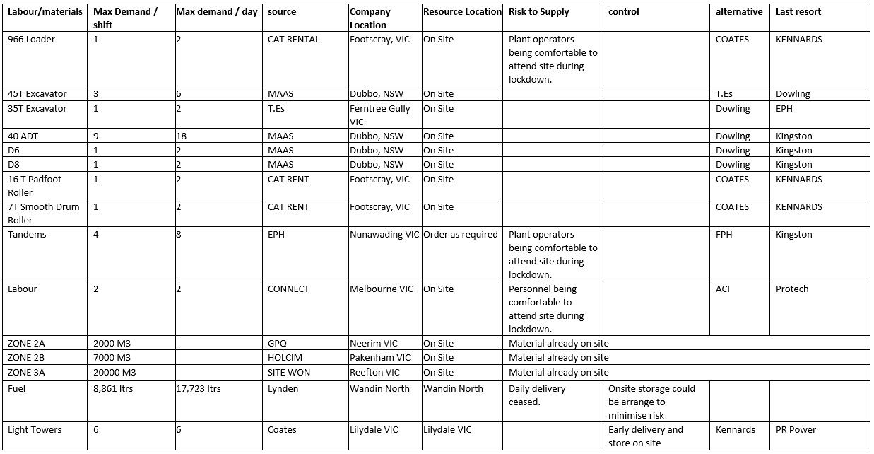

  - Employee Assistance
SWC has partnered with Acacia EAP as provider of employee assistance, this is available to all project and office personnel including subcontractors. Access to their services is available through the App on all SWC provided iPhone and tablets or via www.eapcounselling.com.au. Acacia has increased their resources in readiness for an expected increase in counselling and support enquiries.

  - Project Specific Risk Assessment
This plan does not cover all the potential scenarios that may present as a result of Coronavirus therefore the Project is required to regularly undertake a site-specific risk assessment. This assessment should identify site specific actions / controls that may be required. A copy of the completed risk assessment is to be sent to Christine.Marcek@seymourwhtye.com.au by close of business 19 March. Assistance can be provided by your Safety representative.
A series of Pandemic Response Checklists have been developed by SWC, SFP and Melbourne Water these are provided in Appendix K to assist in the review of implementing this Business Continuity Plan
SWC commits to remaining vigilant with respect to risk levels on projects which we recognise as constantly changing, regular review and updating of the Risk Registers will be undertaken as per the current 4 week look ahead and other reviews as required by SWC-SOP-11 Risk Management.

  - Pandemic scenario preparation
Detailed scenarios and playbook (role play) materials are available to guide Managers through various scenarios, these are consistent with the Appendix A - Coronavirus Decision Tree which is the primary source for all decision making. Where the flowchart in Appendix A is unclear for a situation please refer to your Construction Manager for clarification and direction.

  - Appendix A – Coronavirus Decision Tree
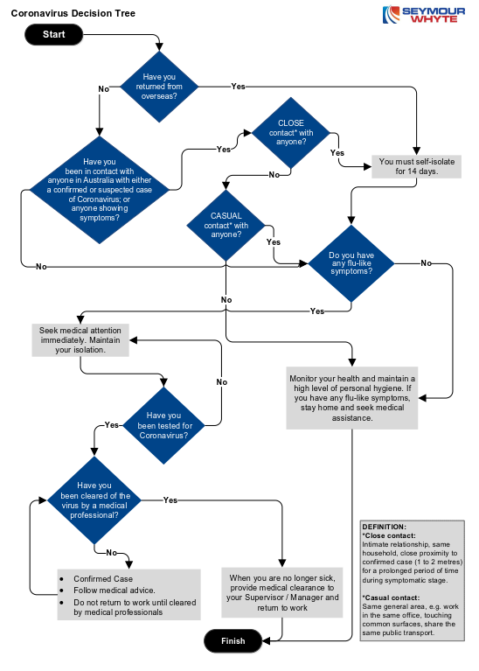
Notes
            - Should a person present on site and require isolation the Project Manager (or nominee) is to isolate the person by accompanying him to the isolation room via the isolation route. The unwell person and person attending to them shall wear PPE
            - The Project Manager (or nominee) is to arrange contact with the designated medical clinic or hospital for referral to medical screening and assessment as advised
            - The Project Manager is to notify SWC State Contraction Manager, Regional General Manager and National HSEQ General Manager
            - The Project Manager (or nominee) is to record names and contact details of all persons working in the same workplace as the unwell person or who have come into close contact with the unwell person.
  - Appendix B – Suspected Infection Case at Work
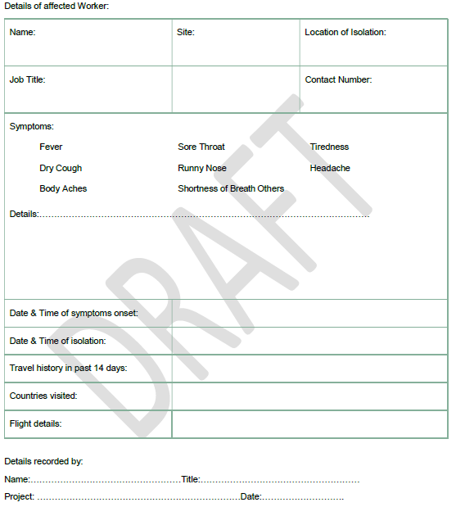

  - Appendix C: Coronavirus - Managing the Risk
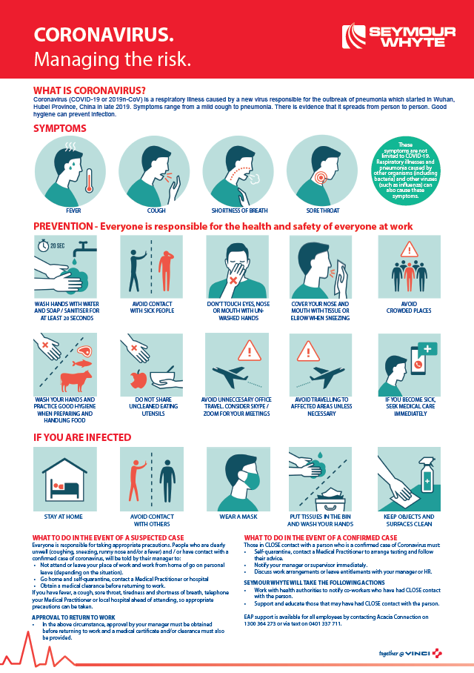

  - Appendix D: Coronavirus – Take Charge – Protect Yourself
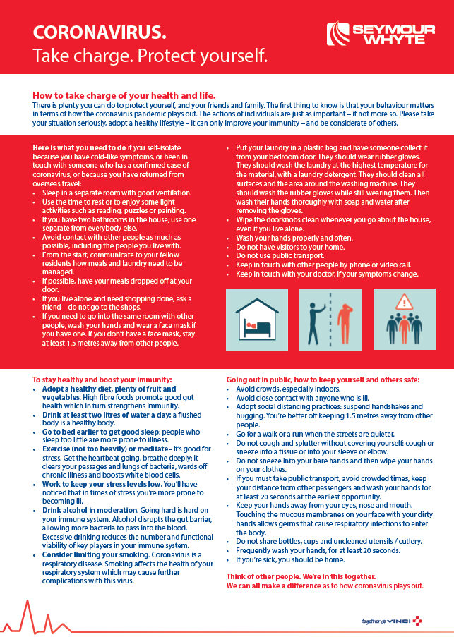

  - Appendix E: Coronavirus – Hygiene – Managing the Risk
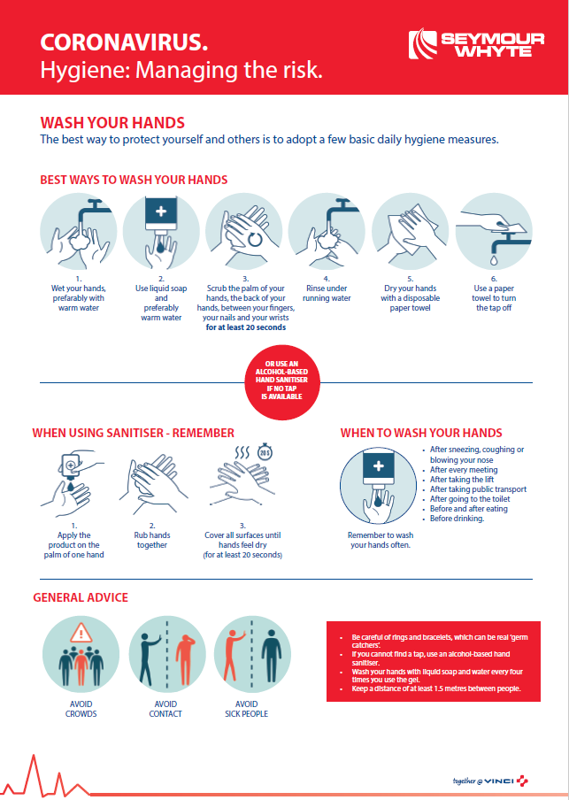

  - Appendix F: Coronavirus – Visitors – Managing the Risk
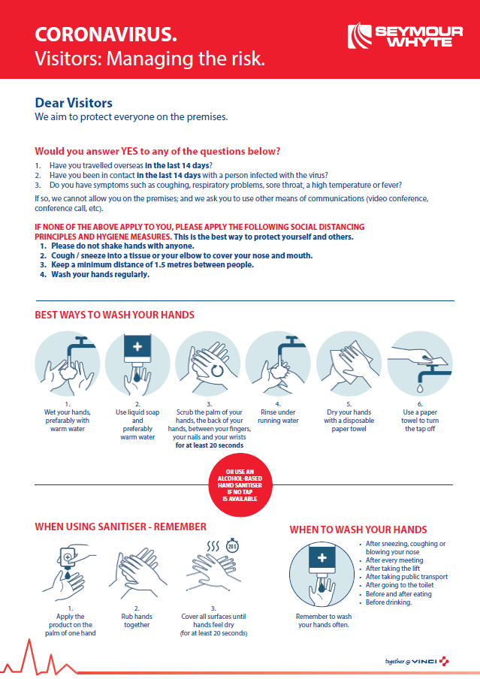

Proper hand washing requires soap and water. The constant rubbing action helps soap break down the grease and dirt that carry most germs. Washing your hands for at least 20 seconds with soap and water reduces germ count by up to 99%. Follow these 8 simple steps to keep your hands clean:
- Palm to palm
- Between fingers
- Back of hands
- Base of thumbs
- Back of fingers
- Fingernails
- Wrists
- Rinse and wipe dry

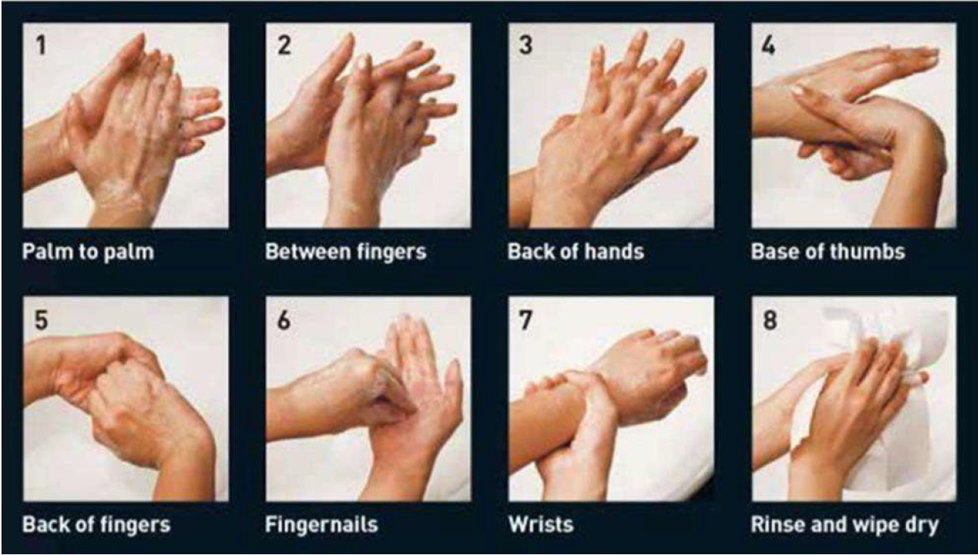

  - Appendix G: Coronavirus – Minimising the Risk of Corona Virus at Work - Toolbox Talk Presentation
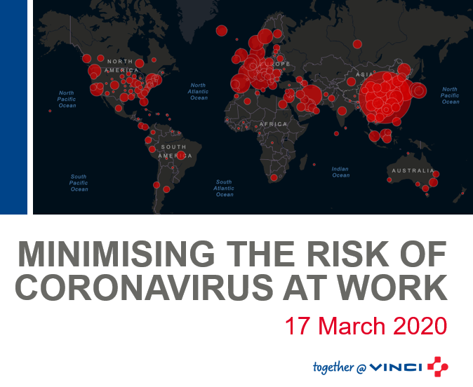

  - Appendix H – How to wear a surgical or P2/N95 mask

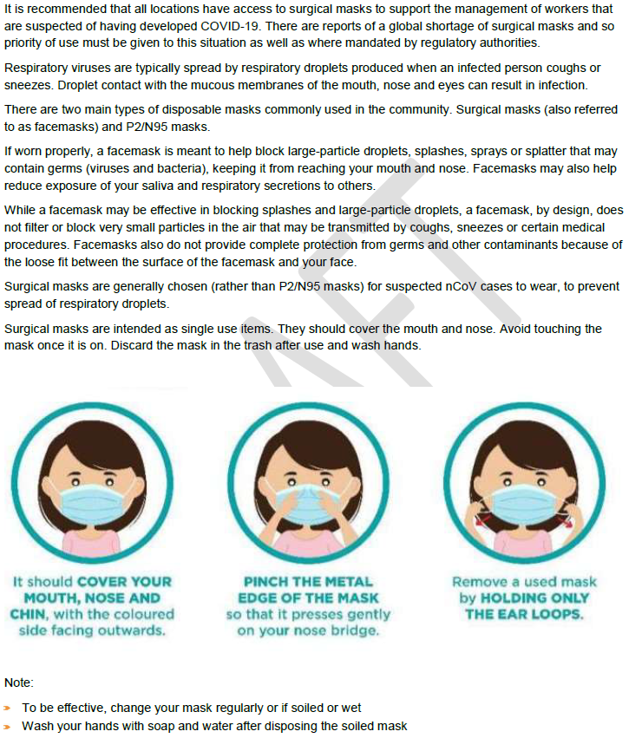

  - Appendix J - Workflow Contact Tracing and Screening
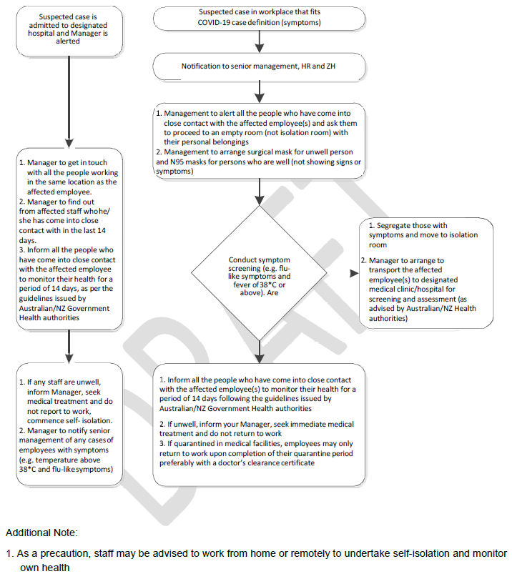
Where screening is required the following form can be utilised
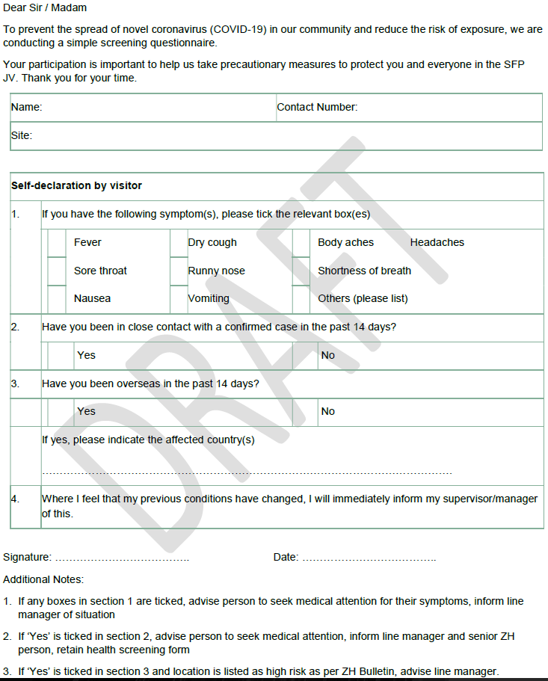

  - Appendix K – Pandemic Response Checklist
Action | Completed | In Progress | Not started
Conduct the enclosed Toolbox Talk by 19 March
Ensure controls identified in the risk assessment are implemented
Ensure you have enough hand soap in all site and office amenities
Ensure you have a good supply of an alcohol-based hand sanitiser available throughout office areas and in site vehicles
Ensure you have tissues available throughout the office
Ensure you have sanitising wipes for employees to regularly clean surfaces
Display the Coronavirus Managing the Risk posters in your offices / sites
Ensure you have adequate face masks (P2, P3 or surgical masks)
Display the Hand Washing Poster in your bathroom and kitchen facilities
Display the Visitor Poster at your entry
Have discussions with your site / office cleaners to understand the availability of sanitisation / disinfectant services that could be provided as a regular preventative or if there is a confirmed case of Coronavirus
Identify roles that could potentially work from home. Ask those employees to complete a Work from Home Checklist.
Identify and split teams to minimise cross contamination and maintaining adequate supervisory and engineering resources to continue works
Identify a responsible coordinator and/or team with defined roles and
responsibilities for preparedness and response planning.
Identify a responsible coordinator with defined responsibilities in the event of pandemic.
Identify critical activities undertaken by your business/contract which would have to continue during a pandemic, as well as the Workers and other inputs that support those activities (e.g. suppliers, sub-contractor services).
Identify the critical contracts/sites within your line of business which would have to continue during a pandemic.
Assess potential resourcing, supply impacts and risks to your contracts, your clients (i.e. reduced manning, deferred work, camp infections, restricted site travel (inspections and tests), supply chain interruption or delays, etc.), identify strategic imperatives and assign appropriate priority to your planning process.
Consider how internal staffing resources could be re-allocated to ensure those activities are maintained.
Consider force majeure provisions if a pandemic makes it impossible or unlawful to fulfil contractual obligations.
Review existing notification obligations relating to possible delays, suspension, or termination of contractual obligations.
Discuss with your suppliers/sub-contractors whether they have robust Business Continuity plans in place to understand impacts on your project
Understand your current Worker profile. Consider what steps you need to take in preparing a contingent workforce and/or identify what contingent workforce you may require, or whether you may need to reduce resource levels.
Consider what key tasks and training an additional pool of workers may require (e.g. contractors, cross train Workers, etc.)
Ensure you are aware of where to access reliable pandemic information on SWC Intranet and the Department of Health Website https://www.health.gov.au/news/health-alerts/novel-coronavirus-2019-ncovhealth-alert#current-status
Establish an emergency communications plan and revise periodically. This plan should identify key contacts (with back-ups), chain of communications (including suppliers, customers and Workers), and processes for tracking and communicating business and Worker status.
Consider testing the specific actions and controls in this plan in a Stress test and revisit the plan periodically.
Consider how to respond to external stakeholder queries on your pandemic readiness.
Identify Workers in critical roles and key customers with special requirements and incorporate the requirements of such persons (e.g. isolation or flexible work environments) into your preparedness planning.
Consider cross-training and identify alternate resources to undertake critical roles.
Guided by advice issued by Government, forecast and plan for Worker absences during a pandemic. This could be the result of a number of factors including personal illness, family member illness, bereavement, possible disruption to other sectors for example closures of schools or reduced public transport.
Assess your projects needs for continued face to face contact with your customers/suppliers and consider plans to modify the frequency and/or type of face-to-face contact (e.g. video or tele-conferencing instead of travelling to meetings) among Workers and with customers.
For office environments, ensure all internal spaces are well ventilated and air conditioners are regularly cleaned.
Communicated policies on personal, sick, carers, compassionate leave due to a pandemic.
Review your workplace contacts, including key stakeholders and update staff and next of kin contact details in PSEM.
Review your supply chain and identify alternative and dual suppliers or products for critical items or equipment.
Test how your project will control entry to the workplace to identify and restrict access to persons who may be infected with a pandemic virus.
Remind Workers about the availability of EAP services and consider the impacts for an increase take-up of these welfare services.
Consider Melbourne Waters operations and access needs during a pandemic and whether to
review your projects arrangements to continue to meet those needs.
Test measures that can be taken to reduce potential for Workers who are in the workplace to infect each other (i.e. flexible work locations and split shifts).
Review and test IT capabilities to support remote working arrangements, consider the ability to continue operational and financial activities when working remotely or an IT disruption occurs.
Test awareness of relevant policies and procedures. Identification and escalation to Steering Committee Lead of policy gaps.
Test knowledge of the latest SWC and Australian Government advices relating to the pandemic. Implementation of pandemic specific policies during a pandemic e.g. hygiene, social distancing, self-isolation, split office working arrangements (to ensure adequate distances between workstations), work from home, etc.
Consider the circumstances under which you might decide to scale back resourcing or suspend operations due to a pandemic.
Consider whether you will allow requests for staff absences where a family member has the virus or is self-isolating, or if schools / child care / retirement village arrangements are impacted.
Restrict Workers from attending work related conferences.
Provide briefing and education to supervisors and managers of pandemic specific policies.
Check personal hygiene practices by provision of hand washing facilities or hand-hygiene products, regularly disinfecting workplaces, etc.) together with other advice regarding
personal hygiene e.g. coughing/sneezing into elbow.
Check that Workers keep work areas clean and discourage workers from using other workers’ desks, phones, offices or other equipment, where possible.
Check how additional housekeeping measures to reduce the risk of infection are working, confirm more frequent cleaning on premises is occurring, and ensure the resources to achieve these will be available.
Check whether Workers can work from home and what communications and information technology infrastructures are needed to support Workers working from home, tele-conferencing instead of face to face meetings and remote customer access if WFH is needed
Ensure adequate Personal Protective Equipment (masks, disposable gloves, wipes) are available.
Ensure Safe Work Practices Posters are up to date. Understand the steps to limit the spread of the respiratory secretions of a Worker who may have been affected by the pandemic.
Review management for Workers who are unwell; isolation rooms and access route to isolation room and medical transport parking location.
Implement processes for Workers to report when they are sick or experiencing symptoms of the pandemic.
Is easily accessible information about this pandemic available to the workforce which includes signs and symptoms of influenza, modes of transmission, personal and family protection and response strategies (e.g. hand hygiene, coughing/sneezing etiquette, contingency plans, etc.).
Disseminate information to Workers about your pandemic preparedness requirements and response plan for your business, including their role in this plan.
Review communications on how the project will respond to various scenarios (e.g. closed schools, isolated workers, work from home requirements (i.e. how to access critical business systems at home), workers returning from overseas, how to respond to rumours and how to return to business as usual work activities)
Establish and maintain clear internal and external protocols for regular and emergency communication with Workers, customers and other key stakeholders.
Review internal communication notification and escalation pathways for reporting and recording potential pandemic exposure.
Ensure you have a current Worker list with up-to-date contact information for all Workers and next of kin.
Ensure you have a current Contacts list including Contract leadership list (including alternates) with contact information (e.g. Emergency/Crisis Management Plan).

  - Appendix L – Corporate Business Continuity Advice
