Community Transport Portal
User Guide v2.3

Table of Contents
Overview 2
What is the Community Transport Portal? 2
Logging In 3
Change the Password 4
Forgotten Password or Username 5
My Reports – Home Page 7
Pending Tab 7
Submitted Tab 12
Download Tab 13
Key Performance Indicator (KPI) Reports 14
Help 20
Documentation 20
Appendix A – Reports List 21
Appendix B – Sample Reports & Tips for working with CSV and Excel 22

Overview
This fact sheet provides information about the Community Transport Portal (the Portal).
The intended audience is Community Transport Service Providers, their IT providers and booking system administrators, Community Transport Contract Officers and Commercial Manager and Support Team.
The document describes:
- The Portal
- Logging in and navigating the Portal
- Uploading and viewing reports
- Downloading reports

What is the Community Transport Portal?
The Portal is built on the web-based Transport for NSW (TfNSW) operator reporting system known as Operator Data Interchange (ODIN).

The Portal is designed for use by Community Transport Service Providers (CTSP) for uploading reports as required under the relevant contract and is monitored by the TfNSW Contract Managers.
The document refers to the Portal and ODIN interchangeably.

Logging In
Please follow the below instructions to log into the Portal.
- Open an Internet Browser. The preferred web browser is Google Chrome. Older versions of Internet Explorer may not work.
- Type or copy and paste this link https://apps.transport.nsw.gov.au/odin/#/login in the internet browser address bar
- Click Enter. Wait for the Welcome to Operator Reporting web page to load open.
- Read the Condition of Use on the Welcome page.

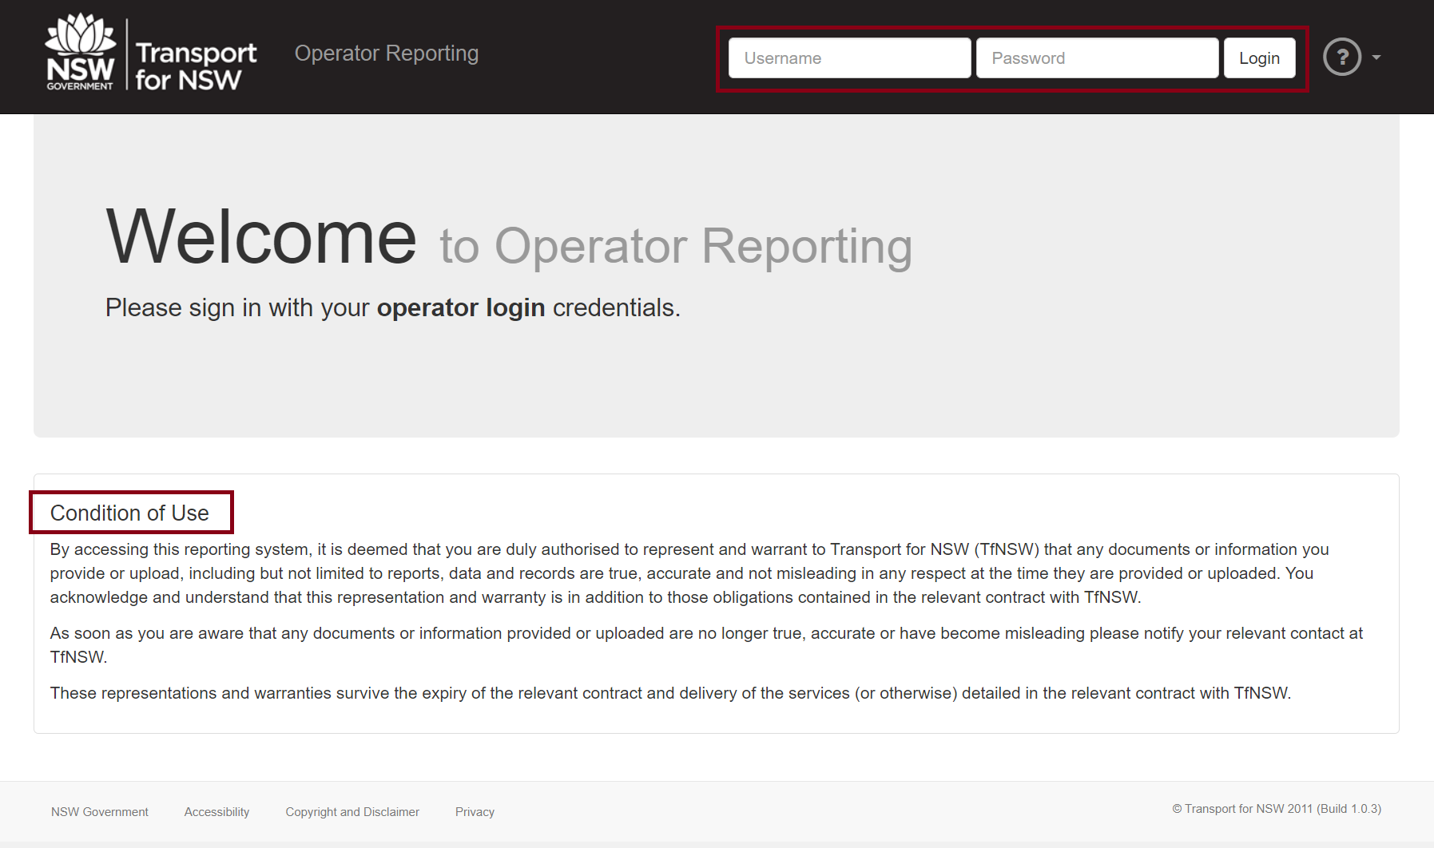
- If you Agree to the Condition of Use, type the Community Transport Username and Password into the spaces provided at the top right of the screen.
NOTE Use the dedicated Community Transport username and password for this service. The username and password are case sensitive. It is recommended to reset your password after the first login – see instructions below

- Next click Login.

Change the Password
If you need to reset or change your password, please follow the below steps.
- Type or copy and paste this link https://appln.transport.nsw.gov.au/portal/login into the web browser address bar.
- Click Enter.
- Type your username and password in the spaces provided.
- Click Login.

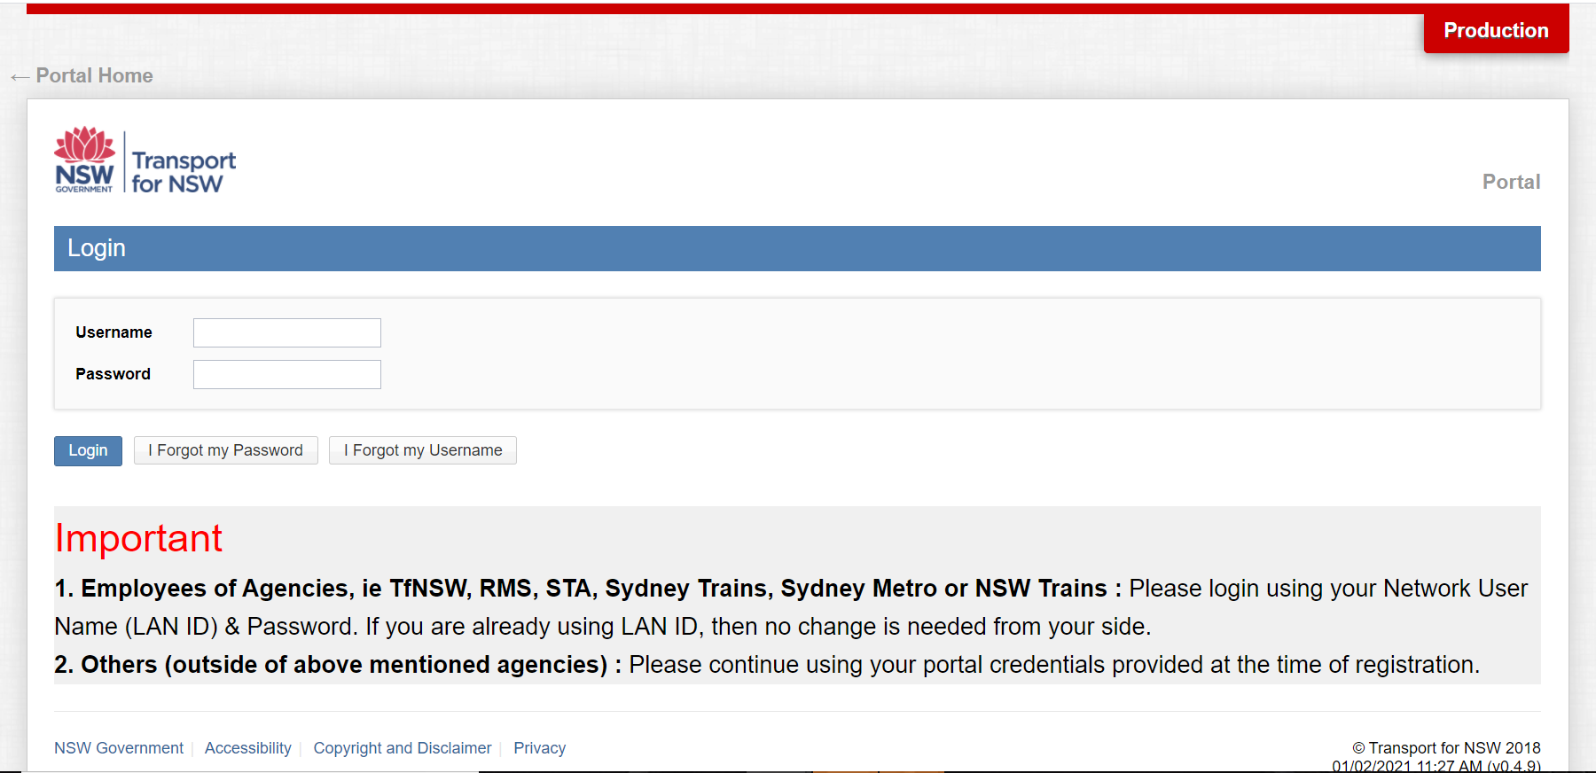

- Next, click the Change Password option.
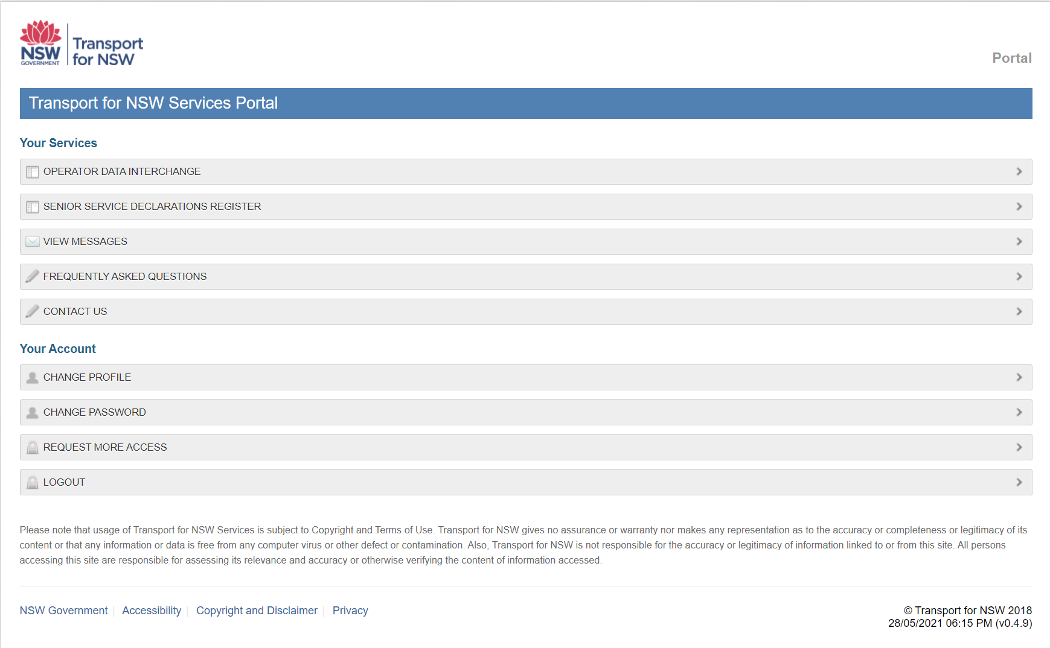

- A Change Password box will appear on screen. Type your Old Password and a New Password into the spaces shown, noting the instructions for password strength.
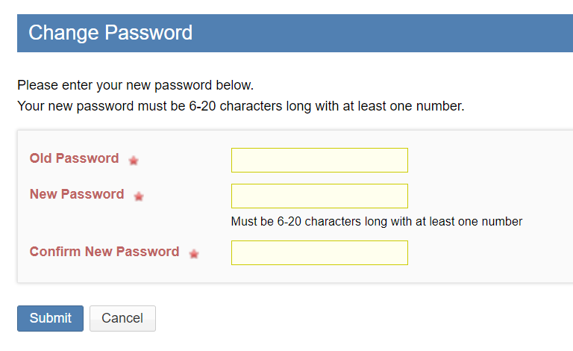

- Re-type your new password into the Confirm New Password space.
- Click Submit.

Forgotten Password or Username
If you have forgotten your password, please follow the below steps.
- Type or copy and paste this link https://appln.transport.nsw.gov.au/portal/login into the web browser address bar.
- Click Enter.
- Select the option Forgot my Password.
- Next, type your Username at the prompt and click Enter.
- Check the mailbox that is associated with your login account for an email with instructions on how to create a new password. Follow the steps provided.
If the email has not arrived within 15 minutes check your Spam or Junk folder before retrying this option.
If you have forgotten your username, please alternatively follow the below steps.
- Type or copy and paste this link https://appln.transport.nsw.gov.au/portal/home into the web browser address bar.
- Click Enter.
- Select Forgot my Username.
- Click Enter.
- The next prompt will request the email address that is associated to your username. Type the email address into the spaces provided.
- Click Enter.
- Check the mailbox that is associated with your login account for an email with your username.

My Reports – Home Page
- Type or copy and paste this link https://apps.transport.nsw.gov.au/odin/#/login in the internet web browser address bar.
- Click Enter.
- Type your Username and Password in the spaces provided.
- Click Login.
The banner of the home page contains three tabs: Pending, Submitted and Download.

Pending Tab
The Pending tab displays Reports due or Reports uploaded by the Due date that are ‘Pending’ processing.
Expand or collapse Report periods by clicking Reports due for... or the use the up arrow.
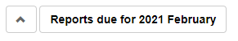
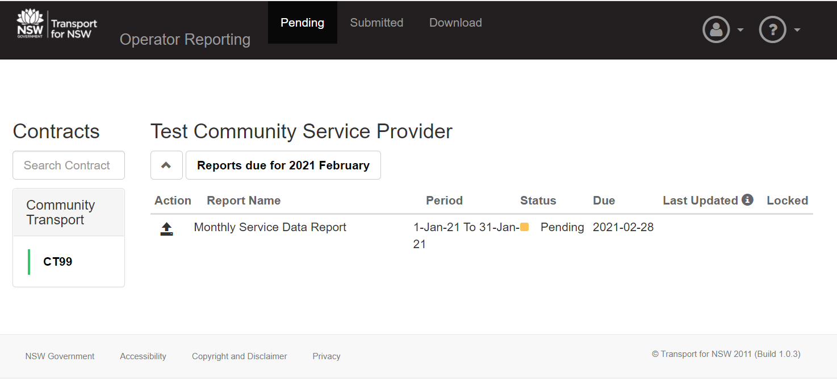
Upload a Report
Before uploading a Report, first ensure that it conforms to the file and data requirements as per the Community Transport Reporting Requirements.
- Click on the Upload icon to the left of Report Name
- When the Upload icon is pressed, a File Upload or Open dialog box will display.
- Navigate to the location where the file to be uploaded is stored on your computer or laptop.
- Select the document by clicking on the file.
- Then select the Open button.
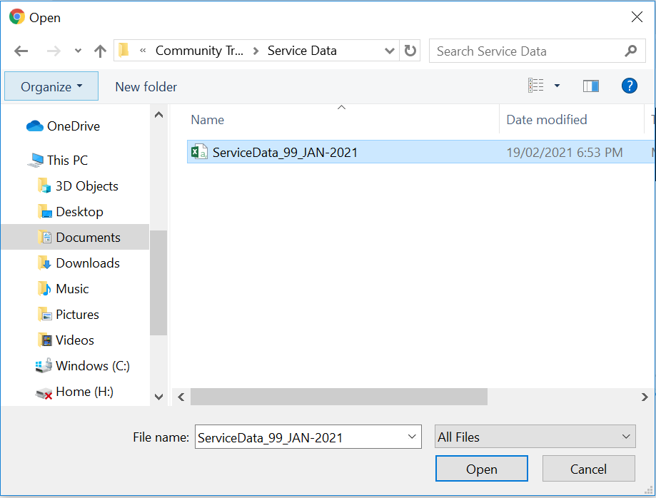
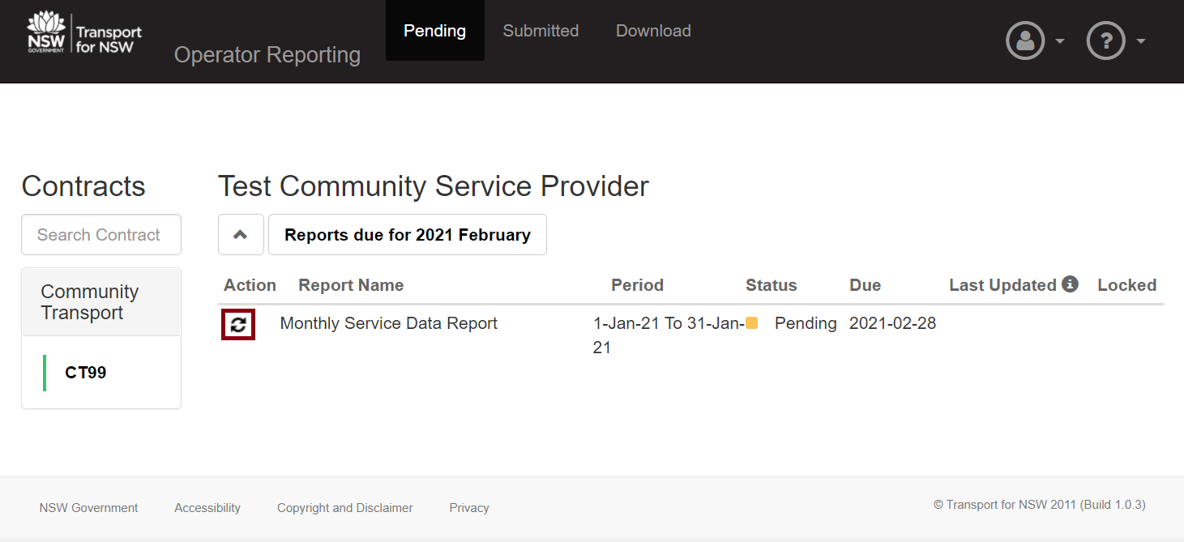
- The system will indicate that the upload progress in the Action column below.

- When a Report is uploaded the Report Status will change to Submitted.
- Hover the mouse over the Last Updated field to view the Username of the person who last updated the file.
NOTE How to know if the Monthly Service Data Report was Successful?
The only proof that the file has been successful is the email notification that is sent to the Service Provider’s registered email address following submission stating:
Successful file submission to the Community Transport Portal
The first stage of validation checks the Report for the correct filename, file format, column headings and ProviderID. If the Report contains errors the Status will change to View Errors. If no errors are detected the Status will change to Submitted. The Report will then progress to the next stage of validation to check each data field (see Community Transport Reporting Requirements for validation rules). If the Report contains data errors the system will send a Rejection email to the Service Provider highlighting the errors. If no errors are detected in the second stage the system will send a Successful email notification to the Service Provider.

Report Error
If a Report fails the validation test it will not be saved in the system.
- When the file fails the first validation test the Report Status will display is View Errors.
- Click the View Errors message.

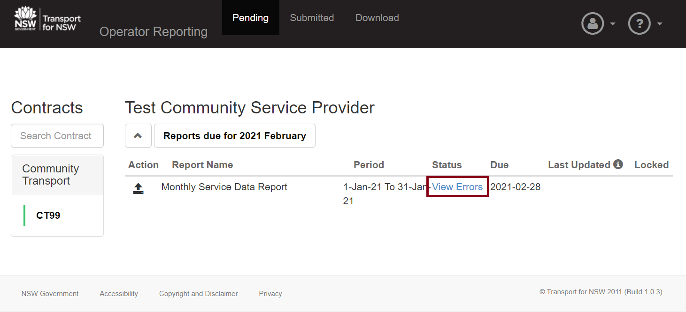
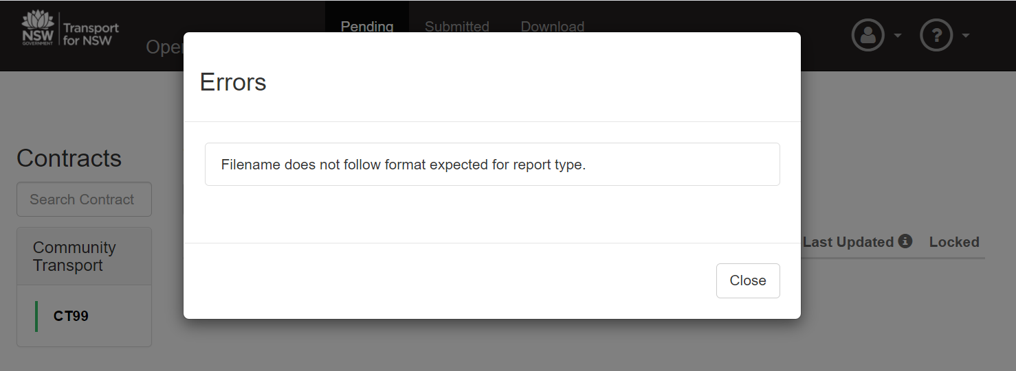
Below are examples of the error messages that may be encountered and the possible cause.
Error Message | Possible Cause
File cannot be empty | File rejected because it’s 0 bytes.
Filename does not follow format expected for report type. | File rejected because file name and/or type is not as specified in Community Transport Reporting Requirements document.
- Following submission of a Report to the Portal, an email notification will be sent to the service provider advising whether the report was successful or contains errors. Examples of email notifications are shown below:
- Successful file submission to the Community Transport Portal: Confirms that the Report successfully passed all validation rules (file, format, schema and data) and is lodged in the TfNSW data warehouse
- The report listed below is rejected by the Community Transport Portal. Please check that the data meets the file and data validation rules and resubmit the file: the rejected Report notification will identify error type:
- File format: Usual cause is opening and saving the CSV file in Excel prior to submission. Excel automatically reformats all dates, removes leading zeroes from cell values and discards the double quotation marks required around every field. Please refer to the User Guide for tips on working with CSV files
- Filename: Cause is an error in the filename, such as the format, reporting period or ProviderID
- File schema: Cause is an error in the columns and field headings in the file
- Data validation: errors detected in the data require a correction in the actual data submitted. Data error notifications are shown in an attachment to the error, highlighting the location and error for example:
- Row 617,TRIP_DISTANCE_KMS,Fields are not Numbers or do not have correct length or do not contain correct data
- Row 918,DEAD_RUNNING_KMS,Fields are not Numbers or do not have correct length or do not contain correct data
- Row 918,DROP_OFF_DATE,Mandatory Fields are blank
- Row 967;968;969,TRIP_PURPOSE, Invalid Trip Purpose
Re-submit a Report
NOTE Wait 5 to 30 mins to receive the email notification. Do not re-submit a Report until you have received the email notification for previously uploaded Report.
Re-submitting a Report will replace the previous version.
- To re-submit a Report click the Action icon next to the relevant Report.
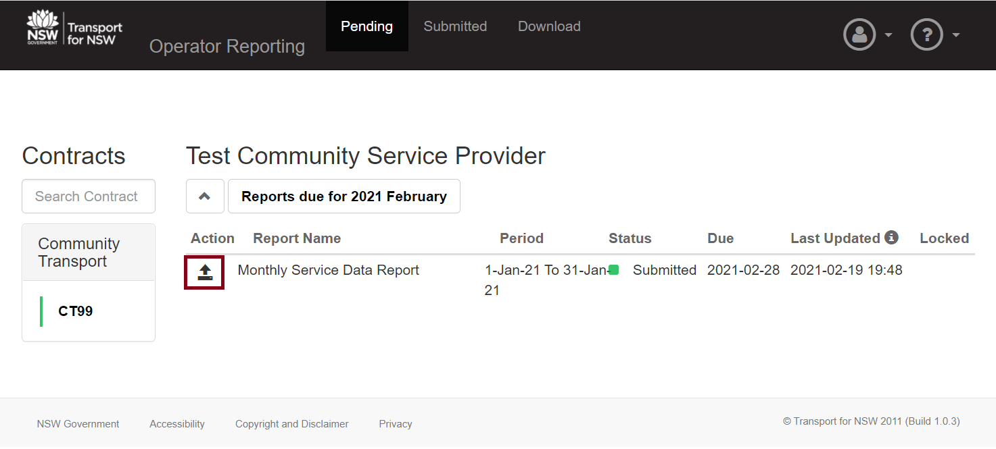
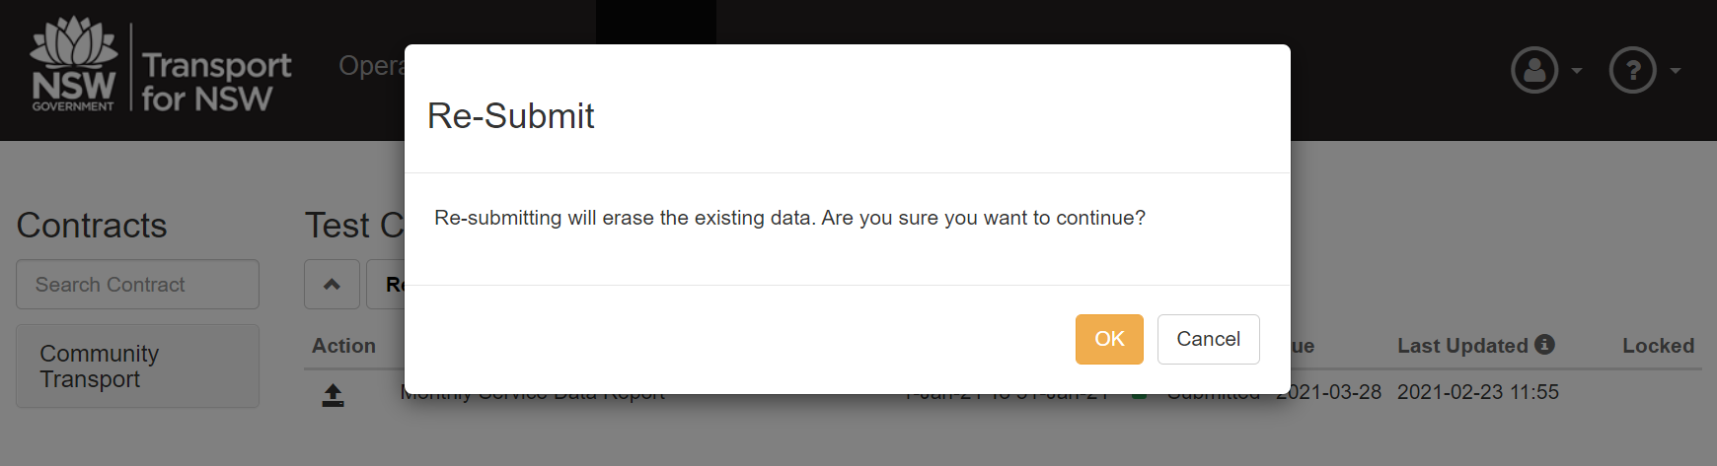

- Click the Action icon again to upload the new Report.
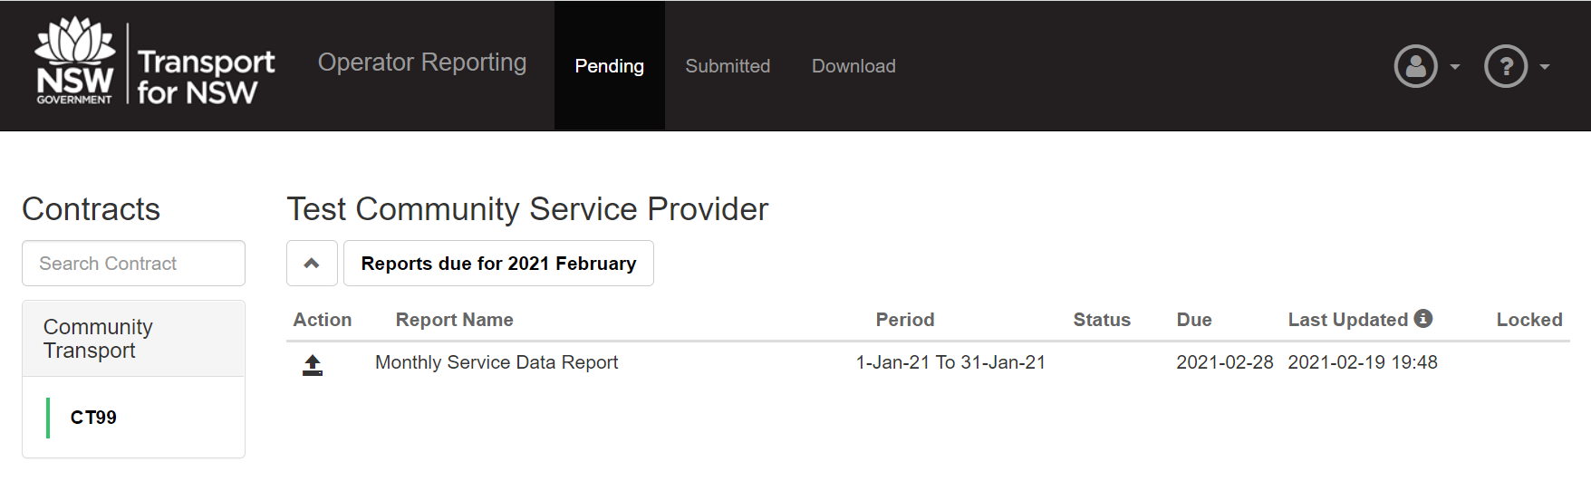

- Repeat steps 1-2 in Upload a Report.
Resubmit a report for a closed reporting period
Reports submitted for a reporting period remain open for re-submission until the end of the Due Date.
Beyond the Due Date all Report submissions for the previous month are locked including for any Reports that are outstanding.
Locked reports are identified by the tick symbol in the Locked column of the Pending and Submitted.
NOTE If a Report needs to be unlocked, it will be necessary to request the unlocking of the report with the Contract Manager responsible for the contract.
- To resubmit a report from a closed reporting period, talk to your Contract Manager to request the report be unlocked.
- Once the Contract Manager has confirmed that the report is unlocked, click the Submitted tab.
- Then click the dropdown list of Reports due for.
Remember when choosing the Reports due for to select the month after the file data. For example, select Reports due for 2021 April to upload March 2021 data.
- Follow the Re-submit a Report instructions to complete the re-submission.

Submitted Tab
The Submitted screen displays all uploaded or omitted submissions for the historical report submission periods (not for current period).
By default the Submitted screen displays the most recent reporting period that has finished.
To select a different period, follow the below instruction.
- Click on the Reports due for… text.
- Select the required period.
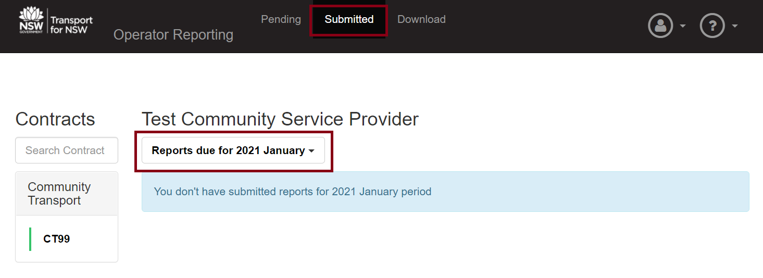

Download Tab
Reports that have been processed and are available for download.

To view and download the reports that have been generated from the data submitted in the self-reporting files

- Select the Download tab within ODIN.
- Double click on report name to download the file to your computer or laptop.
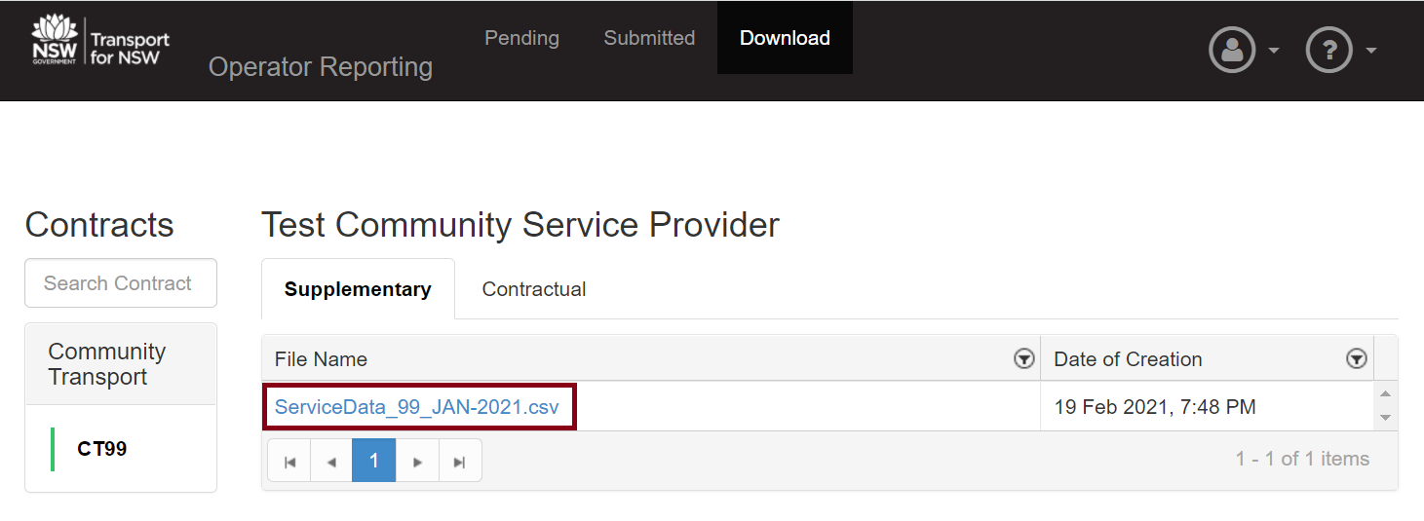

Key Performance Indicator (KPI) Reports
Please refer to the Community Transport Reporting Requirements for the KPI Reporting file and data validation rules. KPI Reports due dates to be uploaded to the Portal by 31 Aug and 28 February each year.
Before uploading a Report, first ensure that it conforms to the file and data requirements as per the Community Transport Reporting Requirements
Follow the below instructions for uploading KPI Reports to the Portal.
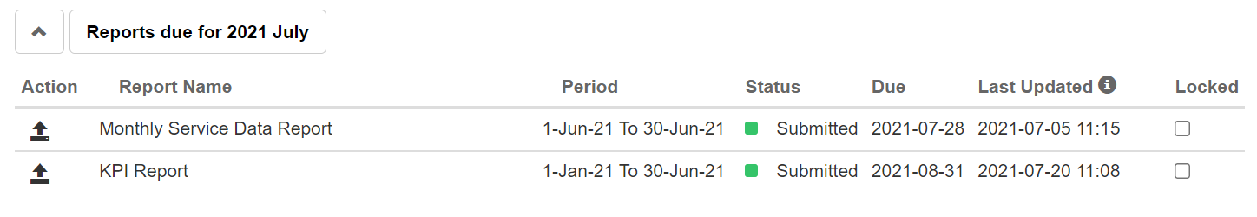
- Login to the Portal
- Select the Reports due for… The KPI Report Period will be for the 6 months prior (e.g. 2021 July or 2022 February)
- Click on the Upload icon to the left of Report Name
- When the Upload icon is pressed, a File Upload or Open dialog box will display.
- Navigate to the location where the file to be uploaded is stored on your computer or laptop.
- Select the document by clicking on the file.
- Then select the Open button.
Creating the KPI Report
Providers may create the KPI manually as shown in the Community Transport User Guide or use the KPI-CSV Maker which is a form-based tool designed to generate a correctly formatted CSV file.
The KPI-CSV Maker is located on the Community Transport web site. Providers can run the tool on the desktop:
- Download KPI-CSV-Maker.ZIP file from the Community Transport web site or send a request to your Senior Contract Officer
- Extract the file KPI-CSV-Maker.html and Save to computer
- Click on the KPI-CSV-Maker.html. The form will open in the browser. If for any reason the form does not load, drag and drop the file onto the browser.
- Complete each field making sure the end squares turn Green
- Click Generate and download KPI CSV
- Save the generated KPI CSV file to your computer
- Login to the Portal as shown above and upload the KPI CSV file exactly as it was downloaded to your computer*.
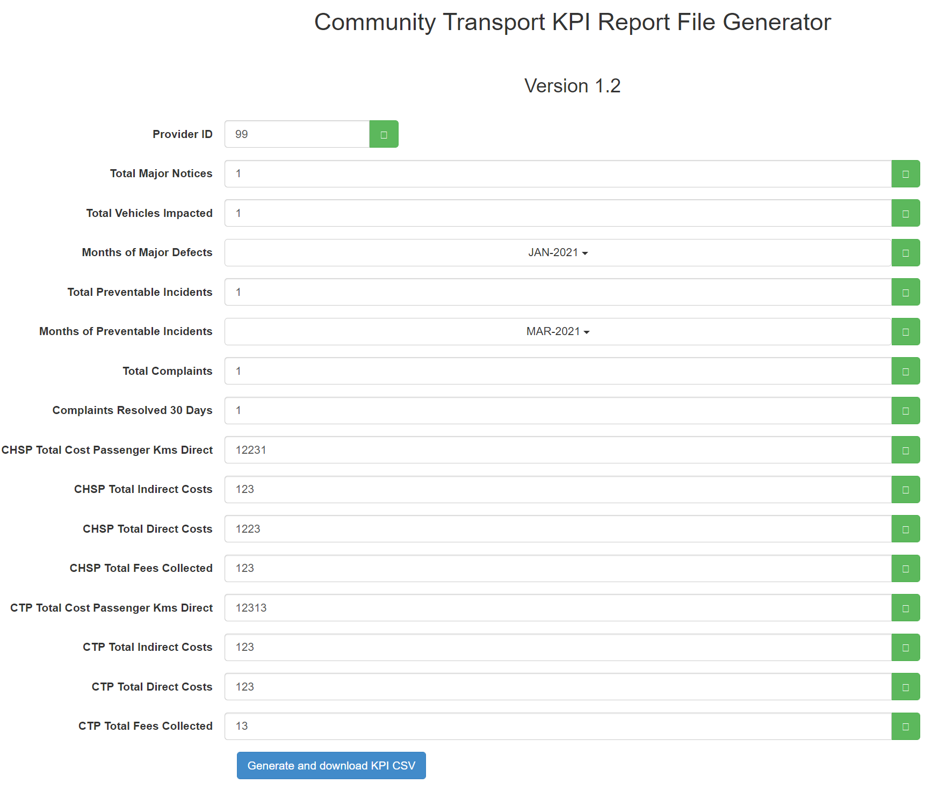
What is my ProviderID?
Your ProviderID is the number in the filename of your Monthly Service Data Report as shown in the example below.
The ProviderID is also found in the first data field within the Report. If you are new to Community Transport or unsure as to your ProviderID please contact your Senior Contract Officer.
*If you need to generate the KPI CSV file more than once, remember to remove any version changes added to the end of the filename when it is saved to your computer.For example, the first file generated filename is KPIData_99_JAN-2021_JUN-2021.csv. Subsequent files generated have the same filename but Windows will automatically append a space and version number to the file if it is saved within the same folder: KPIData_99_JAN-2021_JUN-2021 (2).csv. Remove the space and (2) before the .csv to avoid the Portal rejecting the file due to an unaccepted filename. This holds true for all CSV file uploads not just KPI files as the portal has strict validation rules for the filename format.

KPI REPORT REQUIREMENTS
The KPI Report has a new format. To make it easier to understand the data requirements in the new format, the requirements in the old KPI process (spreadsheet) are copied below.
The new format requires fewer KPI data points and these are highlighted below and included in the CSV Maker.
PLEASE NOTE: The KPIs below are as listed and described in Schedule 9 of your current CT Service Contract (Jan 2021 – June 2022).

KPI 1 - CONTRACT ASSET AND PROVIDER ASSET – MAJOR DEFECTS
This KPI aims to ensure that all Owned Assets are properly maintained and do not have Major Defects which potentially impact reliability and safety.
- Number of Major Defect Notices
- Number of Vehicles Impacted by Defect Notice(s)
- Months in Which Major Defect Notices Received

KPI 2 - PREVENTABLE ACCIDENTS
This KPI aims to ensure that all Service Assets are properly maintained and operated.
- Number of Preventable Incidents
- Months in which Preventable Incidents Occurred

KPI 3 - PERCENTAGE OF TRIPS DELIVERED TO ABORIGINAL AND TORRES STRAIT ISLANDER PEOPLE AND THEIR CARERS (Automatically calculated based on the Monthly Service Data Reports from 1 Jan 2021. Provider data entry not required.)
- Total Number of Trips to all CHSP Customers
- Number of Trips Delivered to Aboriginal and Torres Strait Islander People
- Number of Trips Delivered to the CARERS of Aboriginal and Torres Strait Islander People
- Percentage of Total Trips Delivered to Aboriginal and Torres Strait Islander People and Their Carers

- Total Number of Trips to all CTP Customers
- Number of Trips Delivered to Aboriginal and Torres Strait Islander People
- Number of Trips Delivered to the CARERS of Aboriginal and Torres Strait Islander People
- Percentage of Total Trips Delivered to Aboriginal and Torres Strait Islander People and Their Carers

KPI 4 - PROVIDER TRIP PERFORMANCE
This KPI measures the proportion of Funded Trips delivered by the
Provider. It is a new KPI that was not included in the previous KPI/APSDR Template. (Automatically calculated based on the Monthly Service Data Reports from 1 Jan 2021. Provider data entry not required.)

KPI 5 – CUSTOMER COMPLAINT RESOLUTION
This KPI requires you to ensure that 95 per cent of customer complaints are resolved within 30 Business Days of you receiving them. (This was KPI 4 in the previous KPI/APSDR Template.)
- Total Number of Complaints Received
- Total Number of Complaints Resolved within 30 Business Days of receipt
- Percentage of Complaints Resolved in 30 Business Days of receipt

KPI 6 - COST PER PASSENGER KILOMETRE – DIRECT
This KPI measures the cost of each Passenger Kilometre – Direct delivered to Eligible Customers (including carers). Passenger Kilometres – Direct means the number of kilometres of one way completed journeys provided directly by you to each Eligible Customer including each associated carer. This does not include:
- Trips provided by subcontracted transport service providers, such as taxis or other point to point transport services.
- Dead running (being the kilometres travelled when a vehicle is empty, for example from the depot to the first point at which a passenger is collected).

- CHSP Total Passenger Kilometres – Direct
- CHSP Total Cost of Delivering the Passenger Kilometres – Direct *
- CHSP Cost Per Passenger Kilometre - Direct

- CTP Total Passenger Kilometres – Direct
- CTP Total Cost of Delivering the Passenger Kilometres – Direct *
- CTP Cost Per Passenger Kilometre - Direct

* These values are sourced from your Accounting System. Please refer to Figure 1
below for an example of how this is calculated.

KPI 7 – DIRECT V INDIRECT COSTS
This KPI requires you to decrease the proportion of your costs that are Indirect Costs every six months, until your Indirect Costs are 15 per cent or less of your total costs.
DIRECT COSTS in relation to the provision of transport under any Program means costs that relate directly to delivering trips to Eligible Customers and their carers including:
- vehicle expenses such as brokerage fees, fuel, insurance, registration costs, maintenance costs, cost of tyres;
- the amounts paid to Staff involved in the direct delivery of services;
- booking and scheduling costs.
INDIRECT COSTS means your costs in relation to the provision of transport under each Program that are not Direct Costs.
In the context of this financial KPI:
- CHSP (Total) Indirect Costs *
- CHSP (Total) Direct Costs *
- Indirect Costs as a Percentage of Total Costs

- CTP (Total) Indirect Costs *
- CTP (Total) Direct Costs *
- Indirect Costs as a Percentage of Total Costs

* These values are sourced from your Accounting System. Please refer to Figure 1
below for an example of how this is calculated.

KPI 8 – PERCENTAGE OF FUNDING COLLECTED IN FEES
This KPI requires you to ensure that the percentage of Fees you recover from Eligible Customers for the delivery of CHSP/CTP Services:
- increases as a proportion of CHSP/CTP funding you receive every six months; and
- reaches an amount equal to at least 15 per cent of the Funding paid to deliver CHSP/CTP services by 30 June 2020.
- Total CHSP Funding
- Total CHSP Fees Collected
- CHSP Percentage of Funding Collected in Fees

- Total CTP Funding
- Total CTP Fees Collected
- CTP Percentage of Funding Collected in Fees

KPI 9 – REPORTING
This KPI requires you to ensure that all reports required to be provided under the Service Contract are available to TfNSW within the agreed timeframe. Any report which has material errors will be deemed not to have been received until a correct version is available. (Automatically calculated based on the Monthly Service Data Reports from 1 Jan 2021. Provider data entry not required.)
- Total Reporting Requirements as per 'Reporting Schedule'
- Number of Reporting Requirements NOT Submitted
- Percentage of Reporting Requirements Met

ADDITIONAL PERFORMANCE & SERVICE DELIVERY REPORT (APSDR)
(Automatically calculated based on the Monthly Service Data Reports from 1 Jan 2021. Provider data entry not required.)

FIGURE 1: SAMPLE DATA & CALCULATIONS FOR KPI-6 AND KPI-7

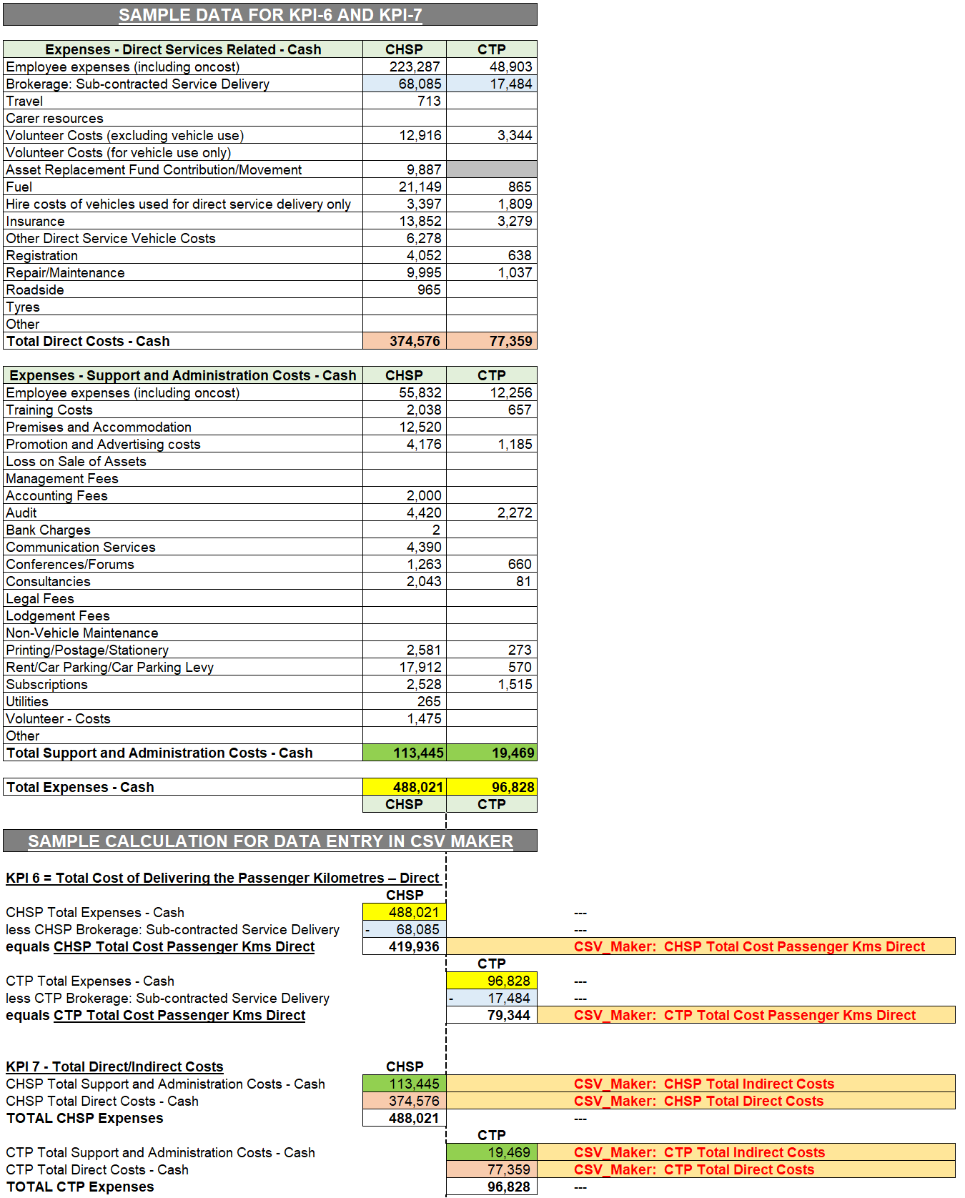

Help
For questions or issues relating to contractual reporting requirements please contact your Senior Contracts Officer.
For Portal assistance please raise an ODIN Request or Incident ticket by typing or copying and pasting the link https://otconnect.ot.transport.nsw.gov.au/sp?id=search&spa=1&q=ODIN into a web browser address bar.
Please use the email address that is associated with your ODIN account to login.

Documentation
Current versions of the Community Transport documentation can be found at https://www.transport.nsw.gov.au/operations/community-transport-operators#Resources

Appendix A – Reports List
List of reports required from Community Transport Service Providers:
NOTE: Refer to the Community Transport Reporting Requirements for detailed reporting requirements.

Ref | Report Name | Frequency | Period Covered | Due Dates | Count of Reports Per FY | Format
1 | Monthly Service Data Report | Monthly | Jan, Feb, Mar, Apr, May, Jun  Jul, Aug, Sep, Oct, Nov, Dec | 28th of next month | 12 | CSV
2 | KPI Report | Bi-Annually | Jan-Jun | 31 August | 2 | CSV
 |  |  | Jul-Dec | 28 February
NOTE: More reports will be added to this list

Appendix B – Sample Reports & Tips for working with CSV and Excel
Sample Monthly Service Data and KPI Reports are shown below to assist in the preparation of reports and provide advice on managing CSV and Excel files.
The following information illustrates the difference between viewing a CSV file in Notepad and Excel.
Sample files (templates) are available for download or upon request from your Contract Officer.
When you downloaded a sample file to your computer make of copy.
NOTE
To copy a file open File Explorer and select the file you want to copy by holding down the right-mouse button (or the alternate mouse button if you're using the mouse with your left hand).
When the context menu appears, select Copy.
Click into the white area, repeat the right-mouse action but this time click Paste. The file will be pasted above or below the original with – Copy appended to the filename.
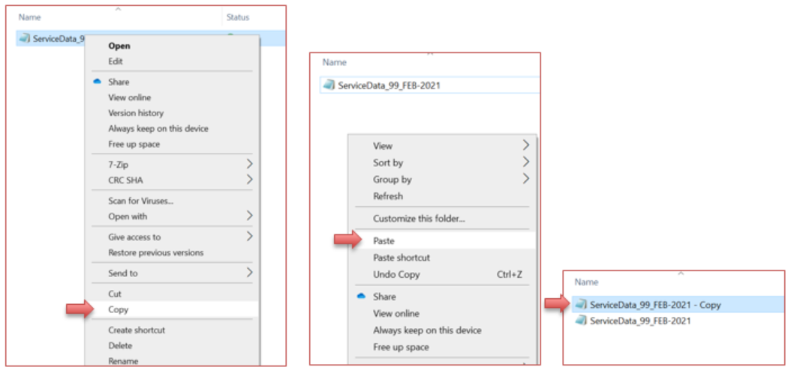
An alternative method is to select the item to copy and click Ctrl+C on your keyboard, then click Ctrl+V on your keyboard to paste it.

Viewing the Report
Open the original CSV file in Notepad to view the report in the format required by the Portal.
NOTE
To open the file in Notepad select the file by holding down the right-mouse button (or the alternate mouse button if you're using the mouse with your left hand).
When the context menu appears, select Open with and click Notepad.
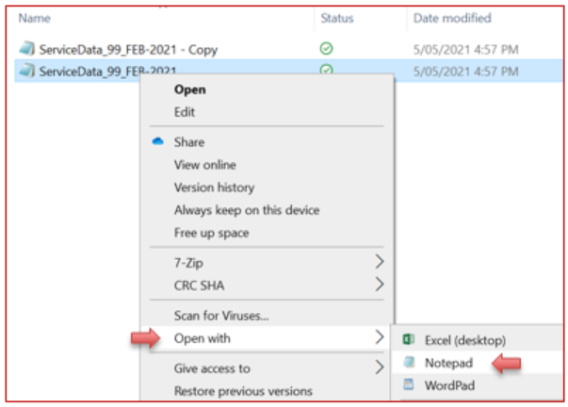
Notepad view
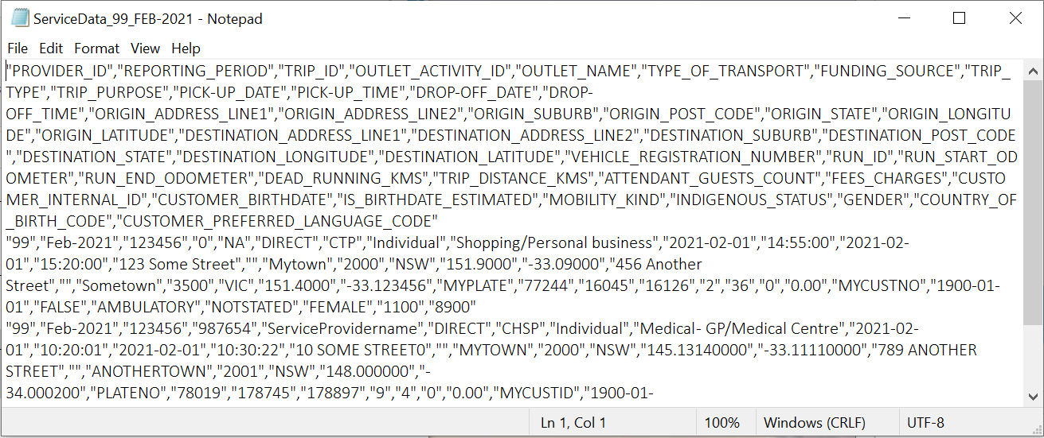
IMPORTANT! Notice that the formatting in the file requires double quotation marks “ “ around every individual field and that every field is separated by a comma.
Excel view
Open the Copy file by double-clicking the filename.
The Excel view provides a more readable experience but obscures the formatting.
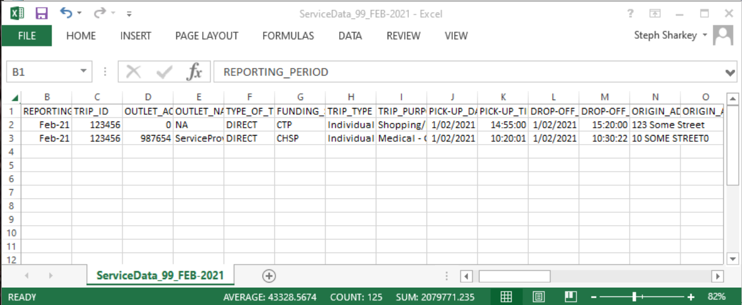
NOTE If the Copy file opened in Excel is subsequently saved, the prerequisite formatting will be removed and the file will no longer meet the validation rules of the Portal. Only the file that is in the original format will meet the Portal requirements.

Example of the CSV KPI Report
Notepad view
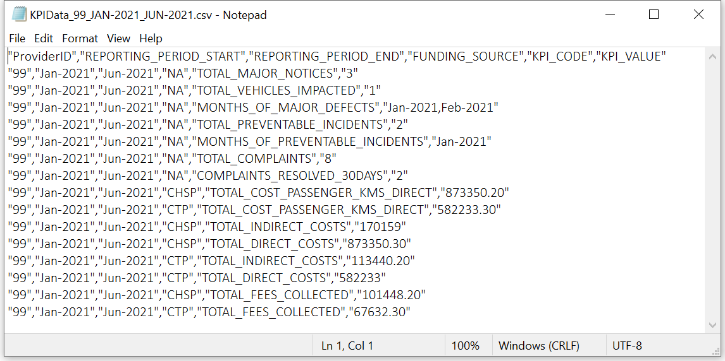
IMPORTANT! Notice that the formatting in the file requires double quotation marks “ “ around every individual field and that every field is separated by a comma.
Excel view
