Contract Management Plan
for Services for the RTA under the RMCC

<<Generic Shire Council>>
<<Long St.,>>
<<Generic NSW 2345>>

Printed copies of this document are uncontrolled

Note to RTA Team:
Text highlighted in grey is an MSWord field and should not be changed or deleted without careful thought.
Note to Council Documenter:
Text shown thus <<yellow>> has be changed to suit your Council.
Text highlighted in blue should be read and then removed before publication.
Text highlighted in grey is an MSWord field and should not be changed or deleted.
The text RTA OH&S Policy 2.15 was, as at 30 July 08 an hyperlink to RTA’s Remote or Isolated Work Policy. If the hyperlink is broken, the Policy should be obtainable by accessing:
http://www.rta.nsw.gov.au/ and then typing Remote or Isolated Work in the search box.
Delete this page including this ⬇ Page Break before publication.

About this release
Document Number: | <<GSC: CMP: RTA: RMCC>> Edition 1 / Revision 0
Title: | Contract Management Plan
Author: | <<XXXX>>

Ed 1 / Rev 0 | 1 October 2008 | <<New Plan OR Replaces Doc. No. OR ………….>> | <<Engineering Director>>
Issue | Date | Revision Description | Authorised by

Management Review
See Section 16 for details
Planned Review Date | Scope | Review By | Review Record  Ref no. Date
1 Oct 2009 |  | General Manager and <<XXX>>
1 Oct 2010
1 Oct 2011

Endorsement of CMP
______________________________ | / /
General Manager | Date
______________________________ | / /
<<Engineering Director>> | Date
______________________________ | / /
<<Position>> | Date

Table of Contents
About this release 3
Management Review 3
Endorsement of CMP 3
Table of Contents 5
1. Overview 6
2. Review of RMCC prior to Council’s acceptance 10
3. Scope of the Services 10
4. Determining RTA’s Requirements- Planning & Communication 11
5. Management of the RMCC 12
6. Price and Cost Management 12
7. Time related responsibilities 12
8. Continual Improvement 12
9. Quality Management 12
10. Risk Management 12
11. Procurement Management 12
12. Worksite Meetings 12
13. Communication, Document & Records Management 12
14. Reporting 12
15. Meetings 12
16. Reviewing this Contract Management Plan 12
Appendix A The Assets 12
Appendix B <<General Manager’s>> Checklists 12
Appendix C Hold Points & Witness Points 12
Appendix D List of Contacts 12
Appendix E Inspection: System and Records 12
Appendix F Risk Management Plan 12
Appendix G Community Relations Plan 12
Appendix H Communications and Reporting Plan 12
Appendix H.1. Preface 12
Appendix H.2. General 12
Appendix H.3. Internal Communications 12
Appendix H.4. External Communications ~ not RTA 12
Appendix H.5. Summary of Identified Records and Reports and Notifications to the RTA 12
Appendices I to L Not Used 12
Appendix M Definitions 12
Last page 12

[THIS PAGE DELIBERATELY BLANK]

Overview

Introduction
<<Generic Shire>> is in the <<XXX>> Region of NSW. It is bounded to the North by XXX, in the South by XXX and to the West by<<XXX>>. The local government area (LGA) has an area of approximately <<XXX>>km².
The <<XXX>>km road network in the LGA comprises State, Regional and Local Roads with a range of road users.
Council undertakes maintenance and servicing of Council Assets and construction of new infrastructure.
Council also undertakes these tasks for external clients, particularly the Roads and Traffic Authority, NSW (“RTA”).
The requirements for the construction, maintenance and servicing of RTA assets are set down in the Road Maintenance Council Contract (“RMCC”) between Council and the RTA. This contract includes specifications which provide much of the detail.
The works and services to meet these obligations are, for brevity, called the “Services” in Council’s RMCC Contract Management System. These will be supplemented by Work Orders which the RTA may issue from time to time.

Scope of this Plan
This Contract Management Plan (“CMP”) sets down Council’s overall management of the Services.
It includes Council’s:
- Risk Management Plan – see Appendix F,
- Community Relations Management Plan- see Appendix G - and
- Communications and Reporting Plan – see Appendix H.
It also provides a framework for Council’s RMCC Contract Management System which comprises the Management Plans shown below.
- the Contract Management Plan itself and the
- Quality Management Plan (which includes a Records Management Plan),
- Site Specific Safety Management Plan ( in this context, “Site” is the road network),
- Environmental Management Plan,
- Traffic Management Plan,
The following model plans will be obtained from the RTA and tailored to Council’s operations if they are required
- Rest Area Management Plan,
- Stockpile Management Plan,
- Landscape Management Plan and
- Vacant Property Management Plan
Should a conflict exist between any of Council’s Plans and the RMCC then the RMCC will prevail.

Purposes of Council’s Contract Management System
The purposes of Council’s Contract Management System are to:
- Set down Council’s management of the RMCC,
- Provide guidance to Council staff on Council’s obligations under the RMCC,
- Ensure that the RTA’s RMCC objectives are met and
- Assure the RTA that Council is fulfilling its obligations regarding the RMCC,
and to identify:
- All positions / roles which have responsibilities with respect to the RMCC,
- The responsibilities and authorities of the above nominated RMCC roles and
- The frequency and responsibilities of contract management review.

Council’s Objectives
Council is the steward of parts of the State Road Network within its LGA.
Council’s objectives with respect to the RMCC are to:
- Deliver to the RTA quality Services cost effectively, in an environmentally friendly way and to the RTA’s specifications,
- Ensure the health and safety of Council employees, subcontractors, all road users, the general public and RTA personnel who may be on or around work sites,
- Provide timely reaction to unplanned situations,
In order to achieve these objectives, Council will:
- Continuously improve work practices and methodologies;
- Adopt where possible best practice road maintenance procedures;
- Ensure pricing is transparent in the delivery of road maintenance services;
- Transfer knowledge between RTA and other councils in NSW via a Peer Exchange Group;
- Communicate openly, honestly and in good faith and
- Focus on value for money in the delivery of road maintenance.
Council’s objectives will be met through good leadership, commitment and continual training.

Principles of Project Management
The CMP has been developed bearing in mind the principles of good project management practice. It addresses the following key elements:
- Scope Management | - Risk Management
- Price & Cost Management | - Managing Community Relations
- Time Management | - Procurement
- Quality Planning and Management | - Resource Management
 | - Communication, Documentation and Reporting

Steps in Project Management - Overview
The main steps in Council’s Contract Management process are:
- Determining:
- What the client (in this case the RTA) wants by examining the contract documents, talking to the client and by site inspection (the joint inspection and the Joint Planning Assessment),
- How Council will carry out the Services,
- The resources (people, skills, systems, equipment etc) required,
- How long the Services will take,
- How much Services will cost and
- Determine the timing of cash flows.
Then either:
- Obtaining a Contract, in this case the RMCC.
This commits and funds Council to carry out the Services.
OR
- For Ordered Work for the RTA:
- Designing the Services
- Obtaining a Work Order.
Ordered Work brings with it additional funding and additional, special requirements for example separate specifications such as M250 Heavy Patch,
RTA 3061 Bound & Unbound Material for Road Maintenance.
Then:
- Planning and Organising: The <<Council Insert Position>> will then expand on the planning carried out above to ensure the team (Council and Subcontractors/ Suppliers) knows what has to be done and the resources required to do it. This results in the Road Maintenance Annual Plan [“RMAP]”), a budget and a Project Quality Plan (“PQP”). See Clause 4 for details.
- Resourcing: Consider whether the resources available are sufficient and supplement them where practicable
- Directing: Ensure Council has, and uses, the tools required to direct operations: team leaders, systems, standards, plans, communications, records.
- Doing: Carry out the Services,
- Controlling: Check to ensure the Services are proceeding to Plan and are of the required quality. Resolve any shortfalls.
- Record Keeping: Keep records to a) be able to show the Services have met the requirements and b) for future reference .
- Analysing: The <<Council Insert Position>> will analyse the work as it proceeds and on completion to discover if it can be improved. See the Quality Management Plan.
- Reporting and Communicating: Council will report, notify and communicate as set down in RTA M2 Annexure G and in the Community Relations Plan (Appendix G hereof) and the Communications and Reporting Plan ( Appendix H hereof).

Review of RMCC prior to Council’s acceptance
The General Manager and <<Engineering Director>> will review the RMCC to ensure Council can meet the obligations it is proposing to undertake.

Scope of the Services
Council has agreed to the scope of the Services under the RMCC. The list of roads to be maintained is reproduced in Appendix A of this CMP.
The Services will be undertaken by Council in accordance to the RMCC particularly the Intervention and Rectification Requirements specifications. The Services, where applicable, pertain to the following Services:
- Pavement Maintenance;
- Corridor Maintenance;
- <<delete if not applicable Maintenance of Rest Areas and Roadside Toilets>>,
- Drainage Maintenance; and
- Traffic Facilities Maintenance.
Generally, the Services include:
- Inspection of the Assets so as to identify Defects and Hazards.
- Appropriate response to all Defects and Hazards–whether Mandatory Activity Routine Services or Supplementary Activity Routine Services (see RTA M2 Annexure D.1) or Ordered Work (see RTA M2 Annexure D.2)
- Providing timely restoration of road network condition in response to unplanned situations
- Providing an Emergency and Incident response service including vehicles, stores and compounds
- Undertaking Services ordered by the RTA
- Negotiating with Utilities, RailCorp and other Authorities when their assets impinge upon Services
- Participating in the Joint Planning Assessment process and
- Reporting.
Delivering the Services requires of the Council:
- Risk Management – see Council’s Risk Management Plan at Appendix F hereto,
- Management of Relations with the Community – see Council’s Community Relations Plan at Appendix G and
- Communication within Council, with the RTA and with external bodies – see Council’s Communications and Reporting Plan at Appendix H.

Determining RTA’s Requirements- Planning & Communication
This section addresses Clauses 7.2 of ISO 9001:2000 and RTA Q4M. It complements Council’s Quality Management Plan.

4.1 Network Planning
As required by the RMCC, Council will carry out with the RTA annual joint network inspections and Joint Planning Assessments (“JPA”) – usually in March of each year. See RTA M1 Clause 3.1.
The <<Council Insert Position(s)>> will represent Council.
The purpose of the JPAs is to:
- Assess the condition and needs of the Road Network.
- Consider Services that improve road safety.
- Identify projects that may be required on the Road Network in the mid to long term (1 to 5 years).
- Provide an input into the development of the Road Maintenance Annual Plan.
The RTA will provide:
- by 28 February of each year of the Contract Term:
- the likely Fixed Upper Limit for the next Maintenance Period; and
- the indicative funding allocation for, and indicative time frames for performance of, Ordered Work, in the next Maintenance Period; and
- by 30 April of each year of the Contract Term, the actual Fixed Upper Limit.
Before the JPA is carried out Council will provide the following information:
- Historical information of maintenance treatments carried out.
- Expected global unit rates for various pavement treatments to assist in planning.
- Reports on maintenance accomplishment, from the accomplishment reporting system.
- List of outstanding Defects from the Maintenance Defects Register.
- Any new Work Proposals.
- Suggested priorities and potential future Work Proposals.

4.2 Road Maintenance Annual Plan
In consultation with the RTA Council will develop with as much precision as is practicable an annual program of works which is based on the particular needs of the Road Network and which is intended to reflect the anticipated (and achievable) work program and the funding available.
The RMAP will set down the nature and timing of the Services. It will follow the sample format in RTA M2 Annexure G.2 & G.3. It will include planned Routine Services (including Mandatory and Supplementary Activities) and their intended order of priority and indicative Ordered Works, taking into account:
- RTA's advice as to the indicative funds available,
- Any planning discussions with RTA regarding maintenance priorities,
- Council’s assessment of required Maintenance Activities, based on its own inspections and forward planning and
- Council’s resources and other commitments.
The RMAP will be agreed with RTA and ready for use at the beginning of each Maintenance Period. It will be reviewed and updated every quarter to reflect the currency of the planned activities. The updated RMAP will incorporate any changes in work priorities and include any major Ordered Work issued. Each update of the RMAP will have a different version number and will be retained in Council’s record management system.
The RMAP will be used to monitor the performance of the Services by comparing, on a quarterly basis, the actual expenditure and accomplishment with the plan. Council, by actively involving itself in the planning process, will seek opportunities to increase Supplementary Activities by coordinating them with other Services and by improving the cost savings in Mandatory Activities.

4.3 Inspection System
The RTA requires that Council systematically inspect each road to identify defects and subsequently to confirm that repairs have been done.
The <<Council Insert Position>> has prepared an Asset Inspection System for Council staff (RTA M1 Clause 3.3.6) to conduct inspections throughout the RMCC on each segment of road network. It encompasses:
- Routine Inspections to identify risks and all defects requiring repair (at the frequency in RTA M2 Annexure D.1.2) These inspections will include:
- Primary (daytime drive-by inspection),
- Night inspections and
- Critical site inspections, (RTA M2 Clause D.1.3).
- Recording Defects and incidents reported by the public.
- Providing a method for tracking compliance with the inspection requirements and Maintenance Intervention & Investigatory Requirements.
It will also provide robust evidence for use in court.
Council will arrange for additional inspections, as considered necessary or prudent following complaints, incidents or events that may cause damage to an asset (e.g. heavy rainfall).

4.4 Inspections, Defect Identification & Monitoring
A flowchart in Appendix E shows Council’s system and its records.
Accomplishment and other reporting will be made as required by the contract (eg RTA M2 Annexure G).

4.5 Work Orders - Customer Communication
The<<Council Insert Position>> is responsible for negotiating, obtaining and initiating Services on RTA Work Orders.
<<Council Insert Position>> will determine and review the requirements of the RTA and any additional requirements not stated by the RTA but necessary, in Council’s view, to make the finished product fit for its intended use and negotiate these with the RTA. (See ISO 9001 Clause 7.2).

Management of the RMCC
Council has warranted that it will provide people, materials, resources and systems to properly perform the Services.
Council and the RTA require the people to be competent, experienced and qualified to carry out the Services.
The RMCC Organisational Chart is: << General Manager: Please insert council’s RMCC organisation >>
 |  |  |  |  |  |  | General Manager
 |  | Record Keeping Representative |  |  |  |  | Engineering Director
Contract Manager
RTA RMCC
Quality Management |  |  |  |  | Environmental Management Representative |  |  |  |  | Site Safety Representative (West) |  |  |  |  | Site Safety Representative (East)
The names of the people holding these positions as at 1 October 2008 are shown in List of Contacts.

Responsibilities
The principle responsibilities and authorities of Council staff are:

General Manager
General Manager will:
- Manage a review of the RMCC documents as soon as they are available,
- Ensure what the RTA requires of Council – the Services – is understood,
- Review Council’s intended commitment before execution of the contract and
- Execute the contract if so authorised,
and throughout the RMCC’s term ensure Council’s delivery of the Services:
- Is properly planned, organised, directed and controlled,
- Is properly resourced with people, equipment, facilities and systems,
- Complies with all safety and environmental legislation,
- Complies with all other legislation and
- Is achieving its objectives.
And, if either Council or the RTA has given notice to the other of an Issue and it has not been resolved within 10 Business Days of the notice of Issue, meet with the RTA's Regional Manager and, acting in good faith try to resolve the Issue quickly.
The General Manager’s responsibilities remain with him / her, however, the General Manager has delegated as follows:
<<Council can re-allocate the responsibilities below as is appropriate to its organisation.
Every responsibility must be allocated to either a) a position shown below or b) to a position Council inserts below and inserts into the Organisation Chart.
If any responsibilities are missing from the Plan submitted to the RTA the Plan will be non-conforming>>.

<<Engineering Director>>
The <<Engineering Director>> has delegated authority from, and responsibility to, the General Manager for:
- The overall RMCC operation,
- Determining what the RTA requires of Council – the Services,
- Risk Management,
- Procurement Management including a) the selection of major subcontractors and suppliers and b) ensuring all subcontractors and suppliers meet the RMCC’s OH&S, QA and Environmental requirements,
- Ensuring that processes and control systems needed for Council’s network inspection, quality management, environmental and safety plans are established, implemented and maintained as stipulated,
- Identifying and planning special processes (including testing and surveying), arranging personnel and monitoring methods, regularly reviewing special process procedures,
- Approving PQPs (where required) for individual projects including those of subcontractors,
- Arranging and approving construction programmes including RMAPs, budgets and cash-flow estimates,
- Liaison with regulatory agencies regarding requirements for approvals licences, permits and authorities,
- Arranging and approving training,
- Applying the Key Performance Measures to monitor progress and costs against programmes and budgets,
- The performance of the team delivering the Services,
- Ensuring that the requirements of all the plans are properly implemented,
- Carrying out final review of all inspection/test results including those of subcontractors,
- Annually reviewing the continuing suitability, adequacy, and effectiveness, of all the plans,
- Community Relations including:
- Analysing community needs, expectations, issues, priorities and preferences and determining which can be accommodated,
- Addressing complaints about Quality, OH&S and Environmental Impact,
- Chairing Community Consultation Meetings and
- Communicating with the RTA Representative regarding the above.
- Being Council’s first 24 hour per day contact for safety and environmental incidents and emergencies on the Network and
- If either Council or the RTA has given notice to the other of an Issue and it has not been resolved within 5 Business Days of the notice of Issue, meet with the RTA's Senior Project Manager and, acting in good faith try to resolve the Issue quickly.

<<Council’s Contract Manager>>
<<Council’s Contract Manager>> is the authorised liaison person with the RTA on all matters associated with this RMCC.
<<Council’s Contract Manager>> has delegated authority from, and responsibility to, the <<Council Insert Position eg Engineering Director>> for:
- Day to day worksite management;
- Allocation of all resources required for the implementation of all the plans,
- Ensuring that the Quality, OH&S and Environmental control measures are maintained and that work-in-progress is inspected,
- Identifying training needs and arranging for employees and subcontractors to attend the training,
- Holding toolbox meetings and team briefings,
- In the absence of the Quality Management Representative, Site Safety Representative or Environmental Management Representative, for all their responsibilities,
- Ensuring subcontractors/suppliers have suitable qualifications and experience, and are inducted into project/worksite-specific requirements prior to commencement of work on site,
- Assessing and monitoring subcontractor’s capabilities and performance in respect of worksite activities,
- Ensuring materials, equipment and other goods are appropriately packaged and stored,
- Ensuring daily plant inspection is carried out and the plant is kept in safe operating condition,
- Carrying out receiving inspection on items purchased for the project,
- Determination of traffic control at the worksites,
- Reporting as required under the RMCC. See Appendix H.5 hereof,
- Implementing process controls developed for the Services;
- Managing Services so disruption and nuisance is minimised,
- Training site staff in the:
- on-the-spot handling of complaints and comments and
- use of the Complaints Register and
- advising RTA’s Traffic Management Centre of delays which are, or are anticipated to be greater than 15 minutes.
- Assisting the Engineering Director at Community Consultation Meetings.
- Being a back-up Council 24 hour per day contact for safety and environmental incidents and emergencies on the Network and
- If either Council or the RTA has given notice to the other of an Issue meeting with the RTA's Authorised Person and, acting in good faith trying to resolve the Issue within 5 Business Days.

<<Office Manager>>
<<Office Manager>> has delegated authority from, and responsibility to, the <<Council Insert Position eg Engineering Director>> for:
- Establishing a Complaints Register,
- Establishing a 24 hour telephone service to ensure prompt response to Hazards,
- Providing details of the complaints which are not within the scope of the Services to the RTA within 24 hours, together with the <<Engineering Director’s>> recommended actions (where appropriate) for dealing with the complaint,
- Managing the Complaints Register,
- Managing the 24 hour telephone service,
- Summarising the data from these for the <<General Manager and Engineering Director>>,
- Drafting, for the <<Engineering Director’s>> approval, and then placing the advertisements developed through the Community Consultation Procedure,
- Drafting, for the <<Engineering Director’s>> approval, advertisements, announcements and flyers to warn of impending traffic and access disruption and delivering or placing them and
- Designing signs for the projects for the <<Engineering Director’s>> approval.

<<Record Keeping Representative>>
The General Manager has nominated <<Council Insert Position>> to be Council’s Record Keeping Representative with delegated authority from, and responsibility to, the <<Council Insert Position (GM or Engineering Director)>> for ensuring that Council’s Record Management Plan is fully implemented for the Services under the RMCC and to be Council’s authorised contact person for communications with the RTA on record keeping matters.
Their responsibilities, which are detailed in the Records Management Plan (“RecMP”), include filing, indexing, storage, movement, retrieval and disposal of records. This person is fully conversant with the RecMP, the record keeping system and progress with hand-over of Identified Records and will promptly provide access to or copies of records to the RTA as required.

Nominated Positions
As required by the RMCC Clause 2.2 and as shown in the organisation chart, the General Manager has nominated the following:
- A person who is authorised to act with Council’s full authority in all matters in relation to the RMCC.
- A Quality Management Representative. See RTA Q4M Clause 5.5.2,
- A Safety Representative. See RTA G21M Clause 4.1 and
- An Environmental Management Representative. See RTA G34M Clause 4.2.

Quality Management Representative:
The General Manager has nominated <<Council Insert Position>> to be Council’s Quality Management Representative (“QMR”) with delegated authority from, and responsibility to, the <<Council Insert Position (GM or Engineering Director)>> for the maintenance of the QMP.
The QMR’s responsibilities are set out fully in the Quality Management Plan.
The QMR is also responsible for creating and keeping current Council’s List of Contacts. See Appendix D.

Safety Representative
The General Manager has nominated <<Council Insert Position>> to be Council’s Safety Representative with delegated authority from, and responsibility to, the <<Council Insert Position (GM or Engineering Director)>>for ensuring that Council’s Occupational Health and Safety Policy and Council’s Site Specific Safety Management Plan are fully implemented for the Services under the RMCC.
The Safety Representative is to keep Council management informed of all issues relevant to the OH&S System.
The Safety Representative is a point of contact within Council on these matters and is particularly responsible for communicating with the RTA Representative on all OH&S related issues.
The Safety Representatives responsibilities are set out fully in the Site Specific Safety Management Plan.

Environmental Management Representative:
The General Manager has nominated <<Council Insert Position>> to be Council’s Environmental Management Representative with delegated authority from, and responsibility to, the <<Council Insert Position (GM or Engineering Director)>> for ensuring that Council’s Environmental Policy and Council’s Environmental Plan are fully implemented for the Services under the RMCC.
The Environmental Management Representative is to keep Council management informed of all issues relevant to the Environmental Plan.
The General Manager has nominated <<Council Insert Position>> to be the authorised contact person for communications with the RTA and the Department of Environment & Climate Change (DECC) on environmental matters.

Price and Cost Management
Council will undertake price and cost management under this RMCC in accordance with Council’s accounting system.
The Services will commence only after RTA authorisation – except in the case of Incident and Emergency Response.
Each Claim for Payment for Ordered Work will be accompanied by progress report (quantities and costing details) and records of conformance.
Under the RMCC, Council’s prices for Services include the cost of everything associated with or necessary for the Services.
Council Staff will complete appropriate documentation in accordance with RTA requirements so that payment claims can be processed.
Variations to Services will be negotiated between Council and RTA depending on prevailing circumstances.

Time related responsibilities
Council will:
- in Meeting, Reporting and Notification:
Meet the timing set down in Appendix H.5
- in Setting up for the Services
Mobilise resources within the specified time for any additional Services ordered by the RTA.
- in Planning the Services:
- Carry out annual Joint Network Inspections (“JNI”) , usually in March each year.
- Following the JNI each year, carry out a Joint Planning Assessment (“JPA”). See RTA M1 Clause 3.1.
- Carry out regular day and night inspections.
- in Performing the Services:
- Commence the Routine Maintenance on 1st October 2008.
- Not proceed beyond any Hold Point until it is released.
- Identify, respond to and rectify defects within the times specified by the Intervention Standards
- Achieve the Time for Completion stared on the Work Orders for works or Services.
- Meet the Response Times specified each type of work or service including Emergencies and Incidents.
- in Community and Road User Relations:
- Notify residents and businesses affected by disruption to property access or by night works in built-up areas. A letter will:
- be “letter-box-dropped” at least three Business Days before the proposed date and
- detail the dates and times of the proposed access restrictions and contact details.
- Perform Services only in the times permitted. See RTA G34M Clause 4.7.
- in Safety:
Council will:
- Immediately remove from the worksites and Services any non-compliant plant.
- Conduct health and safety inspections at least weekly to identify hazards associated with Services performed under the RMCC. This included Services done by subcontractors.
- Review monthly the Risk Assessment and Risk Control Plan (or earlier if there has been an injury, if the Services is to be changed or if is thought to be invalid). See G21M Clause 4.

Continual Improvement

8.1 General
Council is committed to continual improvement of its Performance and its Contract Management System and the Management Plans of which it is comprised. To this end it is expected Council and the RTA will work together as a team to achieve continual improvement in working procedures, the product and in contractual arrangements.
Continual monitoring of the Services and reporting of incidents and non-compliance within Council’s Systems, Plans and this Contract Management Plan will contribute to this improvement.
Improvements will be aimed firstly at those areas where the quality, OH&S or environmental risk is greatest and, wherever possible, such improvements will set measurable targets to allow clear monitoring of results.
In seeking continual improvement, Council will consider any new technologies available and will analyse the Key Performance Measures.

8.2 Key Performance Measures
Council will asses its performance in providing the Services – are the Services:
- Being adequately planned and coordinated;
- On time and within budget;
- Adopting process improvements; and
- Delivering value for money?
Council will, if its performance is not in accordance with the requirements of the Contract, implement process improvement.
Key Performance Measure (KPM) reports will be submitted each quarter and also annually. The reports are based on KPMs and Targets including criteria such as timeliness, value for money, forecasting accuracy and compliance with Quality, Safety, Traffic Management and Environmental requirements. Council will use methodology of RTA M2 – Annexure E.

8.3 Improvement of this Contract Management Plan
The <<Council Insert Position>> is responsible for updating/amending the CMP and the associated Plans following any corrective action and having those changes approved and distributed.
Particularly, if Council’s CMP and other associated Management Plans:
- Do not adequately address the Specification requirements; or
- Are causing nonconformity; or
- Have to be revised as a result of an audit; or
- No longer represent the current and/or appropriate practice, or
- The scope has changed.
Council will immediately implement changes.
The revised document and the input which led to the changes will be reviewed by Council’s General Manager, approved by him/her and then forwarded to the RTA Representative for his/her record.
In addition, Council’s <<General Manager or Engineering Director>> will overview the operation of the RMCC as set out in Clause 16 and using the checklist in Appendix B.

Quality Management
Council has warranted it will deliver the Services through an approved Quality Management Plan which complies with RTA Q4M.
Council management is familiar with Council’s QMP and will use it as a basis for internal auditing and surveillance of Council’s operations.
The <<Council Insert Position>> will develop audit and surveillance checklists which will be based on Council’s QMP.
Council anticipates the RTA contract management team will use Council’s QMP as the primary guide to ensure that Council achieves consistency and best practice in terms of the Quality of Services delivered.
When requested by the RTA for the purposes of RTA audits and surveillance, Council will provide:
- Additional controlled copies of the Quality Manual, Project Quality Plan(s) and associated quality management system documents and
- Records, access to the Services and assistance to allow the RTA to carry out validation of RTA supplied designs.
Council will make suitable facilities available at the site to accommodate an audit team of three persons. The cost of providing such facilities will be borne by Council.

Risk Management
Council recognises it is responsible for managing the risk associated with its operations. Council’s Risk Management Plan, which is incorporated as Appendix F, addresses the risk management process namely:
- Identification of potential risk,
- Analysis of likely frequency and consequences,
- Establishment of the level of risk,
- Determination of the strategies to manage or reduce the risk,
- Determination of the most appropriate method to manage risk and
- Monitoring the effectiveness of Risk Management
Risks in OH&S, Environmental Protection and Traffic Management are addressed separately in the corresponding Plans.

Procurement Management
Council will carry out the procurement of materials and Services in accordance with RTA Q4M and the task specifications, for example RTA M250 Heavy Patch and RTA 3061 Bound & Unbound Material for Road Maintenance.
In following the principles of sound project management, the <<Council Insert Position>> will:
- Determine RTA’s requirements.
- Establish agreed procurement processes with the RTA Representative.
- Conduct procurement processes which establish common goals and minimise uncertainty.
- Review progress, resolve conflicts and achievements of project objectives within the legal framework of the RMCC.
- Manage RMCC finalisation procedures to ensure RMCC deliverables meet contractual requirements.
Council recognises that subcontracting (whether approved or not) does not relieve Council of any of the requirements, liabilities or obligations under the RMCC. Accordingly, it will:
- Ensure subcontractors have, and fulfil, the same quality, safety, environmental and record keeping responsibilities that Council has to the RTA.
- Ensure the right of the RTA:
- To monitor, audit, inspect, test and sample subcontractor’s management systems and plans, products, designs and activities and
- To inspect and copy records and report on the subcontractor’s performance.
Furthermore, Council will ensure that all its subcontractors and all workers employed in carrying out the RMCC are fully paid money properly due and payable to them in connection with the RMCC under relevant awards, contracts and enterprise agreements.

Worksite Meetings
Toolbox talks for employees and subcontractors will be held on a <<weekly>> basis. These will be supplemented with regular planned safety meetings as well as OHS committee meetings.
Topics will include current OH&S and Environmental issues.

Communication, Document & Records Management
Council will meet its obligations regarding the communications, document and record management functions in accordance with its approved Communication Management and Records Management Plans. The <<Council Insert Position>> will ensure that Council implements these functions by:
- Planning the communication process by identifying, documenting and analysing the information requirements to ensure the quality, validity and timeliness of information and communication.
- Maintaining a Complaints Register and 24 hour telephone service.
- Guiding the application of information management by generating, gathering, storing, retrieving and disseminating information which will help the <<Council Insert Position>> manage the decision making process.
- Implementing project reporting processes by establishing agreed communication networks between Council, RTA and other stakeholders and
- Periodically reviewing the outcomes and objectives to determine the effectiveness of management information and communications processes.
Council anticipates Council documentation & records relating to the RMCC will be scrutinised by the RTA at reasonable intervals.

Reporting
Council with report and notify as set down in this report including as set out in Appendix E. The reports and notifications to the RTA are summarised in Appendix H.5.

Meetings
Council and a representative of the RTA will meet as set out in RTA M2 Annexure F.2.
Within one week of the meeting, Council will receive a copy of the minutes of the meeting. Within 3 Business Days of the receipt of the copy of the minutes, Council will notify the RTA of any item from the meeting that in our opinion has not been correctly recorded.

Reviewing this Contract Management Plan
In addition to the revisions set down at Clause 8.3 this CMP will be regularly reviewed.
The planned target dates (or frequencies) at which this will take place and the personnel who will participate in the review are identified in the table at Management Review at the beginning of this plan. Council’s <<insert position>> will maintain records of any review.

- The Assets

A. 1 List of roads
Road No. | Road Name | From | To | Maintenance Category | Generic Nominal Work Limit | Built-up Area (Yes / No)
 |  |  |  |  | e.g. Motorway
 |  |  |  |  | e.g. Formation
 |  |  |  |  | e.g. Kerb
 |  |  |  |  | e.g. Lane

A. 2 Map of roads
<<Insert maps>>

Further details are set down in RTA M2.

- <<General Manager’s>> Checklists

Organisation, Responsibility & Employment Conditions

ITEM | PROMPT | COMMENTS | NCR | CAR
Are the positions on the organisation chart current | Check
Do all positions on the organisation chart have a corresponding Job Description | Check
Have employees sighted them | Seek evidence
Is Council complying with NSW Industrial Relations Guidelines? | Seek Evidence

Training

ITEM | PROMPT | COMMENTS | NCR | CAR
Are the training requirements identified and current:  OH&S  Quality  Environmental | Check training matrix / charts
How does Council know which staff have the appropriate skills and qualifications | Check training matrix / charts
Are all staff identified on the Training Register | Verify
Have separate training records been retained – if so, where are they | Individual training records - verify
Are the training records current | Verify
Do we have proof of training conducted | Check training records
Are Council’s training requirements discussed with individual employees | Randomly check employees

Complaints & Problems

ITEM | PROMPT | COMMENTS | NCR | CAR
Is all nonconforming material / equipment labelled appropriately | Check
Have all employees been informed as to their responsibilities regarding immediate action on problems, customer feedback and suggestions | Check training records  Randomly check employees about relevant responsibilities
Are all employees informed about the correct procedures required to handle customer complaints | Check training records  Are any easy reference charts / guides available
Have there been any accidents since the last Audit. If so, have all Accident Reports been reviewed and forwarded to RTA within 5 working days | If required, check Accident Report Forms
Have all corrective procedures been documented for future reference | Check records
What procedure is used to investigate and action CARS issued by the RTA and to ensure the RTA is advised of the appropriate action within 7 days | Check records  Ask staff to explain how corrective actions have led to prevention of recurrence of problem

Service Delivery Standards

ITEM | PROMPT | COMMENTS | NCR | CAR
How is customer satisfaction monitored | Surveys  Ask individual customers  Assess number of complaints
Have any customer surveys been conducted since the last audit | Seek evidence
How does council organisation ensure all staff are adhering to the Service Delivery Standards | Has the organisation kept a record of complaints

Operational Procedures

ITEM | PROMPT | COMMENTS | NCR | CAR
Have Induction checklists and training records for all staff been completed and appropriately signed and endorsed | Check records
Have all maintenance records been completed and appropriately signed and endorsed | Check records
Have all Supervisors been instructed and trained in the supervision of subordinates including:  - quality of Services  - safety of work practices  - environmental considerations | Check training records  Randomly check staff –
How does the organisation control the quality of its operations and Services | Refer work instructions

Equipment Maintenance

ITEM | PROMPT | COMMENTS | NCR | CAR
Are all daily, weekly and fortnightly inspection and maintenance records being completed and verified | Check records
Have any equipment defect reports been generated since the last audit | Check records
When was the last check of safety items conducted by Council | Check records and record date

Prior to Review by RTA

ITEM | PROMPT | COMMENTS | NCR | CAR
Have previously identified deficiencies been rectified | Check records
What corrective action has been taken to ensure deficiency does not reoccur | Check new procedures
Have all CARS been sent to RTA Representative within 7 days and has a list of completed CARS been retained by Council | Check records and dates
Has results of RTA Review been discussed with relevant staff by Council | Randomly check employees knowledge of previous report
Have all Audit / Surveillance Visits Reports been retained by Council | Check records
- Hold Points & Witness Points
Reference in this CMP | Type  Hold or Witness | Process Held | Submission Details
Appendix G.3.3 | Hold | Start of Services which have any significant impact on any community. | Stakeholder consultation strategy and plan to RTA Representative for approval.
Appendix G.3.7 | Hold |  | Changes to Project Plan to accommodate community expectations, issues, priorities and preferences.
Appendix G.3.9 | Hold |  | Community involvement and communication programme to the RTA Representative.
Appendix G.3.12 | Witness | Placement of advertisements | Draft of advertisements and placement schedule to RTA Representative.

- List of Contacts

Council’s RMCC contact list
Name | Position | Day-time Contact No. | Mobile phone No.
<<Erika Mustermann> | <General Manager
<<Fred Bloggs>> | <Engineering Director>
<<Jock MacGuffin>> | <Contract Manager>
<Wilhelmina Smith> | <Ganger-North>
<Ola Nordmann> | <Ganger-South>
<Ay Nother > | <Safety Representative>
<Heidi Normalverbraucher >> | <Environmental Representative>
<Tomasina Cobley> | <Quality Management Representative>

RTA RMCC contact list
Name | Position | Day-time Contact No. | Mobile phone No.

Other key contacts including subcontractors
Name | Position | Day-time Contact No. | Mobile phone No.

Emergency contacts
Name | Position | Day-time Contact No. | Mobile phone No.
<<Fred Bloggs>> | <<Engineering Director>>
<Ay Nother | <Safety Representative>
<Heidi Normalverbraucher >> | <Environmental Representative>
<Alex MacGuffin>> | <Contract Manager>
<<Add Ambulance, Fire, Police, HAZMAT, DECC, Spill Response Organisation, other Council people, major subcontractors etc>>
- Inspection: System and Records
- System Outline
Additionally: Incidents will be registered and the response to them recorded and
Vehicle Removals and Accidents/ Vandalism recorded. See Appendix E.9 to Appendix E.10.

- Routine Inspection Frequency

Type of inspection | Measurement | Inspection frequency for each Maintenance Category
Type of inspection | Measurement | I | II | III | IV
Carry out daytime inspection of the Assets (excluding off-road cycleways): | Nominal frequency | Twice per week | Once per week | Once every 2 weeks | Once per month
Carry out daytime inspection of off-road cycleways and access roads defined in Annexure C.1: | Nominal frequency | Once per month | Once every 2 months | Once every 3 months | Once every 4 months
Carry out night time inspections of the Assets each year during: | Time of year | March and November | March and November | November | November
Carry out inspections on specific assets defined in Annexure C. | Reference | Annexure C | Annexure C | Annexure C | Annexure C
Carry out inspections relating to critical sites at the frequency specified in: | Reference | --------------- In accordance with RTA M2 Annexure D.1.3 ---------------

- Inspection Calendar Record

- Defect Identification Record
Defect Identification Record <<Generic Shire Council>> 
Certification: The inspecting officer certifies that this inspection has been carried out in accordance with the RTA’s requirements.
Name Position Transferred by: Name Position
- Work Schedule Record

- Maintenance Defect Register Report
Road No. | Location | Defect No. | Defect Code | Date Defect Identified | Defect Due Date | Defect completion date | Quantity
Road number | Location reference | Unique Defect identifier | Use Defect Code in relevant Intervention and Investigatory Levels Specification | Date defect identified | Date Defect must be repaired in accordance with Intervention & Investigatory Levels | Date Defect item of work completed | Estimated extent of Defect

- Daily Work Record
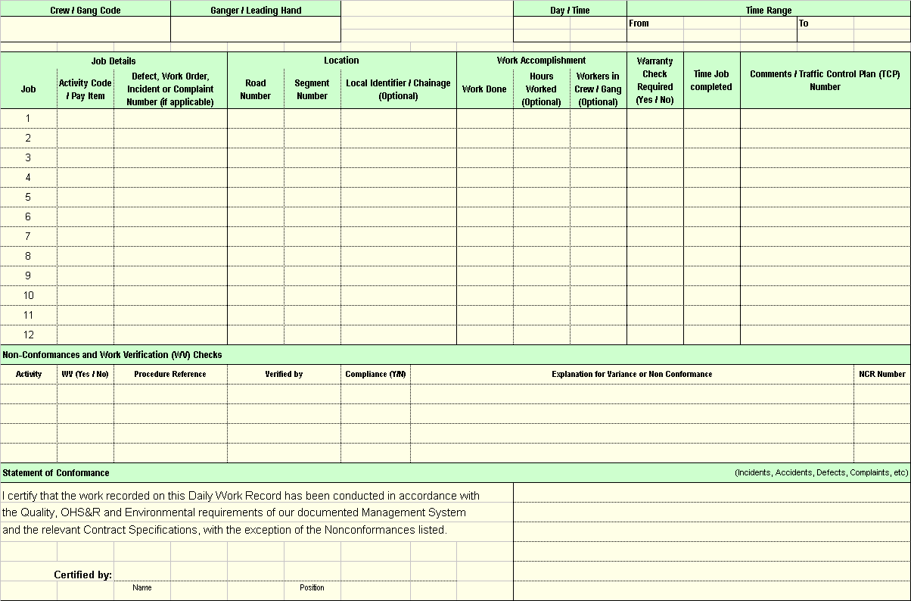

- Accomplishment Reports
Simple
Maintenance Activity Code | Maintenance Activity Description | UOM | Accomplishment for each quarter |  |  |  | Year to date
Maintenance Activity Code | Maintenance Activity Description | UOM | Q1 | Q2 | Q3 | Q4 | Work done | Person Hours
Item code describing the work undertaken. Include all work related to the Services. | Description of the activity as per Annexure D. | Units of measure (eg. m²). | Work done in first quarter | Work done in second quarter | Work done in third quarter | Work done in last quarter | Total work done year to date. | Person hours spent on activity
Notes: | - Refer to RTA M2 Annexure D for Maintenance Activity Codes.  - An Accomplishment Report must include all activities related to the Services: Routine Services, Incident Response Works and Ordered Work.

Detailed
Maintenance Activity Code | Maintenance Activity Description | UOM | Road Number | LGA | Location Reference | Work done | Person Hours
Item code describing the work undertaken. Include all work related to the Services. | Description of the activity as per Annexure D. | Units of measure (eg. m²). | Road number where work performed. | LGA number where work performed. | Location of work. Typically the segment number. | Work done in period. | Person hours spent on activity during period
Notes: | - This report shows the total accomplishment for each segment (for the time period requested). Reporting period is typically the 12 month of the financial year.  - An Accomplishment Report must include all activities related to the Services: Routine Services, Incident Response Works and Ordered Work.  - Refer to RTA Annexure D for Maintenance Activity Codes.

- Incident Register
- Incident Response Form
- Vehicle Removal Report (Unattended & Abandoned Vehicles)

- Accident / Vandalism Report

- Risk Management Plan
- Preface
Risk Management defined
“Risk” itself is the chance of something happening. Its impacts can be either negative or positive eg they can range from injury to an employee to unexpected favourable weather.
Risk Management is a systematic approach to the management of events that might occur and which would have an effect on Council’s and the RTA’s objectives.
Scope of this Plan
The Risk Management Plan deals with the process of risk management in delivering the RMCC.
Although Risks in the vital areas of OH&S, Environmental Protection and Traffic Management are addressed separately in the corresponding Plans, the process of Identification, Evaluation and Treatment is the same for all and all will be entered in the Risk Management Register. Note that for auditting convenience the Site Specific Safety Management Plan reiterates the process.
Council’s Objectives
Council’s objective is to achieve an appropriate balance between realizing opportunities for gains while minimizing negative impacts and losses.
Purposes of Council’s Risk Management Plan
Council’s aim is to manage the risk associated with its operations. This will not only reduce harm but also deliver benefits for Council and the RTA:
- Fewer surprises,
- Improved planning, performance and effectiveness,
- Improved estimates and cost control,
- Better stakeholder relationships and
- Better outcomes.
Risk Management Process Overview
Based upon AS/NZS 4360 – 2004, Council summarises the process thus:
- Risk Analysis
The<< General Manager and Engineering Director and the Safety and Environmental Management Representatives>> will, in the context of the objectives set down in the Contract Management Plan:
Establish the context
- Identify the stakeholders, among them being Council and the RTA, Council employees, subcontractors, all road users and the general public.
- Define the basic parameters within which risks must be managed and set the scope for the rest of the risk management process. The context includes Council’s external and internal environment and the purpose of the risk management activity.
Identify the Risks
The<< General Manager and Engineering Director>> will determine:
- What might happen during each routine activity and each major project that would affect the RMCC’s objectives and
- How would these events arise.
Evaluate and Register each Risk taking the following three steps to do so:
The<< General Manager and Engineering Director>>:
- Will estimate the Likelihood Rating of each risk and the Consequence Rating of each risk using a simplified High / Medium / Low scale for both Ratings.
- They will then combine the above to determine the Risk Rating of each risk using Table 1 as a guide.
Note: If the situation is too complex to be evaluated by this simplified process, the process and matrices set down in AS/NZS 4360 – 2004 will be used
Table 1
 |  | Consequence Ratings
 |  | Low  ⬇ | Medium  ⬇ | High  ⬇
Likelihood Ratings | Low ➔ | N | L | M |  ⬆   Risk Ratings
Likelihood Ratings | Medium ➔ | L | M | H |  ⬆   Risk Ratings
Likelihood Ratings | High➔ | M | H | E |  ⬆   Risk Ratings
- Enter the Risk and its Rating into the Risk Register.
Enter the Risk, its potential consequences and, in the “Original Risk” columns, its Rating.
Council has shown an example of a filled-in Risk Register at Table 4 overleaf. Council will apply the steps set down in Appendix F.2 and Appendix F.3 to Council’s actual circumstances and, within 15 Business Days of being notified of its appointment to the contract, submit to the RTA Representative, a properly filled in Risk Management Register.
Example Risk Register
Table 4
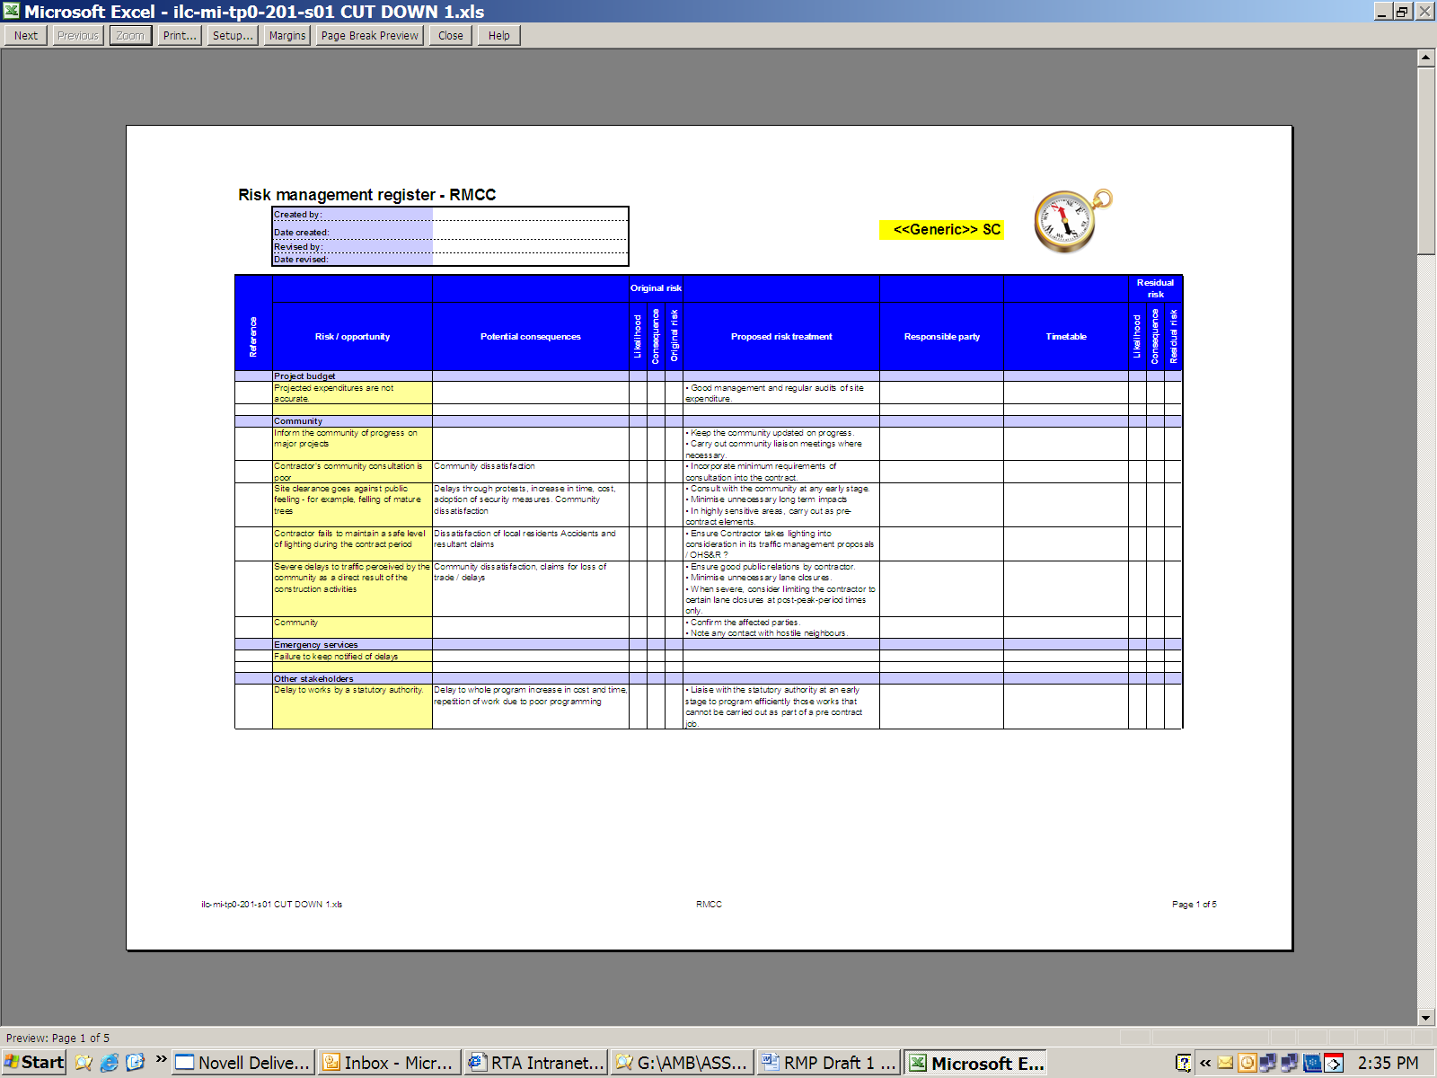
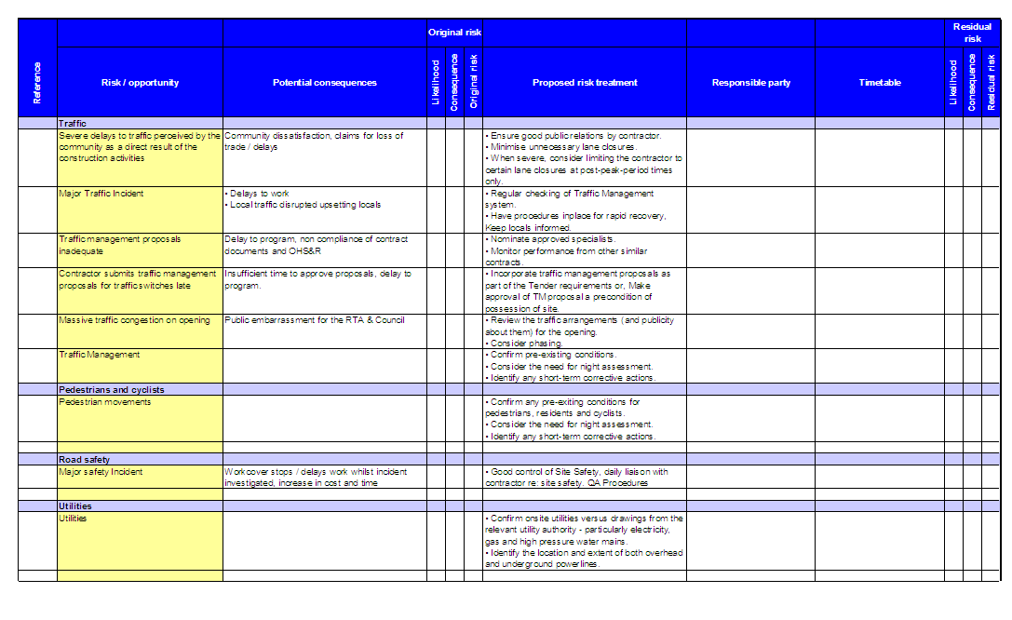
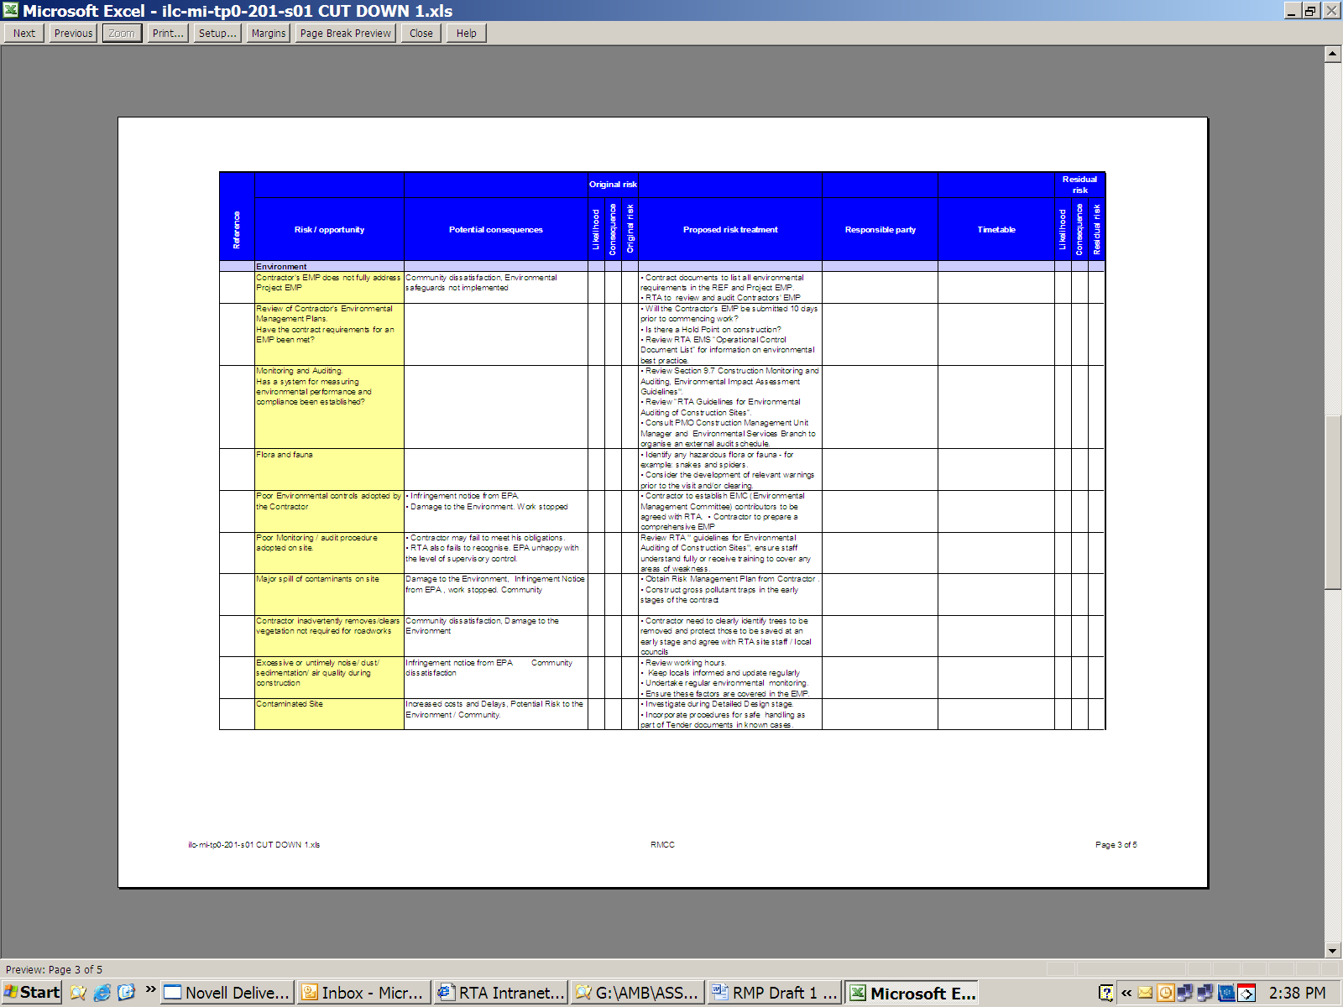
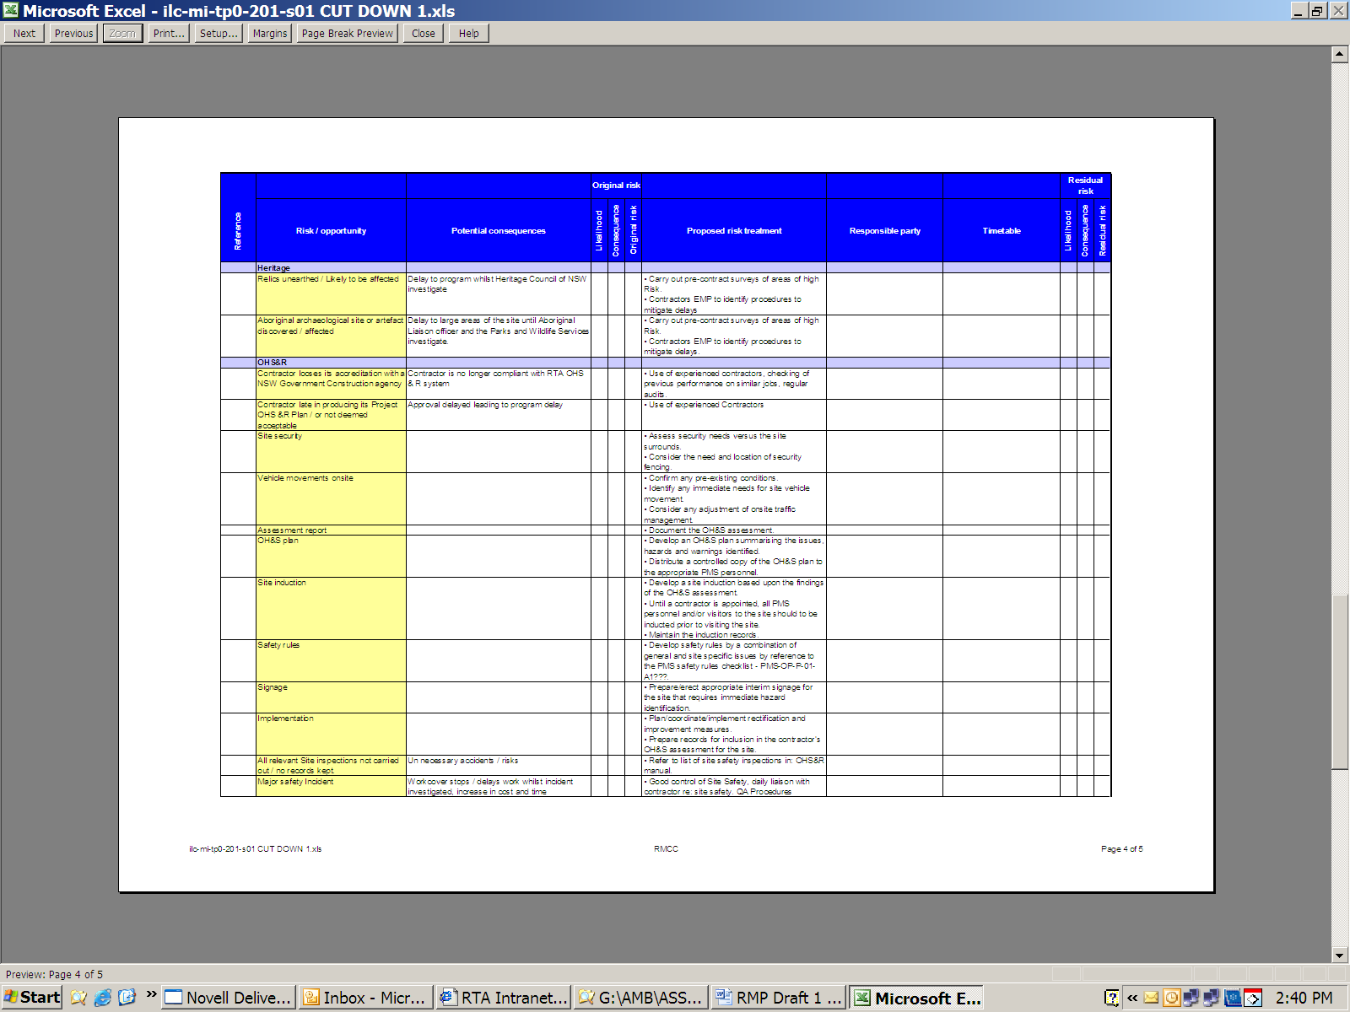
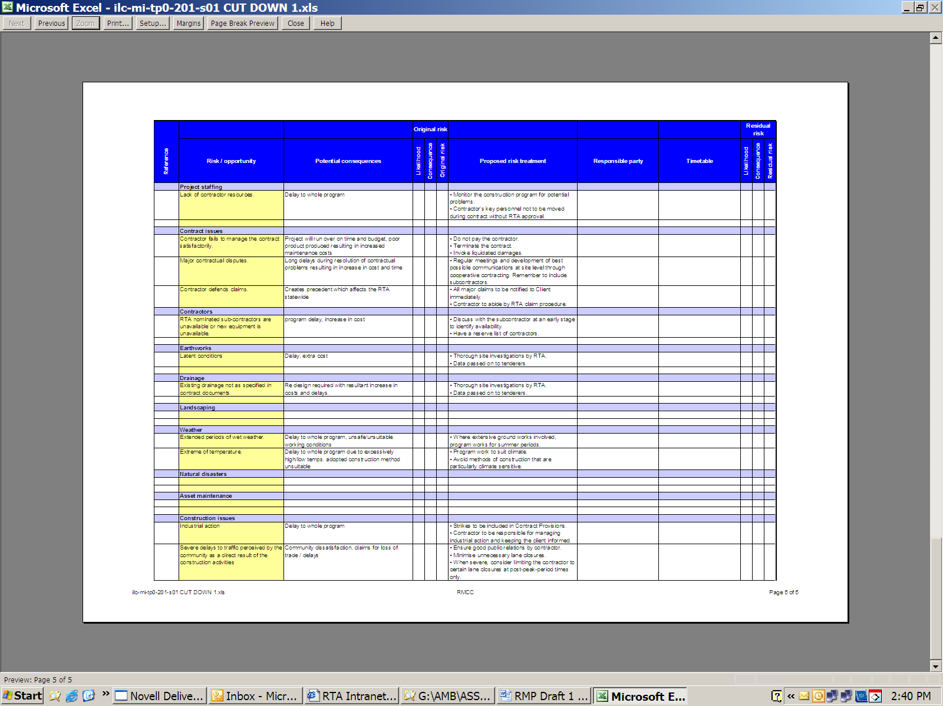

- Risk Treatment
<< General Manager and Engineering Director and the Safety and Environmental Management Representatives>> will determine what to do about each Risk:
Favourable Risks:
- Develop plans to maximise the benefits should the risk eventuate.
Unfavourable Risks Rated E, H or M
- Develop treatments to eliminate each Risk or mitigate it to L or N.
- Enter the treatment into the Proposed Risk Treatment column in the Risk Register.
- Again follow steps 1. 2. and 3 to determine the Residual Risk after the treatment has been applied.
Residual Risks Rated H or M:
- Emphasise these in the Action Plans, SWMS etc
Residual Risks Rated E after treatment:
- Inform the RTA Representative and with him/her develop an Action Plan.
- Community Relations Plan
- Preface
Scope of this Plan
This document defines the community relations practices and processes Council will observe during the execution of all the Services set down in the RMCC.
Council’s Community Relations Objectives
As the steward of parts of the State Road Network within its LGA, Council’s Community Relations objectives with respect to the RMCC are to:
- Manage relations so that trust, good faith and cooperation between the Council, the RTA and the community are maintained or enhanced and
- Foster a customer satisfaction based approach to the management of the network.
Purposes of Council’s Community Relations Management Plan
The purposes of Council’s Community Relations Management Plan are to:
- Define Council’s management of the community relations and
- Provide guidance to Council staff on Council’s obligations under the RMCC,
Principles
Community relations and consultation are important parts of successful Services:
- If the community knows the objectives of Council’s work under the RMCC, what will be done and when, it will be more cooperative and understanding when it is affected and
- When conflict arises, it can be effectively managed.
Moreover, the local community may assist the project team by confirming local conditions that could cause problems during maintenance or construction.
To these ends, Council will consult the community before and during projects which may significantly impact upon the community or which are perceived by it to have that potential.
- Scope
Generally, Council will:
- Manage community relations related to the road network on behalf of the RTA. See RTA M1 Clause 1.4.4. This includes, but is not limited to:
- Representation to the community and media where appropriate,
- Providing guidance, leadership, and oversight of community relations,
- Holding Community Consultation Meetings to ensure that the objectives of the Project are well known to the local communities affected –this includes the local aboriginal community when it is perceived there could be heritage issues,
- Assessing and setting priorities so the Services meet community expectations to the extent possible,
- Minimising traffic delays, noise and other nuisance where possible,
- Ensuring publicity processes are aligned with traffic management and road occupancy approvals. Also ensuring draft letter box drop advices are approved by the RTA,
- Being responsible for the recording and reporting of information and its transmission to RTA,
- Maintaining a ‘Complaints Register’ with a record of all complaints and enquiries,
- Providing a 24 hour telephone service to manage relations with the community,
- Assessing complaints and dealing with them promptly,
- Monitoring and reviewing the effectiveness of the Community Relations Plan, and revising the Plan when its procedures are found not to be fully effective in meeting the community’s expectations,
- Community Consultation Procedure
Before beginning any Services which Council or the RTA believe may have, or could be perceived to have, a significant impact upon the community through traffic or access disruption, noise, light, vibration or upon its heritage, Council will:
- Analyse the stakeholder and community context,
- Clarify any commitments made to date,
- Recommend a stakeholder consultation strategy and plan to the RTA,
- Consult the stakeholders,
- Analyse community needs, expectations, issues, priorities and preferences,
- Determine which can be accommodated and which cannot,
- After consultation and agreement with the RTA Representative, incorporate those which can be accommodated into the Project Plan,
- If appropriate, establish a community liaison group,
- Draw up, submit to the RTA Representative and, upon RTA approval, implement a community involvement and communication programme which sets down:
- A programme of meetings – formal and informal and
- What will be communicated, through Which medium (including informal media) and When.
Council will not neglect the regular reporting of progress to the community with reasons for any delay.
- Draft and place advertisements coordinating this with the RTA’s Communications Plan through the RTA Representative,
- Ensure senior site personnel are trained in the use of the Complaints Register and the Contact Centre and
- Address individual communications during construction ensuring appropriate and prompt response.
- Complaints and Enquiries
Complaints Register and 24/7 Telephone:
Council will:
- Develop and maintain a ‘Complaints Register’ which records all complaints and enquiries. The Complaints Register will be such that it is suitable to track all representations and will include the data set down in RTA M1 Clause 2.5.2,
- Provide a Contact Centre to manage relations with the community. A 24 hour telephone number will be provided for the receipt of complaints and for other customer requests.
Complaints:
Council will:
- Assess complaints and deal with them promptly. Where rectifying the complaint is not part of the SERVICES, Council will provide details of the complaint to the RTA within 24 hours, together with recommended actions (where appropriate) for dealing with the complaint.
Enquiries from the Community, General Public and Media
Council will:
- Use the Complaints Register to log all enquiries from the media (press, radio, television or internet) and the public regarding the Services
- Where their resolution is outside Council’s scope, refer them to the RTA representative within 24 hours,
- Not make statements, conduct interviews or release documents which are not already in the public domain without the written approval of the RTA. Council notes the few exceptions to this rule are set out in the RMCC at Clause 22 and M1 Clause 2.5.5.
- Within 5 BUSINESS DAYS of such a request, provide details relating to an inquiry. These details must be provided in the form of a briefing or a preliminary draft media release.
- Traffic and Access Disruption and Local Nuisance
Council will:
- Conduct Risk Analysis and Risk Treatment of proposed Services in order to minimise disruption to traffic and access and to minimise local nuisance such as noise, light, vibration and smoke,
- During the week before carrying out Services which will result in significant traffic disruption, artificial light, noise, dust or vibration, use newspaper advertisements, radio announcements and / or letterbox drops to notify emergency services and relevant sections of the community and transport industry of the Services. To this end, it will:
- Provide to the RTA a draft of an appropriate advertisement 3 weeks before the proposed placement of the advertisement (This only when Council has not already had typical advertisement content and layout approved by the RTA),
- Notify residents and businesses affected by disruption to property access or by night works in built-up areas. A letter will:
- be “letter-box-dropped” at least three Business Days before the proposed date and
- detail the dates and times of the proposed access restrictions and contact details.
- If conflicts arise, Council will negotiate with affected residents and businesses to resolve them,
- At least twenty four (24) hours before any burning off is commenced, notify the occupiers of adjoining properties of the proposed burning off operation. The burning off operation will be controlled so that:
- Vegetation outside the limits of clearing is not damaged;
- Fences, buildings or other property is not damaged; and
- Smoke does not cause a traffic hazard, nuisance nor contravene air quality requirement,
- Notify the public of pesticide use in accordance with RTA G34M Annexure I,
- Perform the Services only in the times permitted by the RMCC and
- Promptly advise the TMC or RTA Regional Traffic Commander of delays to traffic which are, or are anticipated to be, longer than 15 minutes.
- Signs
Council will:
- Erect information signs about the Services:
- If directed to do so by the RTA;
- Where the Services are undertaken as part of the delivery of the annual program of works and
- At static work sites that have a period of operation greater than two weeks and/or those which delay the traffic by more than 5 minutes at any one time on a recurring basis.
- The signs will be provided on each approach and will be located not less than 750 metres and no greater than 2000 metres, prior to the transition area of the work site.
- As a minimum, Information Signs will indicate the location of Services (road name and Services location), start and finish dates, working days and hours of work, and contact phone number for enquiries.
- The information signs will be installed a minimum of 1 week prior to the start date and removed at the completion of the Services to which they relate. The signs will be maintained in good condition throughout.

- Communications and Reporting Plan
- Preface
Scope of this Plan
This document describes Council’s communications planning and processes and the reports and notifications it will make during the execution of the Services.
It encompasses communication:
- Internal to the Council regarding:
- The RMCC as a project in which many Council people play a role,
- Changes relative to the SIMC,
- Safety and the Environment in the RMCC and
- Emergencies and Incidents.
- With the RTA as a partner and principal and as set down in the contract,
- External to the Council with:
- Department of Conservation and Climate Change (“DECC”),
- WorkCover and
- Utilities and Rail.
Appendix G deals with communication in:
- Community relations,
- Complaint and enquiry management,
- Dealing with the media and
- Proposed traffic and access disruption is dealt with in
Council’s Communications Objectives:
Council’s objective is to ensure each of its communications is:
- Directed to an identified need or objective and to a defined audience(s),
- Accurate in its content,
- Timely,
- Effective,
- Clear, concise and grammatically correct,
- Delivered in the medium appropriate to each message and audience (whether that medium is a council or other meeting, radio, letter-box-drop or newspaper advertisement) and
- Appealing to the extent appropriate and possible.
Purposes of Council’s Communications Plan
This Plan describes:
- The communications needs and expectations for the RMCC,
- How information will be communicated and
- When each communication will be made.
- General
Before beginning the Services, Council will organise, resource, train all relevant people in, test and notify the RTA about:
- Network and site communications,
- Communication with subcontractors,
- Contract communication and
- External communication.
to respond to, manage and report:
- OH&S accidents and incidents,
- Network emergencies and incidents,
- Environmental problems and pollution incidents.
It will maintain a current list of relevant contact names, telephone numbers and facsimile numbers for the RMCC – see Council’s Contract Management Plan Appendix D.
It will ensure the communications requirements (including equipment) for
- Remote Area Work and Lone Worker Protection. (Council will use
RTA OH&S Policy 2.15 as a guide) and
- Rapid contact with emergency services
are taken into account.
- Internal Communications
Council will, within two weeks of being notified its tender for the RMCC is successful, hold a meeting, or meetings, for all Council staff and subcontractors involved with the RMCC to explain:
- the new contractual arrangements’ objectives and outcomes and the opportunities and obligations they bring,
- the communications requirements of the Contract and Council’s plans to meet them as set down in this Plan and in Council’s:
- Safety Management Plan,
- Environmental Management Plan,
- Quality Management Plan,
- Traffic Management Plan and
- Other Plans Council has adopted for the RMCC.
During the RMCC Council will, at intervals no longer than 1 week:
- Conduct tool-box meetings with site employees and subcontractors regarding OH&S, Environmental Protection and Quality.
- External Communications ~ not RTA
Council will not, without the RTA’s prior written approval, release statements, information or documents which are not already in the public domain. Council notes the few exceptions to this rule are set down in the RMCC at Clause 22 and in M1 Clause 2.5.5.
With Other Councils
Council will meet with the Peer Exchange Group as required by RTA M2 Annexure F.2.,
With WorkCover
Council will give notice to WorkCover of an accident or incident where required to do so under Sections 86 and 87 of the OHS Act (2000) and Part 12.1 of the OHS Regulation 2001
With DECC
Council will notify the DEC Regional Manager (or the DEC Pollution Line on telephone 131555 should the incident occur outside normal DEC business hours) of pollution incidents on or around the Network in the following circumstances:
- If the actual or potential harm to the health or safety of human beings or ecosystems is not trivial or
- If actual or potential loss or property damage (including clean-up costs) associated with a pollution incident exceeds $10,000.
With Utilities and Rail
Council will:
- Liaise with the relevant authority, corporation or company before conduction Services which is near or impinges upon a rail asset or an utility,
With Emergency Services
Council will:
- When responding to an emergency, advise the appropriate emergency response agency (see M300 Clause 371.4),
- Notify the Police of Defects which constitute an immediate danger and ask for assistance,
- Before burning off, obtain a fire permit and comply with the requirements of the Statutory Regulations. Council will be guided by the DEC guideline Regulation of Open Burning in NSW and will observe the Hold Point in RTA G34M Clause 6.11.2.
- Summary of Identified Records and
Reports and Notifications to the RTA
Council will submit to the RTA the following Identified Records:
Report / Notification | When | Reference  “RTA Doc (Clause number)”
Committing to the RMCC:
Notification of any ambiguity, omission or discrepancy in the contract documents including the specifications | When found | RMCC (35.10)
Pricing of Ordered Work | Within the specified times – in the case of Work Proposals generally within 5 days | RMCC (7.2)
Setting-up
Submit 3 copies of all Contract Management Systems Plans (including a Traffic Management Plan) | Within 35 Business Days of RTA accepting Council’s Tender | Q4M (4.2.5)
Subsequently, submit any changes to the Plans Council proposes. |  | Q4M (2.2.4)
Traffic Management Plan for Ordered Work | >10 days before work starts | G11 (2.2)
24 hour x 7 days Environmental Emergency Contacts | 10 days before RMCC’s term starts | G34M (4.9)
Properly filled in Risk Register | Within 15 Business Days of being awarded RMCC | Council’s Risk Plan (Appendix F.2)
Report (on the form provided) the training carried out at commencement of the Services and as it occurs subsequently. |  | Q4M (6.2) and RTA G21M/C2
Contract Management:
Routine Management and Monitoring:
Regularly meet with the RTA Senior Project Manager |  | RTA M2 Annexure F.2
Meet with the RTA Representative on specific issues | As required | Eg RMCC (25.2)
Inspection calendar | On request | M1 (2.4)
Asset Inspection Record | On request | M1 (2.4)
Work Programmes | On request | M1 (2.4)
Daily Work records | On request | M1 (2.4)
Maintenance Defects Register | At JPA and upon request | M1 (2.4)
Work Schedules | Two Business Days of request | M1 (2.4)
RMAP for Routine Services | Quarterly and on 31 May each year | M2 (G.1)
RMAP for Ordered Work | Quarterly and on 31 May each year | M2 (G.1)
Quarterly KPM report | Quarterly | M2 (G.1)
Annual KPM report | Annually | M2 (G.1)
Simple Accomplishment Report | Quarterly | M2 (G.1)
Detailed Accomplishment Report | Annually | M2 (G.1)
Routine Services Cost Report | Quarterly | M2 (G.1)
Maintenance Defect Register Report | When requested | M1 (2.4)
Proposals | At JPA and when seeking or considering a Work Order | M2 (7.2)
Notification if Council does not want to do the proposed work | Within 2 weeks of receiving Work Order
Proposal for Variation | When Council wants or RTA requires. | RMCC (10.2)
Financial:
Actual cost records | When requested | RMCC (12.3)
The financial reports required by RMCC Contract Clause 12.3 | When requested | RMCC (12.3)
Claim for Payment |  | RTA M1 (12)
Contract Event triggered:
Advice to TMC about fatal accidents, hazardous material spills, delays to traffic which are, or are anticipated to be, longer than 15 minutes and unattended vehicles which are hazardous or obstructing traffic. | Immediately | M300 (371.5)
Report of Council becoming aware of abandoned vehicle | Within 24 hours | RTA M2 Annexure H.8
Final report regarding impoundment | Within 24 hours | M300 (4.371.13)
Report regarding removal of vehicle | Within 24 hours | M300 (4.371.13)
Report of Accident / Vandalism | within 24 hours of attendance | RTA M2 Annexure H.9
Report of damage to an ASSET or to property of the RTA | Within 24 hours of attendance
Report of Fatality or Injury | Within 24 hours of attendance
Application for Road Occupancy License for Ordered Work | At least 10 days before the work | G11 (2)
Notification to TMC of prior to and on completing any Services for which a Road Occupancy Licence has been issued |  | G11 (2.4.1)
Draft of advertisements and “flyers” advising community, road users about significant traffic disruption | Three weeks before placing advertisement. | M1 (4.3.2)
Notification of a complaint which is not Council’s responsibility | Within 24 hrs of receipt | M1 (2.5.3)
Notification of a media or public enquiry which is not Council’s responsibility | Within 24 hrs of receipt | M1 (2.5.4)
Report of Incident Response | Within 5 Business Days if cost is recoverable | RTA M2 (H.7)
Notification of Wet Weather Event which has caused additional Costs in Additional Services | Within 5 Business Days of end of event | RMCC (11.5.)
Notification of encountering any of the issues which Work Terms assigns to the RTA | When encountered | Work Terms Clauses 5, 6 and 7
Advice of exceptional circumstances |  | M2 Annexure E Note 5.b,
Notification before starting any Services which may impact on RTA assets that are not serviced by Council (bridges, slopes, lights, loops etc), |  | M1 (4.5.1)
Notification if Council damages any of the above so they are inoperable
Notification of all illegal use of vacant land | As per M30 Clause 2.34 | M30 Clause 2.34
Notification any alternative traffic stagings Council proposes |  | G10 (2.2)
Quality:
Advise of any change to any part of RMCC Management System | With 5 business days | Q4M (4.2.2.4)
Provide inspection and test plans | 5 days before contract commencement and 10 days before new Services  processes/ materials | Q4M (8.2.4.2) and Annexure A.2.
Nonconformity Report | Within 2 Business Days of detection of the nonconformity | Q4M (8.3)
Concluded CAR | Within 7 days of Council receiving CAR | Q4M (8.5.2)
Copies of Quality Records | Within 14 days of request | Q4M (4.2.4)
Up-to-date index of all project records | On completion
OH&S:
Notification of any OH&S incident, any accident or injury entailing notifying WorkCover on RMCC Services | Immediately and then in writing within 3 days | G21M (4.9)
Notification of any Notice of Fine by WorkCover | Immediately and then in writing within 3 days | G21M (4.9)
Notification of any Lost time incident, or any dangerous occurrence | Immediately and then in writing within 3 days | G21M (4.9)
Report re Corrective Action re above OH&S issues | Within 3 days | G21M (4.9)
Site Specific Safety Management Plan and/or Safe Work Method Statements for any Services or subcontractor not already covered by an RTA approved Site Specific Safety Management Plan and/or Safe Work Method Statements | 10 days before Services on site | G21M (3.2) and (4.3)
The monthly reviews of the Risk Assessment and Risk Control Plan | Upon request. | G21M (4.6.1)
The completed weekly Health and Safety Inspection forms |  | G21M (4.8.1)
The Safety training records set out in the Site Specific Safety Management Plan | Upon commencement of the RMCC and  with the annual OH&S Report | G21M(4.7)
The records of Subcontractor prior-to-commencement reviews | Upon request | G21M (4.3)
Pre-Start Truck and Plant Checklists | Upon request | G21M (4.8.2)
Register of Licensed Operators | Upon request | G21M (4.8.2)
Report OH&S issues | Monthly | G21M (5) and G21M/L
OH&S Report | Annually | G21M (5) and G21M/L
Environmental Protection:
Temporary Stockpile: Notification with Location, Type and Risk Assessment | 5 business days before use.
Concluded CAR | Within 5 business days of Council receiving CAR | G34M (3)
RTA Form 624 re any failure to meet Enviro. responsibilities | Within 5 business days of incident | G34M (4.12)
Report re on-site storage of chemicals, fuels and lubricants requiring additional bunding | Ten days before storage on site | G34M (6.12.c)
Warrant re any imported material that it is suitable for the intended land use of the site | At least 5 business days before the delivery | G34M (6.12)
Notification of any Aboriginal OR Heritage find | Immediately | G34M (6.13) & (6.14)
Notification to the RTA of any pollution incidents which involve the DECC, | Verbally within 2 hours and  In writing within 24 hours | G34M (4.9)
Report on any DECC visit to any RMCC Services | Within 5 business days | G34m (4.9)
Noise Control Plan if required by RTA G34M Clause 6.7, |  | G34M (6.7)
Vibration Management Plan if required by RTA G21M Clause 6.8, |  | G34M (6.8)
Building Condition Inspection when required by RTA G21M Clause 6.8 | Before Services which may cause damage through vibration to utilities, buildings etc | G34M (6.8)
Notification to the RTA promptly of actual or suspected contaminated land exposed during construction activities |  | G34M (6.15)
Report Waste Information | Annually | G34M/G2
Environmental report | Annually | G34M (4.13)
Copies of Enviro. Records | Promptly | G34M (4.2)
Community Relations:
Community involvement and communication programme | Before beginning any Services which will have a significant impact on the community
Complaints the rectification of which is not Council’s responsibility.  Enquiries from the media and general public where any rectification is not Council’s responsibility. | Within 24 hours of receiving
Legal Actions:
Provide full report based on Council’s knowledge of the relevant matter (except where dispute is Council vs RTA). | Within 10 Business days of RTA request

Appendices I to L Not Used

Appendix M Definitions
CAR | Corrective Action Request
CM | Council’s Contract Manager
CMP | Contract Management Plan
Council Hold Point | A point beyond which a work process must not proceed without the express written authorisation of Council Manager specified.
JPA | Joint Planning Assessment
PQP | Project Quality Plan
QMP | Quality Management Plan
QMR | Council’s Quality Management Representative
RecMP | Records Management Plan
RMCC | The contract between Council and the RTA for the construction, maintenance and servicing of RTA assets
RMP | Risk Management Plan
RTA | Roads and Traffic Authority of New South Wales
RTA Hold Point | A point beyond which a work process must not proceed without the RTA’s express written authorisation
Services | All Services and other activities Council carries out to meet its obligations under the RMCC
SO | Surveillance Officer
With respect to Risk Management, Council has adopted the definitions set down in AS 4360.

Last page

