Transport  for NSW |  | Level Up  Rail Safety  A Minecraft Experience  Student Workbook

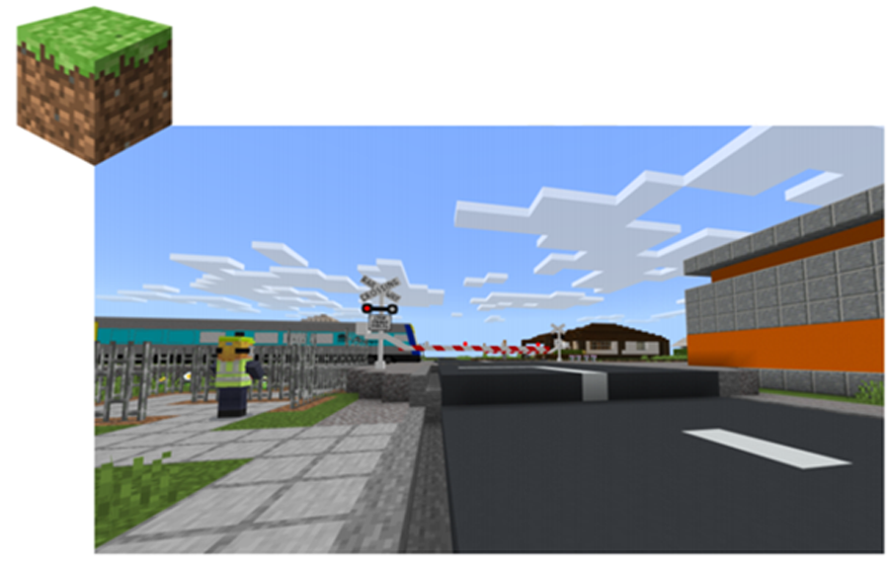

Name:

Group members:

Class:

Acknowledgements

This student booklet was devised by NSW Department of Education teacher Karyn Morrison for use by her students engaging in Level Up Rail Safety. Karyn has offered this booklet to all teachers for use in the program.

You are welcome to edit and adapt this booklet to suit your student needs.

To complete Mission 1, you will need to successfully add key local landmarks to your virtual town. When you have done this, return to Town Hall to report your progress to the Town Councillor. You will then collect instructions for Mission 2 to upgrade the level crossings.

Spawn point – Town Hall - Coordinates 75 65 630

- What do you know about level crossings? What are some of the safety rules that apply at rail lines and level crossings?

- What are some of the safety issues in the town? (Hint: Talk to NPC’s to get feedback.)

- What are some of the changes you will make to this town? What landmarks or features will you include to make the town your town?

Build these features in your town. When you have done this, tick this box ☐

- Go to ‘News’. Right click on the bookshelf to export the coordinates. When you have done this, tick this box ☐
Write the coordinates here in case you need to refer back to them.
____________________________________________________________________________________________________________________________________________________________________________________________________________________________________________________________________________________________________________

To complete Mission 2, you will need to successfully upgrade the level crossing to active crossings.

- Visit the rural crossing to find out why it's urgent that we upgrade it first. The rail engineer will meet you and guide you to The Lab for research and simulation testing. The engineer will use your settings to create the upgrade.
- Then at the town crossing learn about the slower speed and pedestrian issues.
- In The Lab carry out your simulation testing for this second crossing then give your settings to the engineer at the Rural Crossing
- When both upgrades are complete, report your progress to the Town Councillor

Rural Passive Crossing
- What is a rural passive crossing?

- Before visiting the Lab Library, you will need to visit the passive rural crossing and meet with the rail engineer who will explain the safety issues at this crossing. What is a passive crossing?

- Can you cross anywhere along the track as long as you check that a train is not coming? Why?

- According to the Station Master, what types of crossings will make a great start to making people safe?

Lab Library (2, 66, 60)
To answer the following questions, visit the Lab Library. You will need to do research in the library before you can attempt the simulation.
You will find sets of resources linked to computers, books, and posters in the library. Some will be informational. Technical information relevant to the crossing upgrades can be found upstairs and the downstairs library hosts the human resource material relevant across all 4 missions.

- Read the books and export these. When you have done this, tick this box ☐

- Why can a moment of distraction cost so much?

- If you could turn back time, what message would you give to the girl and her boyfriend?

- What are some of the distractions listed in the video and websites?

- Fill in the blanks:
_____________ behind the lines
_____________ both ways for trains
_____________ for trains coming
_____________, “is it safe to cross?”

Safety Town
- What can active pedestrian crossings include?

- What types of protection do passive crossings use?

- Click on the ‘Interpretive Map’ of NSW. Search Wagga Wagga. How many crossings are in Wagga Wagga? What types of crossings are these?

Simulation
The simulation will ask you to decide the distance from the crossing to [place the signal box and to create the correct sequence and timing for the lights and booms gates to ensure the safety of people on the side roads. Instructions for using the simulation are available in-world.
HINTS:
- Right click on the VR Technician to watch a video about completing a successful simulation!
- Setting a signal box distance far enough away from the crossing is vital – Think BIG!
What are the successful settings?
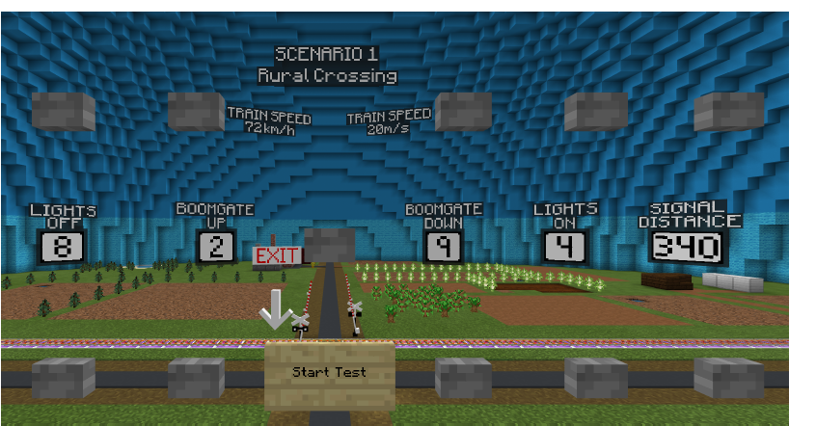
NOTE: you will be required to complete three consecutive successful tests in order to be able to upgrade each of the two crossings (rural and urban).

Once you have completed three consecutively successful trials you will be asked to take those settings to the engineer at the rural crossing to have him install the upgrade. The engineer will take the settings, use them to implement the upgrade, and call the train through the now active crossing. You will be able to observe the successful passage of the train through the crossing.

Town Crossing

Once you have completed the rural crossing upgrade you will then be directed to meet the engineer at the town crossing who will explain the issues and reason for upgrading this second crossing.

You will be advised trains crossing through built up areas travel at lower speeds than in the open rural areas. Afterwards you will be invited to return to the lab and test for the new settings that will be required for this in-town upgrade. You will follow the same process as the first upgrade challenge and bring back successful settings to pass to the engineer to implement the upgrade.

What are the successful settings for the urban crossing?
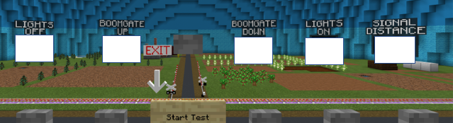

After completing 3 successful tests, head out of the simulation, and visit the VR Technician. Then head to the Town Crossing and share your results with the rail engineer. The Engineer will upgrade the crossing.
To complete this mission, go back to the Town Hall and advise the Town Councillor that Mission 2 is complete.

Reflection
“Upgrading the rail crossings helped me to understand…

To complete Mission 3, you will need to adopt a crossing and become safety ambassadors.

- Revisit both crossings and select one (town or rural) that is most like the one in or near your town or local area. If there is more you would like to build, to make it like your town's crossing, do that now.
- Your team should also think about who uses this crossing and how they will make their crossing (on foot, on bike, or in a car). Think about the risky behaviours that might take place there. Do more research if you need to.
- Report your progress to the Town Councillor.

Crossing Research

- Which crossing have you chosen and why?

- Who uses this crossing? How is it typically used? (by cars, pedestrians on foot or bicycle?)

- What are some of the risky behaviours seen at the crossing?

- What are the rules for pedestrians at level crossings?

- What are the rules for cars at level crossings?

- What are the most likely causes of crashes and near misses?

- What advice can you give to people to use to level crossings more safely?

To complete Mission 4, you will need to create a safety campaign.

- Choose the group of people you want to influence. Research and discuss their behaviours. Remember you are now the official town safety ambassadors.
- Create a campaign to influence those people to be safe in the level crossing. How will you use what's in this town to get your message across?
- Test your campaign and vote to decide on the team with the most powerful message and influence.
- When your campaign has been tested the Mayor will award you the ambassador's medal.

Congratulations!

You have now completed the game!!

Take a photo of you with you medal to share in class.

© Transport for NSW
Users are welcome to copy, reproduce and distribute the information contained in this report for non-commercial purposes only, provided acknowledgement is given Sto Transport for NSW as the source.

