Community notification
June/July 2023

Sutherland to Cronulla Active Transport Link - Stage 2 East
Transport for NSW acknowledges the Dharawal people as the Traditional Custodians of the lands on which we work and pay respects to Elders past and present.
Transport for NSW is delivering the Sutherland to Cronulla Active Transport Link (SCATL). A pedestrian and bicycle path linking Sutherland to Cronulla.
Stage 2 East construction is underway between Jackson Avenue, Miranda and Gannons Road, Caringbah.
The section of SCATL Stage 2 East we are currently delivering is Kingsway between Jackson Avenue and Miranda Road, Miranda.
What work are we doing in June/July?
In June/July we will complete the first section of the active transport link on Kingsway from Miranda Road to Carramar Crescent.
We are preparing to start construction on the next section on Kingsway from Miranda Road to Jackson Avenue. Work will start from early June.
Work planned for June/July includes:
- set up of temporary work area with fencing and barriers
- installation of tree protection fencing
- signage and line marking changes
- clearance of vegetation like turf and shrubs
- installation of erosion and sediment controls
- start excavation and construction of cycleway
- minor tree trimming and removal, subject to assessment.
We are continuing to investigate the retention of trees on Denman Avenue and will keep the community informed.
When we’ll be working
Working hours are 7am to 6pm, Monday to Friday.
We will notify nearby residents and businesses in advance if we need to work outside these times.
What will this mean for you?
We will be using a range of equipment including excavators, dump trucks, concrete trucks and pumps, vacuum trucks, delivery trucks, power tools and hand tools.
Managing our impacts
We aim to manage our work to avoid impacts to the community and the environment.
This includes:
- traffic control and signage in place for changes to access and parking
- temporary fencing for safety and security
- traffic controllers operating
- reducing our noise as much as possible by turning off equipment when not in use and using non-tonal reversing beepers
We will work with nearby residents and provide notification ahead of work in the area.
Temporary driveway closures
We will work closely with residents where temporary driveway closures are required to carry out construction. Access will be maintained outside our working hours.

Initiatives during construction
We are looking for not-for-profit and/or local community organisations who have innovative ideas for the recycling and reuse of timber and mulch.
Please reach out to Deborah and Courtney at community@sydneycivil.com to connect on recycling and reusing timber during the construction phase of Stage 2 East.

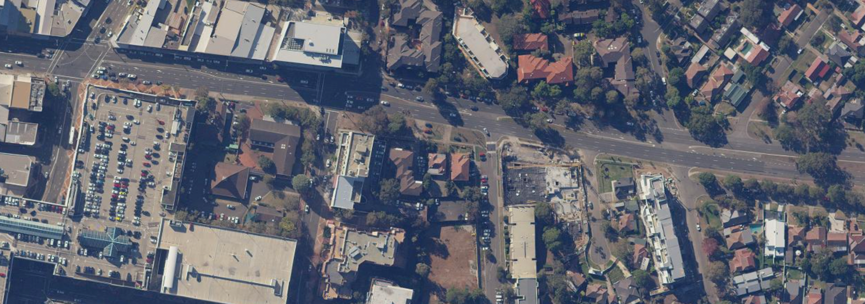
Subscribe to project emails
Jackson Ave
Miranda Westfield
Temporary construction area (Kingsway from Miranda Road to Jackson Avenue, Miranda)
Send an email to us at community@sydneycivil.com to subscribe.

Higherdale Ave

Kingsway
To Cronulla >
Gurrier Ave
Miranda Road

North
Construction work area

