Guidance to completing a Plan of Management

Transport for NSW

This guide provides instructions on how to complete the Plan of Management template for vessels with portable toilets, so it is specific for your vessel.

Open the downloadable file ‘Plan of Management - portable toilets template’ in Microsoft Word.

**Cover Page**

* Type the vessel’s name and AMSA UVI in the specified fields in the cover page.

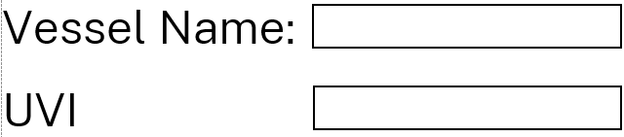

**Vessel characteristics page**

* Type your vessel’s characteristics in the right column fields. Leave field ‘Gross Tonnage’ blank if not know.

An example is shown below:

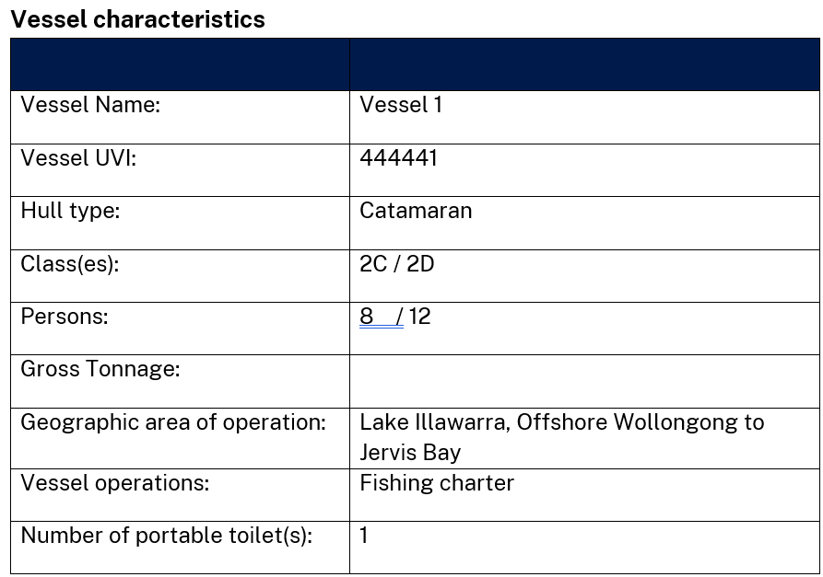

**Operational characteristics**

* Describe your vessel’s normal operations (you can use some of the examples below and modify them to be appropriate for your vessel).

Specify:

* the waters in which the vessel will operate,
* the areas of those waters in which untreated sewage may be discharged from the vessel and
* the areas in which no sewage may be discharged from the vessel.



*Example1:*

*The vessel is a charter vessel assigned class(es) #X and #X and operates with xx passengers and xx crew in smooth/partially smooth/open waters of Botany Bay and up to 30nm to sea.*

*The vessel has a portable toilet onboard so there is no overboard discharge of raw sewage from the vessel unless it is directly into a waste collection facility.*

*When the vessel operates in open waters beyond 12 nm from shore the crew may discharge one cassette of untreated sewage overboard.*

*A procedure for the sewage discharge operations is included in the vessel’s SMS.*

*Example2:*

*The vessel is a charter vessel assigned class(es) #X and #X and only operates in sheltered waters of Lake Illawarra. The only toilet fitted on board the vessel is a portable cassette type.*

*An empty waste cassette is installed in the portable toilet and a second (spare) cassette carried on board in case the first one becomes full.*

*Waste cassettes are only discharged directly in a shore-based waste collection facility.*

**Variation to standards**

For a vessel with portable toilets the minimum sewage tank capacity will not comply, and this should be included in this section. Any other variation of the sewage system that doesn’t comply with the NSW sewage standards, should be included here.

* Describe the aspect of the sewage system on the vessel does not comply with the NSW sewage standards. Provide any details of existing proven operations (if any) and reasoning for non-compliance (if any) - (you can use the example below and modify it to be appropriate for your vessel).



*Example*

*The owner of “Vessel name” – UVI is seeking approval for the reduction of the minimum sewage tank capacity as stated in the Marine Pollution Regulation 2024 as it only has portable toilet(s) on board. The procedures in this Plan of Management set out the operations to achieve compliance with the requirements of the Marine Pollution Regulation and eliminate the possibility of sewage pollution in State waters. The installation of a portable toilet is aimed at keeping the vessel compliant with its National Law requirement to have a sanitary facility.*

**Plan of Management for waste operations and procedures**

For any variations to standards described in the previous chapter, provide proposed procedures and operations to eliminate the risk of pollution due to the variation.

* Describe actions by a specified person and procedures for maintenance that are required to ensure the smooth operation of the sewage system and the removal of pollution risk if the system has variation(s) to the NSW sewage standards. (you can use some of the examples below and modify them to be appropriate for your vessel).



*Examples:*

*The following operations will be carried out by the vessel’s crew, in order to ensure that there will be no accidental discharge from the portable sewage tank(s) due to the reduction in capacity from the standards.*

*- The vessel has a portable toilet onboard so there is no overboard discharge of raw sewage from the vessel unless it is directly in a waste collection facility.*

*- The crew is to check that there are no leaks in the portable toilet before each charter.*

*- Pump out of a cassette to a shore facility is expected to be required after a charter with a voyage duration of 2 hours.*

*- A spare portable tank is available on board to replace the one fitted in the portable toilet after 2 hours of operation with full complement.*

*- When the vessel is operating on half of the passenger capacity, the spare tank may be replaced at a 3 hours operations maximum.*

*- In some case and weather permitting, when the vessel operates in open waters beyond 12 nm from shore, the crew may discharge one cassette of untreated sewage overboard on the return voyage following advice from the Master.*

*- A record of the date, time, location and estimated volume of discharge will be made in the vessel’s log.*

*- A procedure for the sewage discharge operations is included in the vessel’s SMS.*

*- All efforts will be made to minimise any potential threat to the health of persons and to the environment by following safety procedures for accidental spills.*

*- Master to ensure that any normal operations will not cause discharge of sewage into State waters.*

*- Any other operations that support the approval of this plan of management based on the required outcomes of the NSW sewage standards.*

**Flushing schedule procedures**

It is a requirement of the legislation to provide a schedule for flushing of the sewage holding tank (cassette), to avoid effluent build up and creation of toxic hydrogen sulphide gases.

* Describe the procedures of regular flushing schedule of the sewage tank (you can use the examples below or modify them to be appropriate to your vessel).

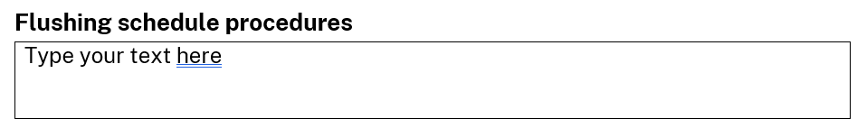

*Example:*

*All portable tanks (cassettes) will be cleaned and flushed after each use. During flushing the cassettes will be checked for leaks. The waste cassette shall be drained and sanitized before each service use.*

**Table of Contents**

* After you have completed all required fields in the Plan of Management, return to page 2 and click on the Table of contents.
* Click on Update Table (red arrow)
* Select ‘Update entire table’, and
* Click OK button

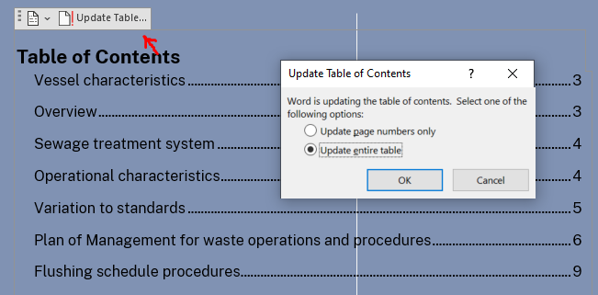

Save your file and submit to TfNSW at [SPPC@transport.nsw.gov.au](mailto:SPPC@transport.nsw.gov.au)