Guidance to completing a Plan of Management

Transport for NSW

This guide provides instructions on how to complete the Plan of Management template, so it is specific for your vessel.

Open the downloaded file ‘Plan of Management – Built in toilets template’ in Microsoft Word.

**Cover Page**

* Type the vessel’s name and AMSA UVI in the specified fields.

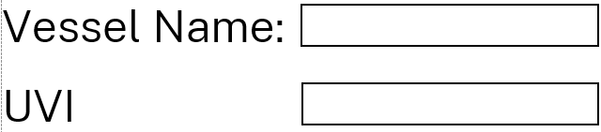

**Vessel characteristics page**

* Type your vessel’s characteristics in the right column fields. Leave field ‘Gross Tonnage’ blank if not known.

An example is shown below:

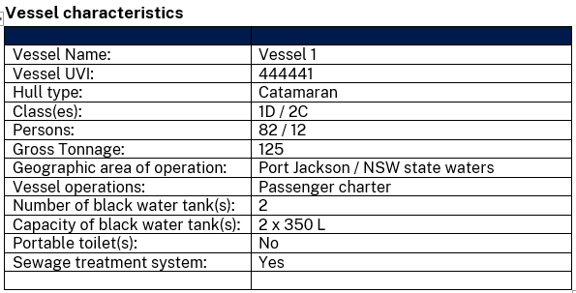

**Sewage Treatment System**

If your vessel doesn’t have a sewage treatment plant then delete this whole section.

If your vessel has a sewage treatment plant then

* fill in the information of your system (make, date of installation, type of treatment, maintenance date and treated sewage specs)

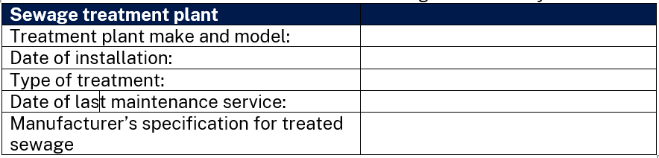

* Describe the operational procedures for ensuring safe operation of treatment plant.

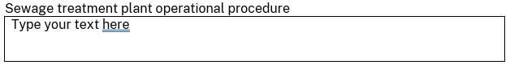

* Describe operational procedures that crew will need to do to ensure there is no accidental discharge of sewage that is not treated.

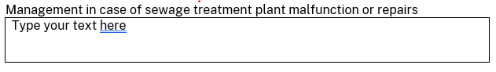

* Describe maintenance procedures to ensure treatment plant operates in accordance with the manufacturer’s specifications.

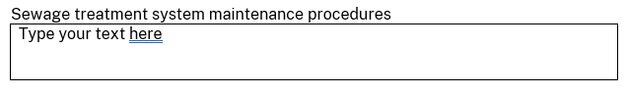

* Delete the following chapters:
* Variation to standards and
* Plan of Management for waste operations and procedures

**Operational characteristics**

* Describe your vessel’s normal operations (you can use some of the examples below and modify them to be appropriate for your vessel). Specify:
* the waters in which the vessel will operate,
* the areas of those waters in which treated/untreated sewage may be discharged from the vessel and
* the areas in which no sewage may be discharged from the vessel.



*Examples:*

*The vessel is assigned service category class(es) #X and #X and operates in smooth/partially smooth/open waters up to 30nm with xx passengers and xx crew.*

*Vessel is a charter vessel that operates Thursday to Sunday for 10 months/per year in Sydney Harbour. The vessel is also occasionally hired by groups for events within Port Jackson.*

*There will be no overboard discharge of raw sewage from the vessel unless it is directly in a waste collection facility.*

*The vessel operates in open waters and will discharge untreated sewage beyond 12 nm under the conditions described in the* [*Marine Order 96*](https://www.legislation.gov.au/Series/F2018L00329)*.*

*The vessel only operates in sheltered waters and doesn’t have an overboard discharge valve. Sewage holding tank can only be discharged directly in a waste collection facility.*

**Variation to standards**

For a vessel with any variation of their sewage system to the NSW sewage standards, these should be included in this part. Delete this whole section if this is not appropriate to your vessel.

* Describe the aspect of the sewage system on the vessel does not comply with the NSW sewage standards. Provide any details of existing proven operations (if any) and reasoning for non-compliance (if any) - (you can use some of the examples below and modify them to be appropriate for your vessel).



*Examples*

*Example 1*

*The owner of “Vessel name” – AMSA ID is seeking approval for the reduction of the sewage holding tank capacity from xxx litres to xx litres based on this Plan of Management operations and conditions. This reduction in capacity is aimed at reducing the deadweight of the vessel, to meet vessel’s design request for low wash and improved performance.*

*Example 2*

The owner or master of *“Vessel name” – AMSA ID is seeking approval for dispensation from having a gauge, sensor or other method to alert the master when the sewage holding tank is more than 75% full. The vessel has been operating with only a dip stick as a method to measure the level of effluent in the tank and the crew alert the Master when level reaches 75%. This arrangement has been followed since 20xx, with no incident of pollution and procedures are in place to eliminate the chance of tank overflow or a pollution incident.*

*Example 3*

*The owner or master of “Vessel name” – AMSA ID is seeking approval for dispensation of the sewage holding tank having a sloping bottom designed for self-cleansing. The vessel has a schedule for periodic flushing of the tank as described in the flushing schedule procedures below or the vessel’s safety management system (SMS).*

*Example 4*

*The owner or master of “Vessel name” – AMSA ID is seeking approval for the reduction of the sewage holding tank capacity from xxx litres to xx litres based on this Plan of Management operations and conditions. The vessel doesn’t have a greywater tank and uses the existing sewage holding tank to collect and hold greywater without complying with the required additional tank capacity. The vessel is an existing vessel built on Dec 20xx and operating in xxxxx.*

*Example 5*

*The owner or master of “Vessel name” – AMSA ID is seeking approval for dispensation of the sewage holding tank having its fittings and connections in accordance with section 12 of the NSW sewage standards (Schedule 5 of MPR 2024). The vessel has limited accessibility due to size of tank and limited space for an installation as per the requirements. The vessel is an existing vessel with procedures in place to eliminate the risk of effluent leaking inside the vessel or overboard.*

*Example 6*

The owner or master of *“Vessel name” – AMSA ID is seeking approval for the sewage holding tank vent to terminate at a point lower than the minimum 300mm higher than the highest point of overflow. The vent terminating between the vessel hulls is an as-built arrangement, and the installation of a new vent through the vessel’s deck is not a practical option.*

*Example 7*

*The owner or master of “Vessel name” – AMSA ID is seeking approval for dispensation from having an inspection opening on the sewage holding tank in accordance with section 16(2) of the NSW sewage standards (Schedule 5 of the MPR 2024). The vessel has been operating with this arrangement since xxxx, and there is a schedule for periodic flushing of the tank as described in the flushing schedule procedures below or the vessel’s safety management system (SMS).*

**Plan of Management for waste operations and procedures**

For any variations to standards described in the previous chapter, provide proposed procedures and operations to eliminate the risk of pollution due to the variation.

* Describe actions by a specified person and procedures for maintenance that are required to ensure the smooth operation of the sewage system and the removal of pollution risk if the system has variation(s) to the NSW sewage standards. (you can use some of the examples below and modify them to be appropriate for your vessel).



*Examples:*

*Example 1*

*The following operations will be carried out by the vessel Master and crew, to ensure that there will be no accidental discharge from the sewage holding tank due to the reduction in capacity from the standards.*

*- Pump out to a shore facility is expected to be required after each charter with a voyage duration of 2 hours.*

*- Heads are fitted with efficient flushing system that uses less than 1.5L of water per flush.*

*- The sewage holding tank is fitted with an electronic level sensor and high-level alarm (80%) that is monitored from the wheelhouse.*

*- In case of alarm signalling, the Master is to assess level of tank every 15 minutes and modify any vessel operations accordingly.*

*- When level sensor shows 90%, crew member is to ensure the toilets are not to be used except for emergency. Announcement to passengers should be provided advising of sanitary arrangements. If galley and bar sinks drain back to sewage holding tank the Master will instruct personnel and crew to stop using sinks and any related washing equipment’s i.e. dish/glass washers*

*- Master to ensure that any vessel operations will not cause discharge of sewage into State waters and organise pump out at a shore facility.*

*- Any other operations that support the approval of this plan of management based on the required outcomes of the NSW sewage standards.*

*Example 2*

*The following operations will be carried out by the vessel’s Master and crew, to ensure that there will be no accidental discharge from the sewage holding tank due to the lack of a gauge or sensor or other method to alert the master when the sewage holding tank is more than 75% full.*

*- Vessel has been operating since 20xx and the operator’s experience shows that pumping out every day after a 3-hour charter has been sufficient frequency to ensure tank capacity is adequate.*

*- Vessel has a Fresh water tank of xxx litres and a black water tank of xxx litres. Water from toilet flushing and handwashing basins leads to the black water tank.*

*- The Master will keep a record of pump-out activity in the log book as evidence of the vessel’s compliant operation.*

*- The vessel’s toilets and handbasins are checked before each charter and during the charter to ensure there is no dripping taps or flushing system faults.*

*- The black water tank’s level is checked by a crew member before each charter and report it to Master.*

*- A crew member will check black water tank level after two hours of the charter and every hour thereafter. Crew to report to Master when level is at 75% full.*

*- If black water tank is at 90% full, Master is to ensure the toilets are not to be used except for emergency. Announcement to passengers should be provided advising of sanitary arrangements.*

*- Master to ensure that any vessel operations will not cause discharge of sewage into State waters and organise pump out at a shore facility.*

*- Any other operations that support the approval of this plan of management based on the required outcomes of the NSW sewage standards.*

*Example 3*

*The following operations will be carried out by the vessel’s Master and crew, to ensure that there will be no solid accumulation in the sewage tank due to the sewage holding tank not having a sloping bottom designed for self-cleansing.*

* *The vessel has a schedule for periodic flushing of the tank as described in the flushing schedule procedures below or the vessel’s safety management system (SMS).*

*Example 4*

*The following operations will be carried out by the vessel Master and crew, to ensure that there will be no accidental discharge from the sewage holding tank due to the reduction in capacity from the standards.*

* *The vessel doesn’t have a greywater tank and uses the existing sewage holding tank (capacity of xxx litres) to collect and hold greywater. The Fresh water tank onboard which supplies the sanitary facilities, showers and galley has a capacity of xxx litres.*
* *The vessel is an existing vessel built on Dec 20xx and operating in xxxxx.*
* *The vessel pumps out only at shore based facilities and records this activity in the log book.*
* *The sewage holding tank has an electronic sensor with an indicator in the wheelhouse and an alarm at 75% full.*
* *In case of alarm signalling, the Master is to assess level of tank every 15 minutes and modify any vessel operations accordingly.*
* *The Master will ensure that any vessel operations will not cause discharge of sewage into waters where it is prohibited.*
* *Any other operations that support the approval of this plan of management based on the required outcomes of the NSW sewage standards.*

*Example 5*

*The following operations will be carried out by the vessel Master and crew, to ensure that there will be no accidental leaking of effluent inside the vessel or overboard in waters where discharge of untreated sewage is prohibited.*

* *The vessel has limited accessibility due to size of tank and limited space for an installation as per the requirements.*
* *The vessel is an existing vessel operating as a class 1 vessel doing charter operations since 20xx.*
* *The sewage system is part of the pre-departure checks of the vessel.*
* *A maintenance schedule for parts of the sewage system that require frequent replacement or maintenance (e.g. urinal cartridge, or silicone diaphragm etc.) is available in the vessel’s SMS.*
* *As the inlet connection enters the tank at the side and not the top of the tank, the crew are all aware that the tank is not to be filled more than 80% to avoid blockage of the inlet piping. Procedures for the sewage system operation are included in the vessel’s SMS.*
* *Outlet pipe is fitted at xx mm above the tank bottom, being more than the 40mm required by the sewage system standards. This may allow for accumulation of solids in the tank, however to mitigate this the operator flushes the tank with a pressure washer during pump-out (by suction) to minimize the change of solid build-up.*
* *Vent pipe is only xx mm in diameter, falling short of the requirements in the NSW sewage standards. The vessel has been operating with this arrangement since 20xx and there have been no issues with the tank venting or pump out rate. The operator will ensure that sewage system will be maintained in good order and the pump-out procedures and tank’s flushing schedule observed consistently.*
* *The Master will ensure that any vessel operations will not cause the discharge of sewage into waters where it is prohibited.*
* *Any other operations that support the approval of this plan of management based on the required outcomes of the NSW sewage standards.*

*Example 6*

*The following operations will be carried out by the vessel Master and crew, to ensure that there will be no accidental discharge of untreated sewage in State waters. The vent terminating between the vessel hulls is an as-built arrangement, and the installation of a new vent through the vessel’s deck is not a practical option.*

*- The sewage holding tank is fitted with an electronic high level alarm (75%) that is monitored from the wheelhouse.*

*- In case the alarm signals, the Master is to ensure the toilets are not to be used except for emergencies.*

*- Announcement to passengers should be provided advising of sanitary arrangements.*

*- Arrangements for the sewage holding tank to be pumped out should be made to avoid any effluent accidentally escaping through the vent pipe.*

* *The Master will ensure that any vessel operations will not cause discharge of sewage into waters where it is prohibited.*
* *Any other operations that support the approval of this plan of management based on the required outcomes of the NSW sewage standards.*

*Example 7*

*The following operations will be carried out by the vessel’s Master and crew, to ensure that there will be no solid accumulation in the sewage tank due to the sewage holding tank not having a sloping bottom designed for self-cleansing.*

* *The vessel has been operating with this arrangement since xxxx, and there is a schedule for periodic flushing of the tank as described in the flushing schedule procedures below or the vessel’s safety management system (SMS).*
* *For any internal tank inspections there is a spin-out that has been installed on the inlet piping that can be used to access an endoscope camera.*

**Flushing schedule procedures**

It is a requirement of the legislation to provide a schedule for flushing of the sewage holding tank, to avoid effluent build up and creation of toxic hydrogen sulphide gases.

* Describe the procedures of regular flushing schedule of the sewage holding tank (you can use some of the examples below and modify them to be appropriate to your vessel).

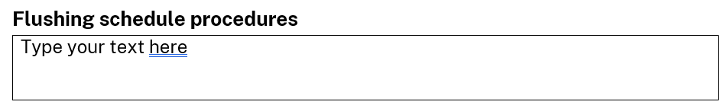

*Example 1:*

*All sewage holding tank cleaning and flushing procedures to be carried out as outlined in vessel’s SMS.*

*Example2:*

*Flushing schedule*

*Vessel is operated for 10 months per year, excluding months of July and August.*

*The black water tank is pumped out every night after the charter operation. The Master (dual ticketed) is responsible to ensure that the black water tank has been emptied. The pump out is recorded in the vessel’s log.*

*Since the vessel’s sewage holding tank is pumped out on a daily basis, the tank is only flushed and cleaned on a fortnightly basis. Flushing of the tank also occurs upon return from the two-month operation-break and also before the vessel is slipped. Sewage holding tank cleaning and flushing is recorded in the vessel’s log.*

**Table of Contents**

* After you have completed all required fields in the Plan of Management, return to page 2 and click on the Table of contents.
* Click on Update Table (red arrow)
* Select ‘Update entire table’, and
* Click OK button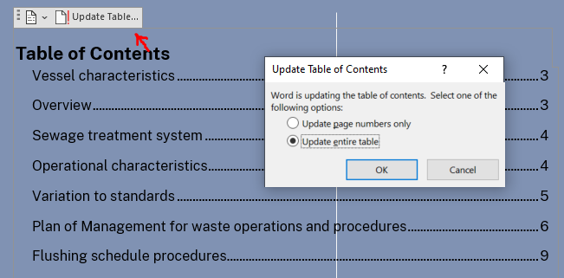

Save your file and submit to TfNSW at [SPPC@transport.nsw.gov.au](mailto:SPPC@transport.nsw.gov.au)